To: | Jonathan Koester, P.E., District 7 Consultant Contracts
COPY: | Daniel Grilliot, P.E., District 7 Geotechnical Engineer
FROM: | Stephen Taliaferro, P.E., Office of Geotechnical Engineering
DATE: | July 11, 2024
SUBJECT: | LOG-33-20.86, PID 118780 Geohazard (Landslide) Remediation Design Memorandum

Introduction

It is understood that this project will involve the stabilization of a landslide along Eastbound US 33 in Logan County. The site is below the roadway and has been included in ODOT’s Landslide Inventory since 2014. The ODOT Office of Geotechnical Engineering (OGE) was tasked with performing the geohazard exploration for this site. This memo discusses that exploration, including remediation recommendations.

Geology and Observations of the Project
The project site is located at the transition of the Bellefontaine Upland and Mad River Interlobate Plain. The Bellefontaine Upland is characterized as having moderately high relief, with dissected topography including moraine complexes. Boulder belts, high gradient major streams, along with caves and sinkholes are also noted. The Mad River Interlobate Plain is characterized as having moderate relief and being the area between two major converging glacial lobes with extensive outwash, outwash terraces, and bordering moraines. Springs and groundwater fed surface waters are also noted. Both Physiographic Regions are described as loamy, high-lime Wisconsinan-age till (along with sand and gravel outwash in the Mad River Interlobate Plain) over Silurian to Devonian-age rocks and Ohio Shale.
The site has been visited on multiple occasions by OGE or our Geohazard Inspection Consultant teams in the past decade. The site was originally inventoried (LS00007408) in June 2014 by Intertek-PSI staff performing statewide landslide inventory work. A small dip in the pavement (1-inch) was noted in that initial inspection. The guardrail showed evidence of vehicle strikes with minimal further displacement due to slope movement. In May 2016, Intertek-PSI returned to the site for a re-inspection. There was little to no change at the roadway level but the inspection did identify a “J-shaped” tree along the lower slope, a common feature of slope instability. Figure 1 shows this feature.

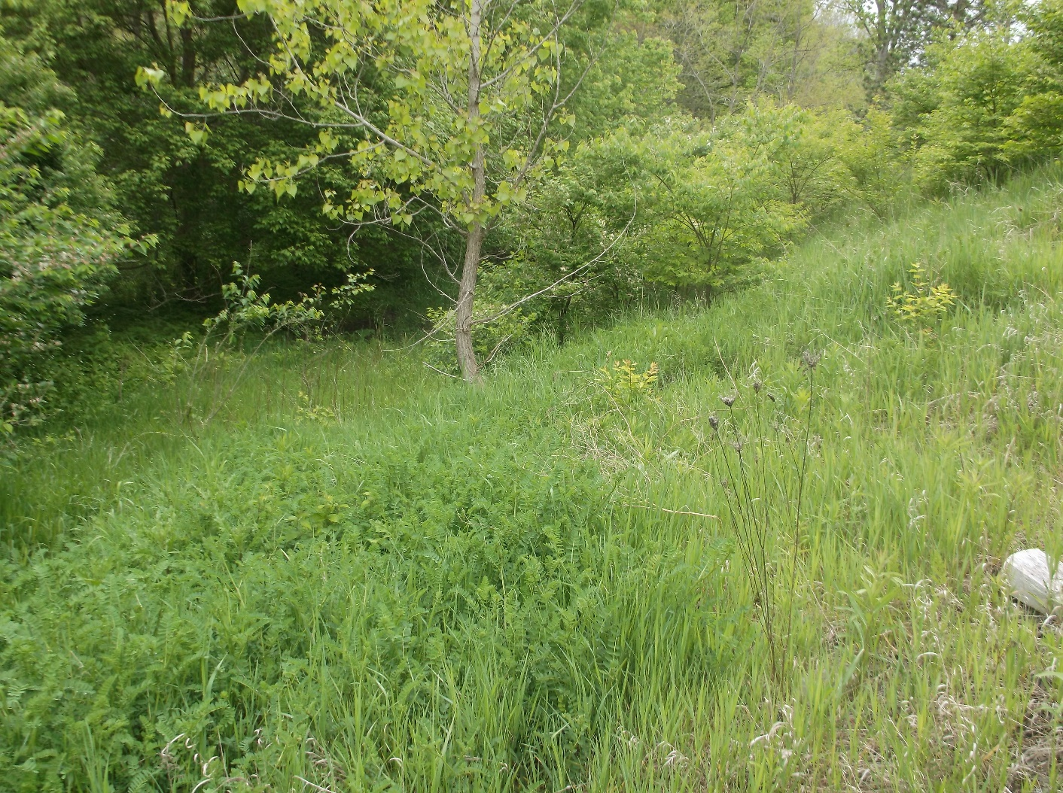
Figure 1 – Toe of LOG-33-20.86 Slope – “J” Tree Identified May 2016
In June 2017, Intertek-PSI again returned to the site. Possible pavement cracking due to slope movement was noted just inside the white line. Subsequent review by OGE found the source of the cracking to be inconclusive. In March 2022, OGE staff re-inspected the site. The lower slope was found to be exhibiting deformation with soft conditions at the toe of slope. The upper slope appeared to be stable, likely aided by large trees serving as reinforcement. Figure 2 shows a photo taken at the toe of slope looking up at the failed mass at the time of the March 2022 re-inspection. Subsequent visits in May and June 2024 have found the failed mass and toe of slope to be challenging to access due to further pronouncement of the failed mass and very wet conditions in June.
Despite minor expansion of the landslide vertically up the slope towards US 33, the rating for the site has remained a Tier 2 with a moderate probability of further movement and a moderate probability of significant impact to ODOT assets. Increasing the detailed rating (risk) score for the site in comparison to other Tier 2 landslides across the state was the daily traffic volumes, with an Annual Average Daily Traffic (AADT) number of nearly 23,000 vehicles according to ODOT Collector for Geohazards.

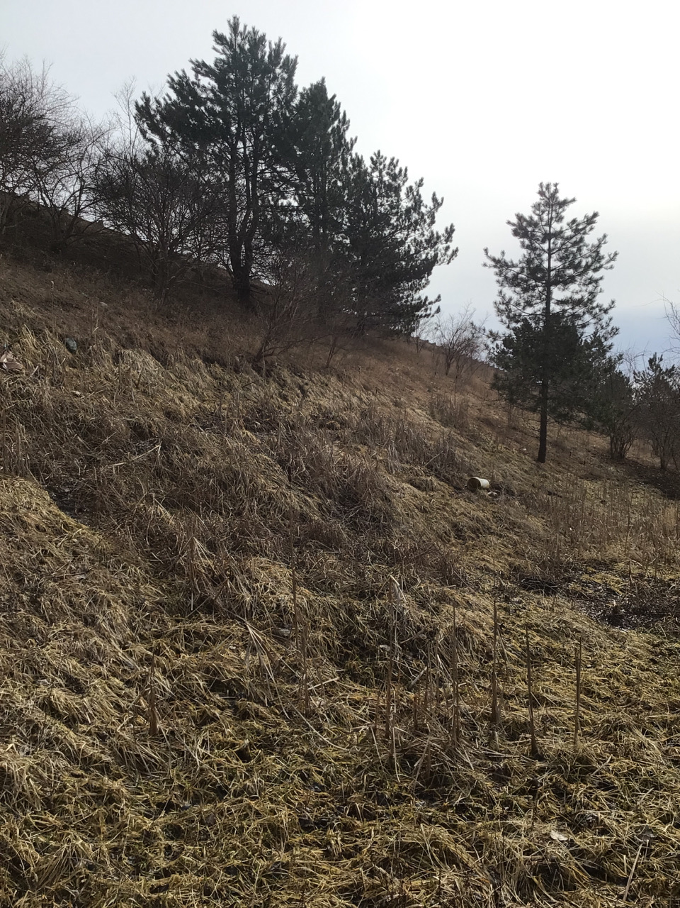
Figure 2 – Toe of LOG-33-20.86 Slope – March 2022
Exploration – Historic Records
Historic Records were obtained and reviewed from ODOT’s Transportation Information Mapping System (TIMS) for LOG-33-17.36, Sub-batch 13100, completed in 1960. This exploration was for the major relocation of 5.5 miles of US 33 beginning in Bellefontaine and extending beyond Zanesfield. Within the current project limits, there was extensive drilling in a grid pattern with 17 borings drilled along 4 cross sections between Sta. 1105+00 and Sta. 1109+00.
Records for LS00007408 and LOG-33-20.855 were also obtained from the TIMS and ODOT Collector for Geohazards.
Figure 3 shows the historic boring plan and Landslide LS00007408 limits (note that in the Legend below, BMP = Beginning Mile Point and EMP = Ending Mile Point, both taken along the US 33 shoulder per the ODOT Manual for Landslide Inventory).

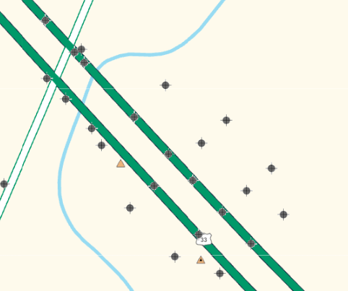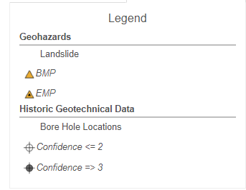
Figure 3 – Geotechnical Records from ODOT TIMS for LOG-33-20.86 Region
The geotechnical profile cross section at Sta. 1106+65 (1st cross section of borings southeast of the BMP) included borings drilled at 75 and 150 feet right of US 33 centerline for the proposed 30 to 35-foot tall 2:1 embankment. The borings initially encountered 2 and 1.5 feet respectively of cinders, gravel, and natural soil. Below this at 75 feet right, 1-foot of wet sandy silt (A-4a) with a moisture content of 37% was encountered. Below the cinder mix at 150 feet right, 1-foot of unsuitable elastic clay (A-7-5) with organics noted and a moisture content of 38% was found underlain by 1.5 feet of clay (A-7-6) with a moisture content of 28%. The remainder of both borings were found to consist of granular material with auger refusal on boulders in the vicinity of elevation 1038 feet.
The geotechnical profile cross section at Sta. 1108+00 also included borings drilled at 75 and 150 feet right of centerline. In the boring drilled at 75 feet right, the upper 5 feet consisted of unsuitable elastic clay (A-7-5) with organic material and moisture contents ranging from 43 to 105%. In the boring drilled at 150 feet right, the upper 4 feet consisted of gravel and stone fragments with sand, silt, and clay (A-2-6) with the next 4 feet consisting of unsuitable elastic clay (A-7-5) with organic material and moisture contents ranging from 43 to 48%. Below the elastic clay in both borings, granular material was encountered with auger refusal on boulders in the vicinity of elevation 1042 feet.
Due to the significant amount of unsuitable soil with organics encountered at Sta. 1108+00, the recommendation in October 1960 from OGE’s predecessor office was to excavate 4 feet of existing foundation and replace with “E-4 Granular Borrow”. The 1961 construction plans for LOG-33-17.29 obtained from the District 7 server included this recommended undercut, from Sta. 1107+50 to 1109+50, extending to around 138 feet right of centerline. In 1992, an embankment widening occurred in the same area as the current landslide. The plans for LOG-33-17.82, also obtained from the District 7 server, show no extension of the undercut beyond the previous toe, nor do they show any benching into the existing slope. Cross sections for the vicinity of Sta. 1107+50 from 1961 and 1992 are included in the attachments.
Due to uncertainty over the actual extent of the undercut performed as part of the 1961 construction project, the geotechnical profile will only note the historic records on the cover sheet, and those records will not be presented in plan/profile view or on cross sections.
Project Exploration
One (1) boring, B-001-0-23, was drilled for the geohazard exploration. Eleven (11) Wildcat dynamic cone penetrometer (DCP) soundings, D-001-1-24 through D-005-2-24, were also completed.
B-001-0-23 was drilled behind the guardrail at the top of the slope and initially encountered a thin topsoil layer (4-inch) and over 4 feet of medium dense granular soil consisting of varying amounts of stone fragments, sand, and silt (A-1-a, A-2-4). The remainder of the embankment consisted of 7.5 feet of very stiff to stiff sandy silt (A-4a), 1.5 feet of loose stone fragments with sand and silt (A-2-4), and approximately 20 feet of very stiff sandy silt (A-4a). The initial 4 to 5 feet of embankment foundation soils consisted of approximately 3 feet of hard sandy silt (A-4a) and 1.5 feet of very dense stone fragments with sand (A-1-b). OGE believes that this was the undercut backfill from the 1961 construction project. Below what we believe to be the 1961 undercut limits, there was a material color change to 1.5 feet of dark gray and black sandy silt (A-4a) which was very stiff in consistency. The remaining 6 feet of the boring encountered dense and very dense stone fragments with sand and varying amounts of silt (A-2-4, A-1-b). The boring was terminated at a depth of 46.5 feet at elevation 1141.7 feet due to elevated head pressures from artesian conditions. Based on field observations, it is the opinion of OGE that the soil classifications were somewhat influenced by poor sample recovery due to the prevalence of rock fill within the embankment.
Free water was noted at depths of 11.8 feet (elev. 1176.4 feet) and 17.4 feet (elev. 1170.8 feet). Water level measurement at 24 hours after completion was found to be at approximately 22 feet (elev. 1166.2 feet).
Wildcat DCP sounding locations have not been surveyed at the time of this report and reference will therefore be made to their approximate stationing. Wildcat DCP sounding D-001-1-24 was located within the failed soil mass in the vicinity of Sta. 1107+50, 150’ RT. The sounding initially encountered approximately 3 feet of very soft to soft cohesive soil, believed to be sandy silt and rock fill. Below this, approximately 2.5 feet of medium stiff to stiff cohesive soil was encountered, transitioning to very stiff to hard soil just prior to reaching the 6-foot termination depth. DCP Sounding D-001-2-24 was located just beyond the toe of the failed soil mass in the vicinity of Sta. 1107+50, 180’ RT. The sounding initially encountered approximately 1-foot of very soft to soft cohesive soil overlying approximately 1.5 feet of medium stiff to stiff cohesive soil. Below this, approximately 2 feet of medium dense to dense granular soil was encountered to termination of the sounding at about 4.5 feet. To better identify possible limits of the 1961 undercut, D-001-3-24 was added in the vicinity of Sta. 1107+75, 200’ RT. After initially encountering 3 feet of medium stiff to very stiff cohesive soil, the remainder of the 10-foot deep sounding encountered soil that was either soft to medium stiff cohesive or very loose to loose granular.
The remainder of the Wildcat DCP soundings, D-002-0-24 through D-005-2-24, were performed to provide the contractor with geotechnical information if a sidehill access road is needed as an approach to the project from the southeast. Those soundings encountered very stiff to hard cohesive soil within the first foot (+/-) of penetration and no more than a depth of 4.5 feet in any sounding.
Analyses and Recommendations
OGE analyzed the existing slope stability at Sta. 1107+50 using Plaxis LE Connect Edition Version 21. The analyses can be found in Appendix D. As expected, the critical failure surface was located in the lower slope within the presently failed mass. A factor of safety (FS) of 0.98 was calculated for a shallow failure surface within the lower slope.
When the analysis was limited to only a deeper (global) slide, the entire slope was found to be marginally stable (FS = 1.15), due in part to the uncertainty over the amount of soft organic material beyond the toe of slope. This marginally stable condition has likely exhibited itself over decades with minor guardrail post rotation, minimal pavement cracking, and perhaps a small dip in the outside shoulder that got addressed with routine maintenance/resurfacing projects.
The proposed remediation solution is similar to what was proposed during past on-site meetings with District personnel as well as the FY 2026 Geologic Site Management Program funding application. Excavation would be limited to the lower slope, with the replacement material consisting of 601 Dump Rock, Type B. If District Construction personnel would prefer that the dump rock also include Type C, that would be acceptable to OGE. The reconstructed slope will be built at a 2.5:1, which will also address the marginally stable condition for the overall slope. A conservative assumption of elev. 1172-1174+/- feet as the start of the 1:1 excavation is recommended for Stage 1, with the lateral extents being Sta. 1106+25 to 1108+00. As recommended in our 6/27/24 email to the District, better delineation of the slide mass should be pursued late this fall for the Stage 3 plans. OGE is available to participate in that delineation.
The 1:1 excavated slope should not extend beyond 20 feet in height. It is proposed that the excavation will extend 2 feet below the toe of existing slope into the embankment foundation. Depending on the Stage 3 delineation of the slide mass, a plan note that restricts the time and/or lateral extents that the 1:1 excavation can be left open prior to commencement of backfilling operations is likely.

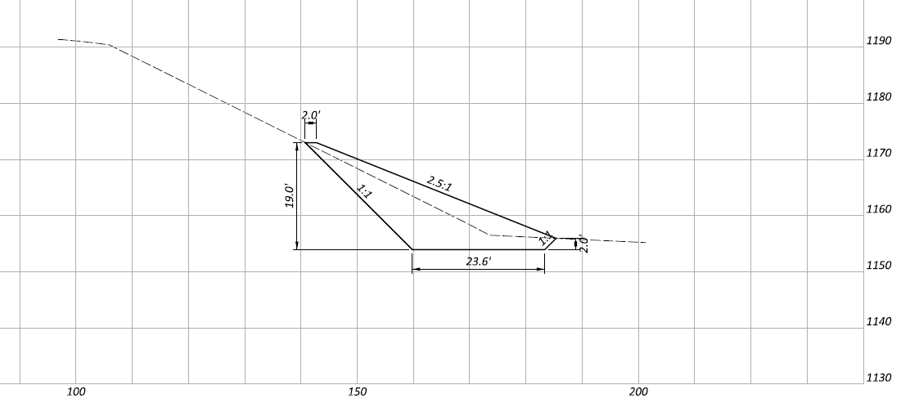
Figure 4 – Conceptual Cross Section for Sta. 1107+25

Closing Remarks:
If you have any questions, please feel free to contact me at 614-351-2873.
Thank you,
SAT
pc: File
Attachments:
- Exploration Plan
- Project Boring Log
- Wildcat DCP Sounding Reports
- Historic Construction Plans
- Slope Stability Analyses

