INTEROFFICE COMMUNICATION
TO: Nick Chaney P.E., District Bridge Engineer
FROM: Brian Ross P.E., Structures & Pavements
DATE: January 28, 2026
SUBJECT: Abbreviated Structure Type Study (STS) for bridge STA-30-1421 (SFN: 7607776) PID:123671

Existing Structure Overview
This memo serves as a brief structure type study for the subject bridge to assist in establishing a rehabilitation or replacement strategy. The conclusions of this study are based upon analysis of the existing structure design, previous project history, existing conditions, and field observations.
STA-30-1421 is a 206’ 4-span steel continuous multi-beam bridge carrying Harrison Avenue over US30. Constructed in 1977, the bridge originally featured a 1½-inch asphalt concrete wearing surface, which was replaced in 2013 with an integral concrete overlay. That project also included extensive patching and structural steel painting. The bridge currently supports 110% legal load of the HS 20 design loading. The substructure is supported by spread footings, presumed to bear on soil.
Condition Assessment
The 2025 bridge inspection summary indicates the bridge is currently in fair condition with a GA of 5, primarily driven by the superstructure’s fair rating (5). The bridge has a documented history of frequent collisions with over-height vehicles, particularly in the EB direction of US 30, where the vertical clearance under the right lane is 15 feet. The most recent incident damaged 4 of the 9 beams, which are scheduled for repair during winter 2025 or early spring 2026. Notable prior collisions occurred in 2007 and 2008 resulting in partial replacement of the fascia beam. Numerous minor impacts have occurred over the bridge’s service life, evidenced by prevalent dings and scrapes. Additional steel deterioration has been observed at the beam ends, where previous section loss has been painted over. The bearings at the abutments are prematurely rusting from prolonged element exposure passing through the sliding plate expansion joints.
The deck is currently rated as being in fair condition (5). In all four spans the deck floor shows numerous spalls varying in size and severity. The most severe areas are in spans 2 and 3 which exhibit large areas of primary rebar exposure with signs of section loss. Additional delamination is seen along both deck edges. The top surface of the concrete deck received a concrete overlay in 2013 and currently presents map and block cracking. Epoxy urethane sealing of spalls has been attempted in a previous project, but deterioration persists with new spalls forming around treated areas. The deck floor requires continuous monitoring for potential spalling hazards to US30 traffic. Additionally, the bridge railings on both sides show significant deterioration, including map cracking with occasional delamination and spalling.

The substructure (rated 6) is in satisfactory condition. The latest inspection noted deterioration in previously patched areas of the pier columns and abutments, as well as delamination’s at both the forward and rear abutment beam seats. Spalling was also observed in the forward and rear backwalls. Deterioration of the backwalls is reflected in the asphalt surface at the forward joint, where cracking and potholes are forming.
Findings
Given the accumulating spalls and delaminations in the deck floor, along with the overall age of the structure, a superstructure replacement is warranted. The substructure has a satisfactory rating (6) suggesting that a full replacement is not required per BDM C401.4.
An additional objective of the superstructure replacement is to increase the minimum vertical clearance, particularly in the eastbound direction of US 30 to a minimum of 15.5 ft. According to current bridge inventory records, this structure has the lowest vertical clearance on US 30 eastbound aside from SFN 7606125 STA-241-4.21 (15.25 ft.) which was rebuilt in 2002, however on/off ramps exist at this location and allows for a run-around. While other nearby structures have similar clearances, increasing the clearance at this location is still considered beneficial to help protect the new superstructure from future collision damage. The following table summarizes the minimum vertical clearances of overhead structures along STA US 30:
SFN | Bridge Number | Overhead Route | Route Type on Bridge | Min Vertical Clearance Under Bridge Cardinal (ft) | Min Vertical Clearance Under Bridge Non-Cardinal (ft) | Date Built
7607164 | STA-30-0.000 | Deerfield Ave | County | 16.583 | 16.5 | 2008
7606125 | STA-30-4.007 | Millersburg Rd (SR241) | State (ODOT) (Toll Free) | 15.25 | 16.083 | 2002
7607539 | STA-30-11.532 | Perry Dr | County | 16.5 | 15.5 | 2007
7607733 | STA-30-13.911 | Clarendon Ave | Municipal | 18.167 | 15 | 1977
7607776 | STA-30-14.210 | Harrison Ave | Municipal | 15 | 15.5 | 1977
7607806 | STA-30-14.410 | Dueber Ave | County | 15.167 | 15.417 | 1977
7601069 | STA-30-16.883 | Belden Ave (SR43) | State (ODOT) (Toll Free) | 15.4 | 15.8 | 1984
7601077 | STA-30-18.785 | Trump Ave (US30) | State (ODOT) (Toll Free) | 18.2 | 16.75 | 1998

Design Alternative/Strategy Evaluation
For all replacement strategies described below the use of conventional abutments, bearings, and expansion joints is not considered due to long-term maintenance concerns.
- Deck Replacement with Steel Beam Repairs and Spot Painting – This strategy proposes replacing the bridge deck while retaining the existing steel beams and converting to semi-integral abutments. The scope includes steel beam retrofits and repairs, spot painting, substructure repairs, and modifications to increase vertical clearance.
  - PROS:
    - Reusing existing structural steel may provide short-term cost savings compared to full replacement.
    - Limits changes to the current substructure loading configuration.
    - Maintains the existing PCS (rated 7) with spot painting limited to areas of steel repair or localized coating failure which may provide a short-term cost savings.
    - Construction time is likely shorter compared to full superstructure replacement.
  - CONS:
    - Relies solely on adjusting the profile of Harrison Avenue or US30 to achieve increased vertical clearance.
    - Fatigue life concerns in previously heat-straightened beam sections may require further analysis to determine repairs and impact on overall service life.
    - Future painting and maintenance of the PCS is costly when evaluated over the full life cycle of the bridge.

- New Galvanized or Metalized Multibeam Superstructure – This strategy involves replacing the superstructure with new steel beams with a galvanized or metalized PCS. The abutments would be converted to semi-integral type.
  - PROS:
    - Galvanized or metalized PCS will provide cost savings over the full life cycle of the bridge.
    - Additional beam lines may be added to reduce individual beam height, helping to minimize changes to the Harrison Avenue roadway profile.
    - Known service life of new beams compared to previously damaged beams.
  - CONS:
    - Higher initial construction cost compared to reusing existing structural steel.
    - Still susceptible to future collision damage if vertical clearance is not improved.
    - Additional beam lines will require modifications to the substructure bearing points, increasing design and construction complexity.

- New Concrete I-beam or concrete slab Superstructure – This alternative replaces the superstructure with either concrete I-beams or a concrete slab deck. Both options present significant structural and geometric challenges under current site conditions.
  - PROS:
    - Eliminates the need for a PCS.
    - Provides a very long service life with minimal lifecycle maintenance costs.
  - CONS:
    - Concrete I-beams are significantly heavier and larger than steel members. The increased beam depth worsens the vertical clearance issue.
    - A continuous concrete slab design is not possible with the current span and pier configuration.
    - The increased loading from either option would likely exceed the bearing capacity of the existing spread footings, requiring full substructure reconstruction. This effectively represents a full bridge replacement, which would be significantly more costly and time-consuming than the other alternatives
Preferred Alternative
For superstructure replacement on STA-30-1421 the preferred strategy is a superstructure replacement with new structural steel fabricated with a galvanized or metalized PCS. Preliminary cost estimates indicate that new galvanized structural steel carries approximately a 56% premium over reusing the existing steel. However, when evaluated over the full service life of the bridge, the need to reapply an OZEU paint system one to two times makes the galvanic PCS 33% to 117% more cost-effective in the long term. Costs for both concrete I-beams and Concrete slab superstructures were not directly examined as both options will require complete bridge replacement with a likely longer construction time and higher costs.
Design Considerations
The new superstructure design (beam size and placement) should follow the existing as closely as possible to limit the need for analysis of the substructure and spread footing foundations. Substructure elements with existing defects should be addressed using Item 519 or 844 patching. To increase the vertical clearance to a minimum of 15.5 ft. profile adjustment of Harrison Ave. is the preferred alternative. District investigated adjusting the profile of U.S. 30, but it would require additional work such as full-depth pavement replacement at a minimum of 200 ft., reconstruction of median and shoulder barrier wall, guardrail replacement, median drainage and light poles. However, by replacing the approach slabs and 60 ft. of pavement on each approach, as well as minimal resurfacing to the ramps, a vertical clearance increase of 6 inches can be achieved. For the PCS consider providing both galvanizing and metalizing options in the construction contract to allow more flexibility in fabrication and procurement.
Profile adjustment to Harrison: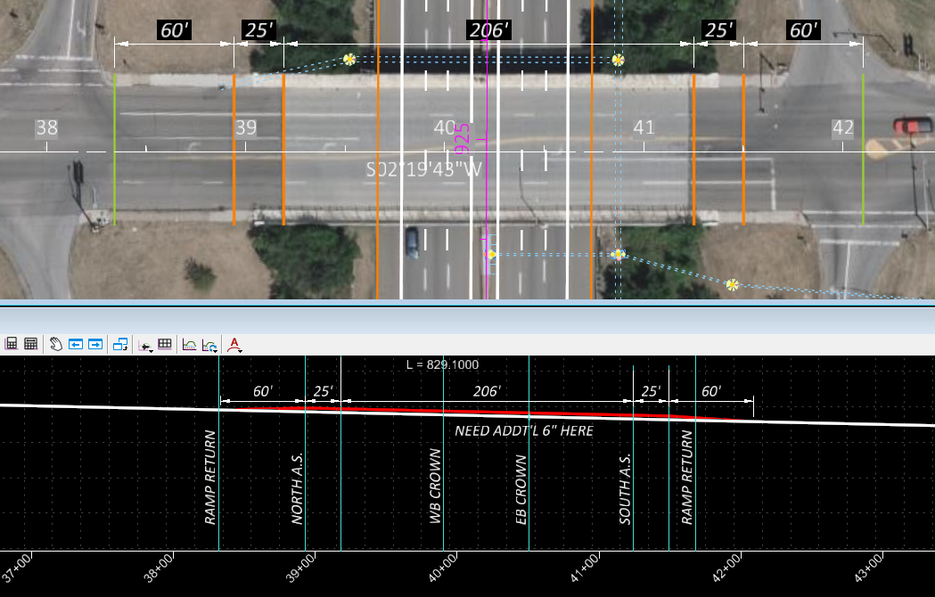

Profile adjustment to U.S 30 Eastbound: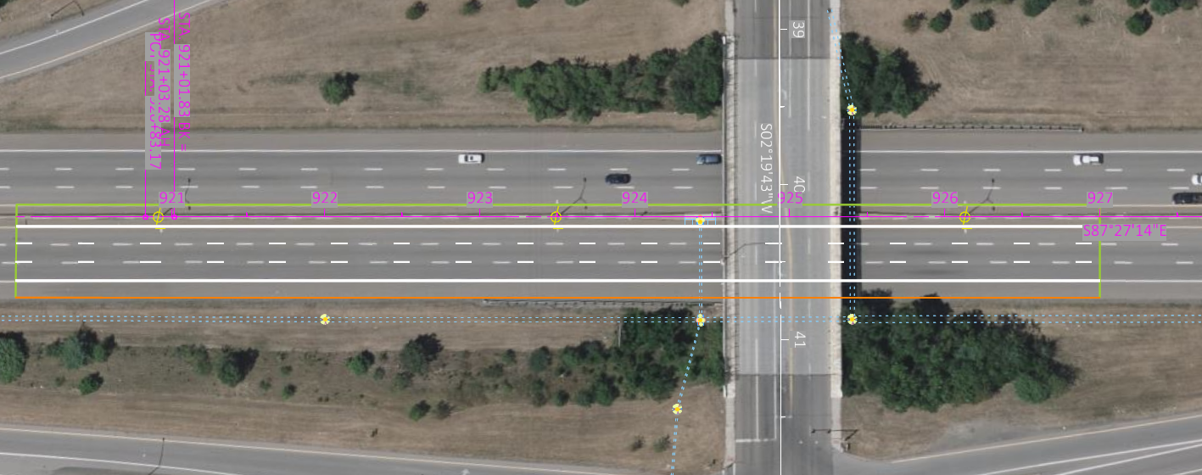
MOT Considerations
The district’s preference is to close and detour Harrison Ave. for the duration of the project while maintaining the US 30 exit ramps and including striping to eliminate turn lanes that would send traffic across the bridge. Nearby interchanges can be utilized to allow US 30 traffic to flip that are seeking to cross the bridge.

Conclusion
Based on lifecycle cost, constructability, and compatibility with the existing substructure, the recommended strategy is a full superstructure replacement using galvanized or metalized steel beams with semi-integral abutments on the existing substructure. As of the writing of this memo, the planning estimate for the superstructure replacement on STA-30-1421 is $4.5 million. Further refinement of the cost estimate is anticipated upon the completion of conceptual / stage 1 review.

