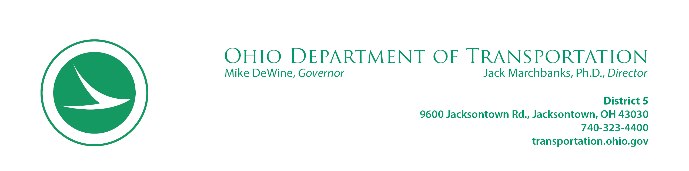

**ENCROACHMENT LETTER**

April 19, 2021

Eichhorn Limited Partnership

1410 Pleasantville Road

Pleasantville, OH 43148

Dear Eichhorn Limited Partnership:

Section 5515.02 of the Ohio Revised Code (ORC) provides that any individual, firm or corporation that uses or occupies any part of a road or highway on the State Highway System with lines, pipes, or any object or structure, without a legal permit, shall remove same from the bounds of the highway. Section 5515.02 of the ORC also provides that if removal of any such lines, pipes, objects or structures is not started within 5 days after notification, the Department of Transportation may do so with their own forces and the expense incurred will be certified to Chief Legal Counsel for collection by civil action.

You are requested to move concrete pad, stump.

It is the desire of the Department of Transportation to cooperate with you to the extent of legal limits and obligations to the general public. You are advised, however, to proceed immediately with the removal requested above. Should you have any questions, please call Kimber L. Heim, 740-323-5422.

Respectfully,

Jack Marchbanks, Ph.D., Director

By: John R. Wooldridge

District 5

9600 Jacksontown Road

Jacksontown, OH 43030

cc: File