WORK AGREEMENT EXHIBIT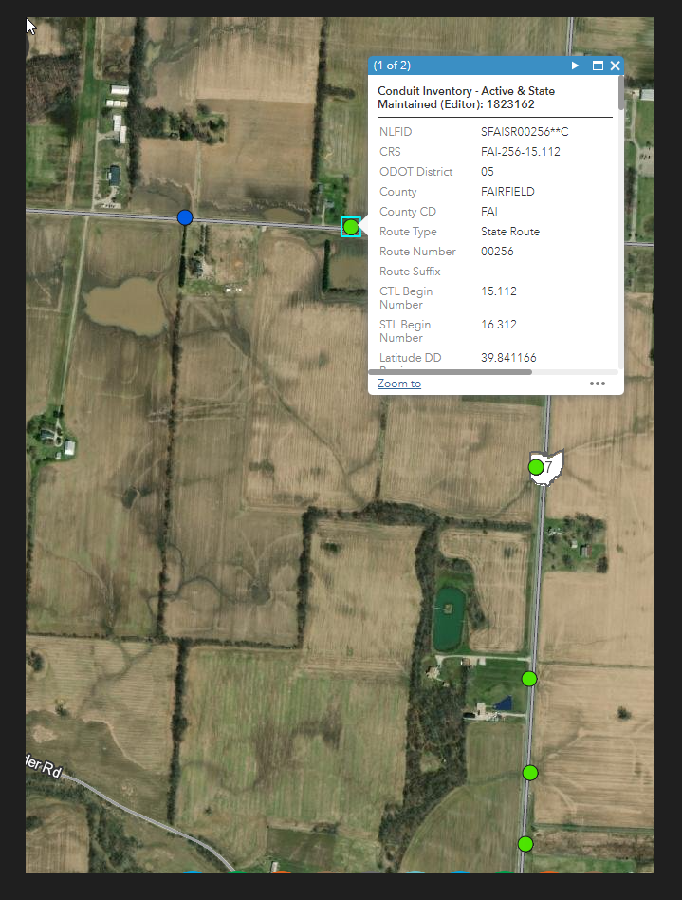

WORK AGREEMENT EXHIBIT

GOOGLE EARTH PIC of 110412 Project Area

