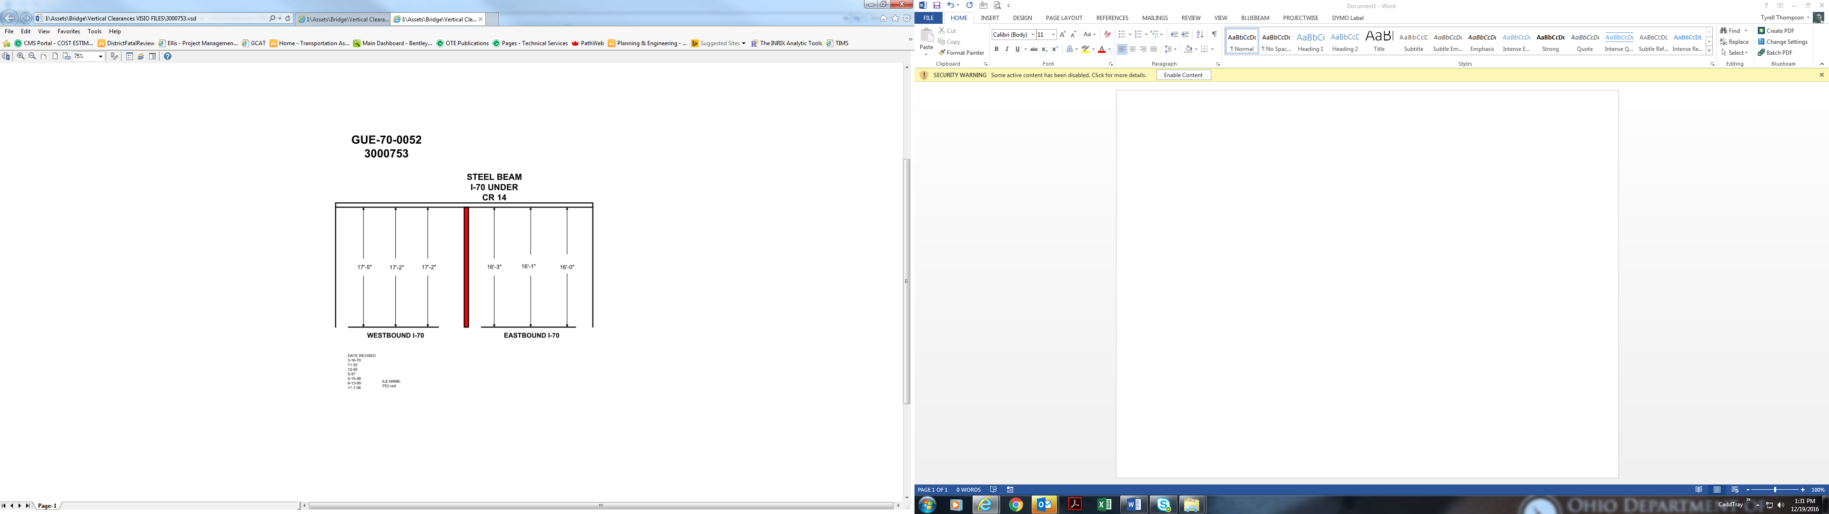

Date Revised: 3-16-70

11-92

12-95

5-97

4-15-98

6-13-99

11-7-06

16’-3” 16’-1” 16’-0”

17’-5” 17’-2” 17’-2”