BRIDGE MOUNTED OVERHEAD SIGN INSPECTION

BRIDGE NUMBER: GUE-70-0655R

SFN: 3001059

FEATUR INTERSECTED: EB I-70 over CR 15

LOCATION OF THE SIGN ON BRIDGE: One sign on the right bridge rail over CR 15.

TYPE OF SIGN (cantilever, box truss, skewed, flat, other): Flat, W12-2p

CONDITION OF ANCHOR BOLTS/NUTS: Minor rust

CONDITION OF CONCRETE: The deck edge has some leaching cracks.

CONDITION OF SIGN SUPPORTS: none

CONDITION OF SIGN ATTACHMENTS: none

CONDITION OF SIGN LIGHTING: none

COMMENTS: The sign is in good condition.

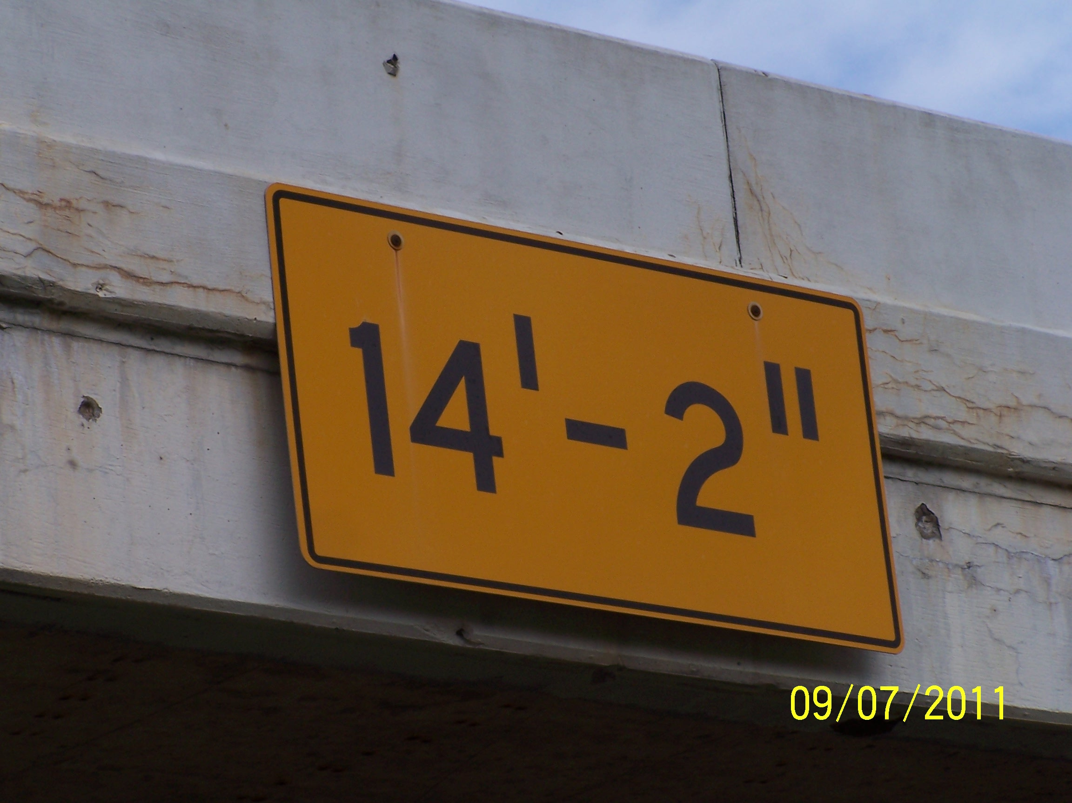

INSPECTED BY: Albert Abel
DATE: 9-7-2011

