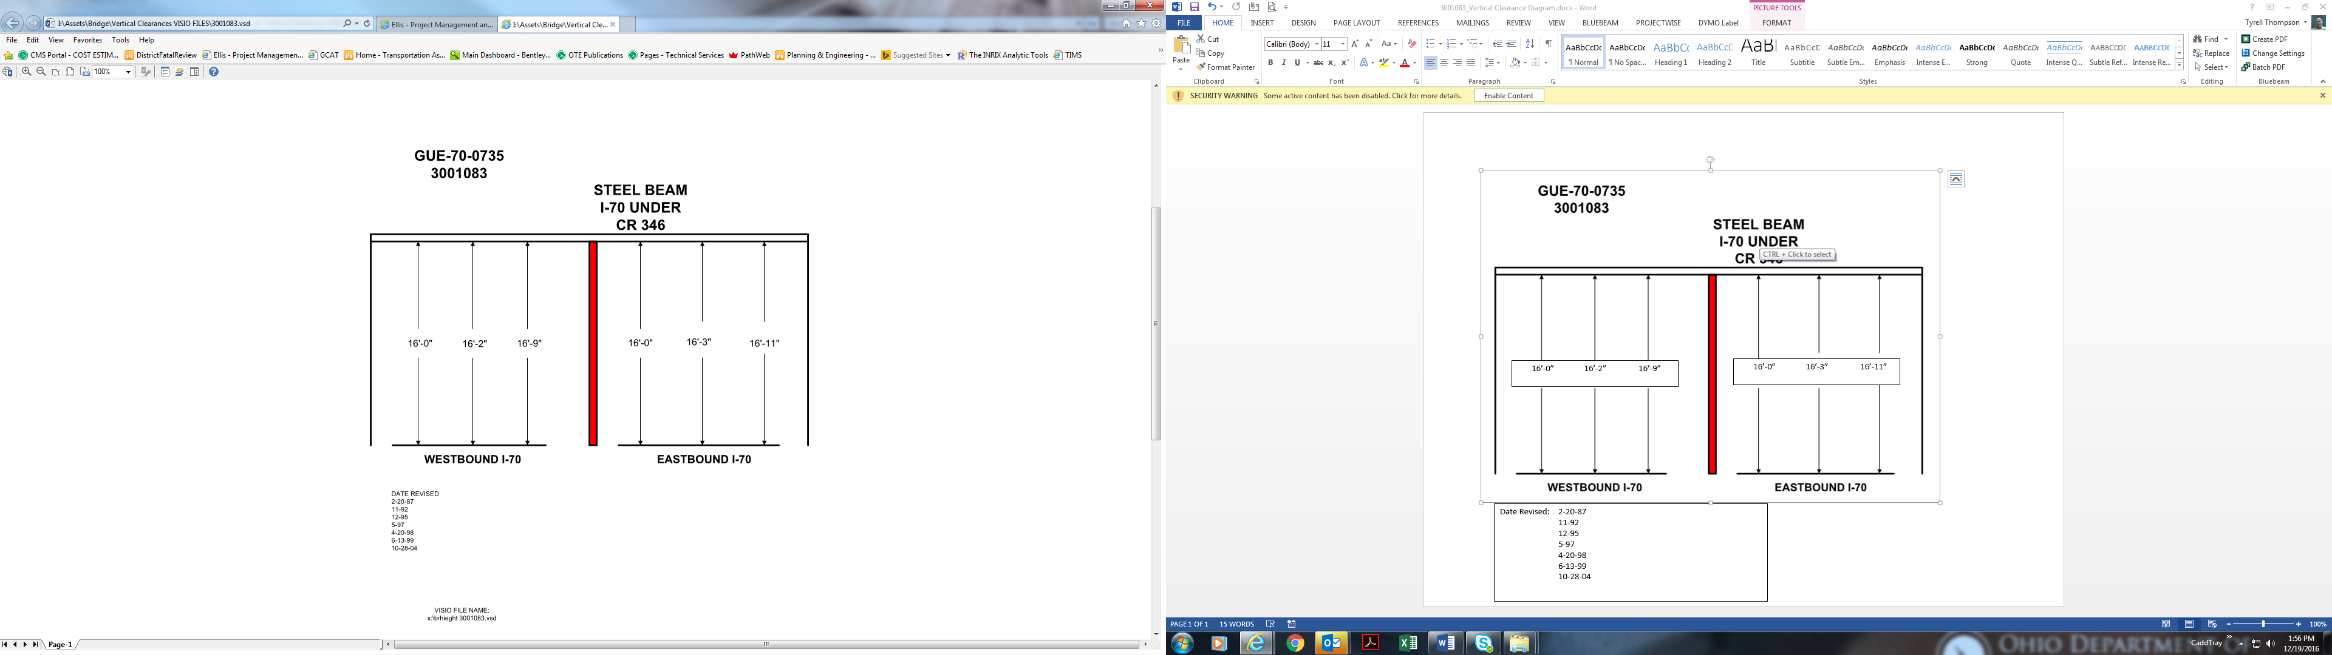

16’-0” 16’-2” 16’-9”

16’-0” 16’-3” 16’-11”

Date Revised: 2-20-87

11-92

12-95

5-97

4-20-98

6-13-99

10-28-04