TO: Bridge File DATE: 1-24-2013

By: Albert Abel, BSII

BRIDGE NUMBER: GUE-70-0943A SFN: 3001202

On January 24, 2013 the Bridge Engineer, Curtis Zigan was notified by the Guernsey County Manager, Mark Adkinson that bridge GUE-70-0943A had been hit by an over-height load. I inspected the bridge for damage on the same day. Beam 1 of span 3 over the paved roadway had been struck by the vehicle in the same location that has been hit several times previously. No new structure damage was found. No repairs will be required due this accident.

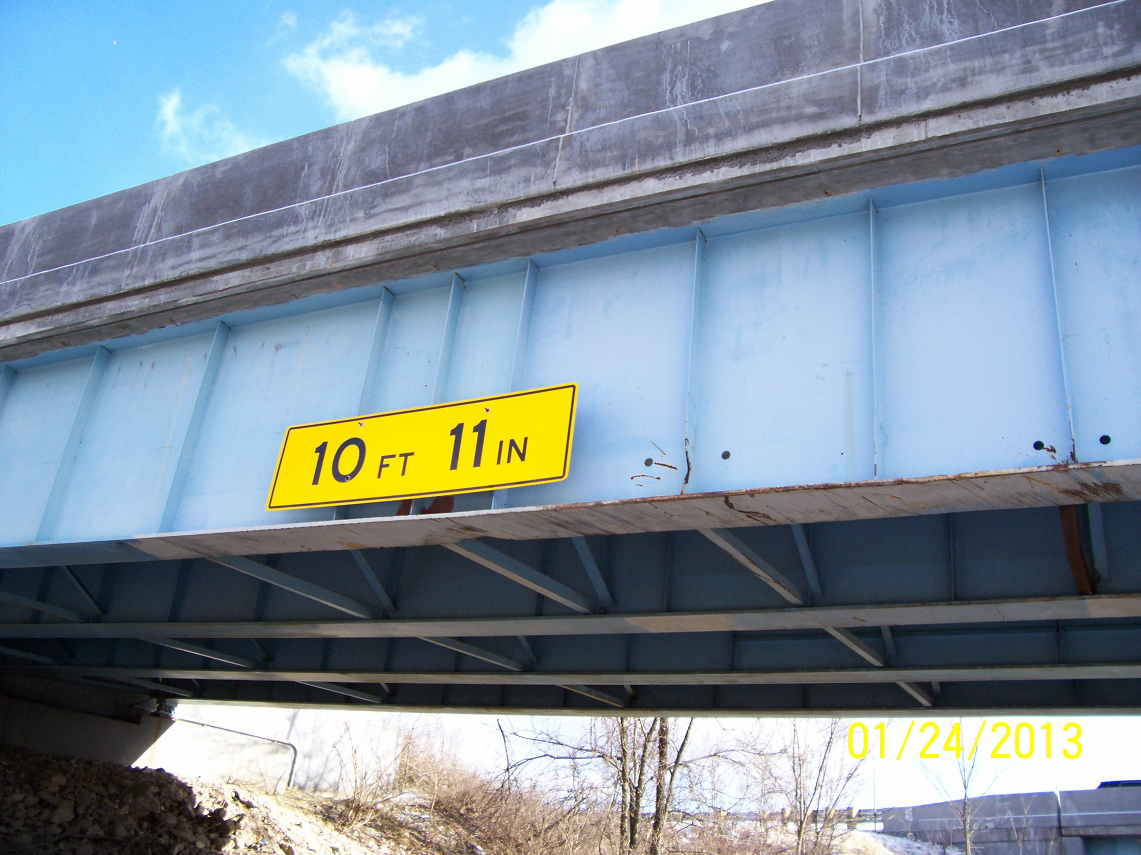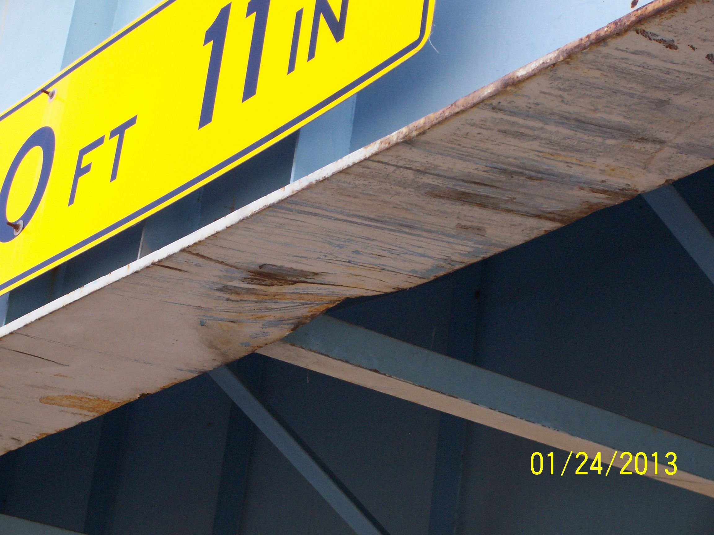
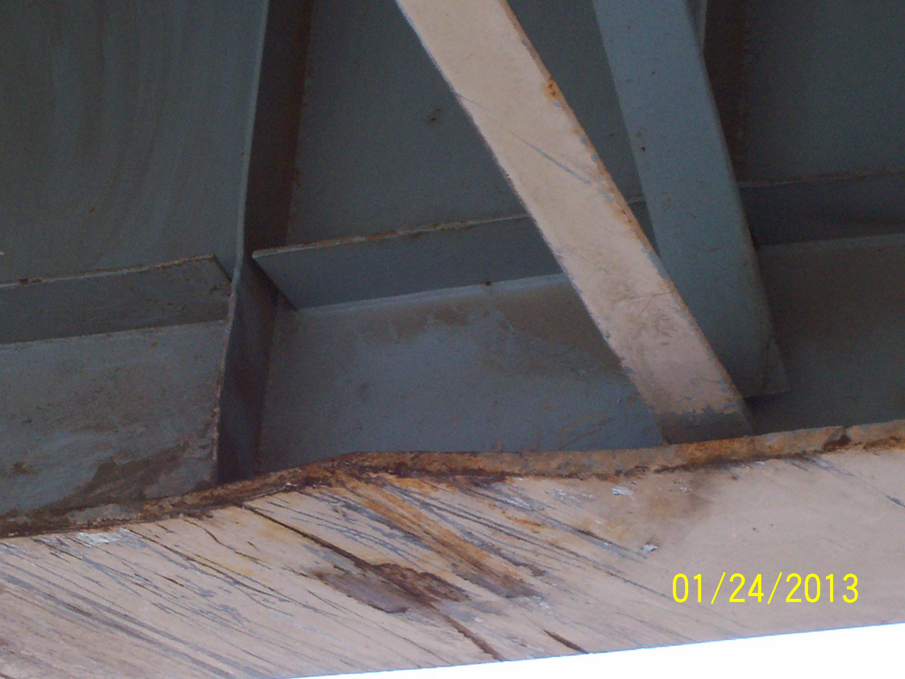

C: bridge file

/tmp/in/input.doc

