TO: Bridge File
cc: Curtis Zigan DATE: 6-11-2014

By: Jeff Watson, Bridge Specialist 2

BRIDGE NUMBER: Gue-70-0943A SFN: 3001202

On June 9, 2014 I received a phone call from Mark Atkinson’s reporting that Gue-70-0943A 3001202 was hit by an over height truck. Damage was in span 3 were beams 1 was impacted. On June 11, 2014 I conducted a damage inspection on span 3 and completed the In-depth inspection of the impacted location. See below for Photo’s measurements and illustrations of the damage. This report will be sent to District Bridge Engineer for review and placed in bridge file. Please refer to the Bridge folder for additional photos.

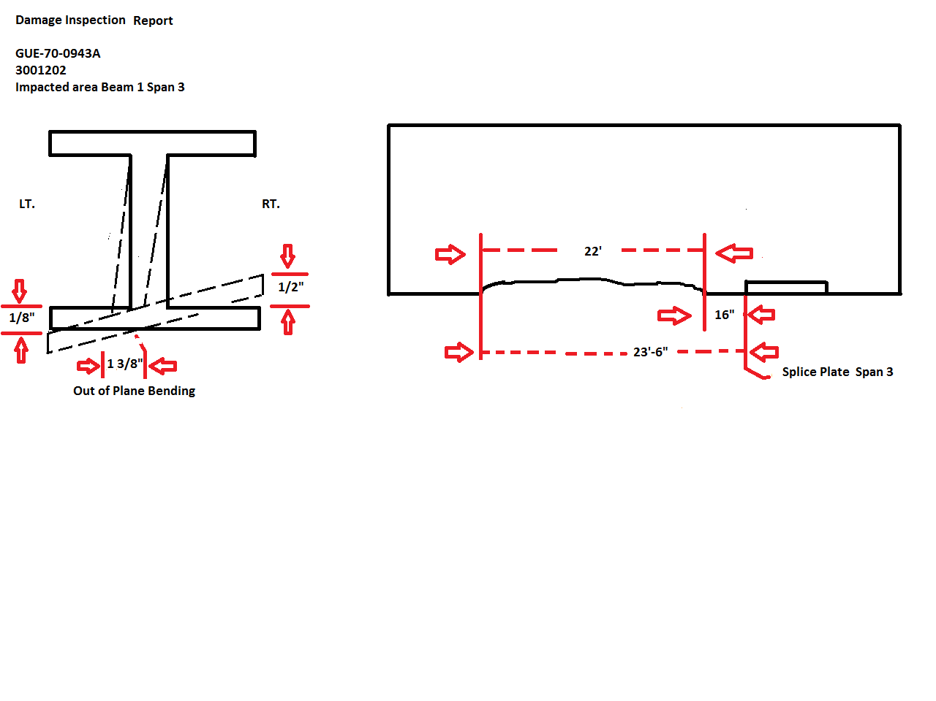
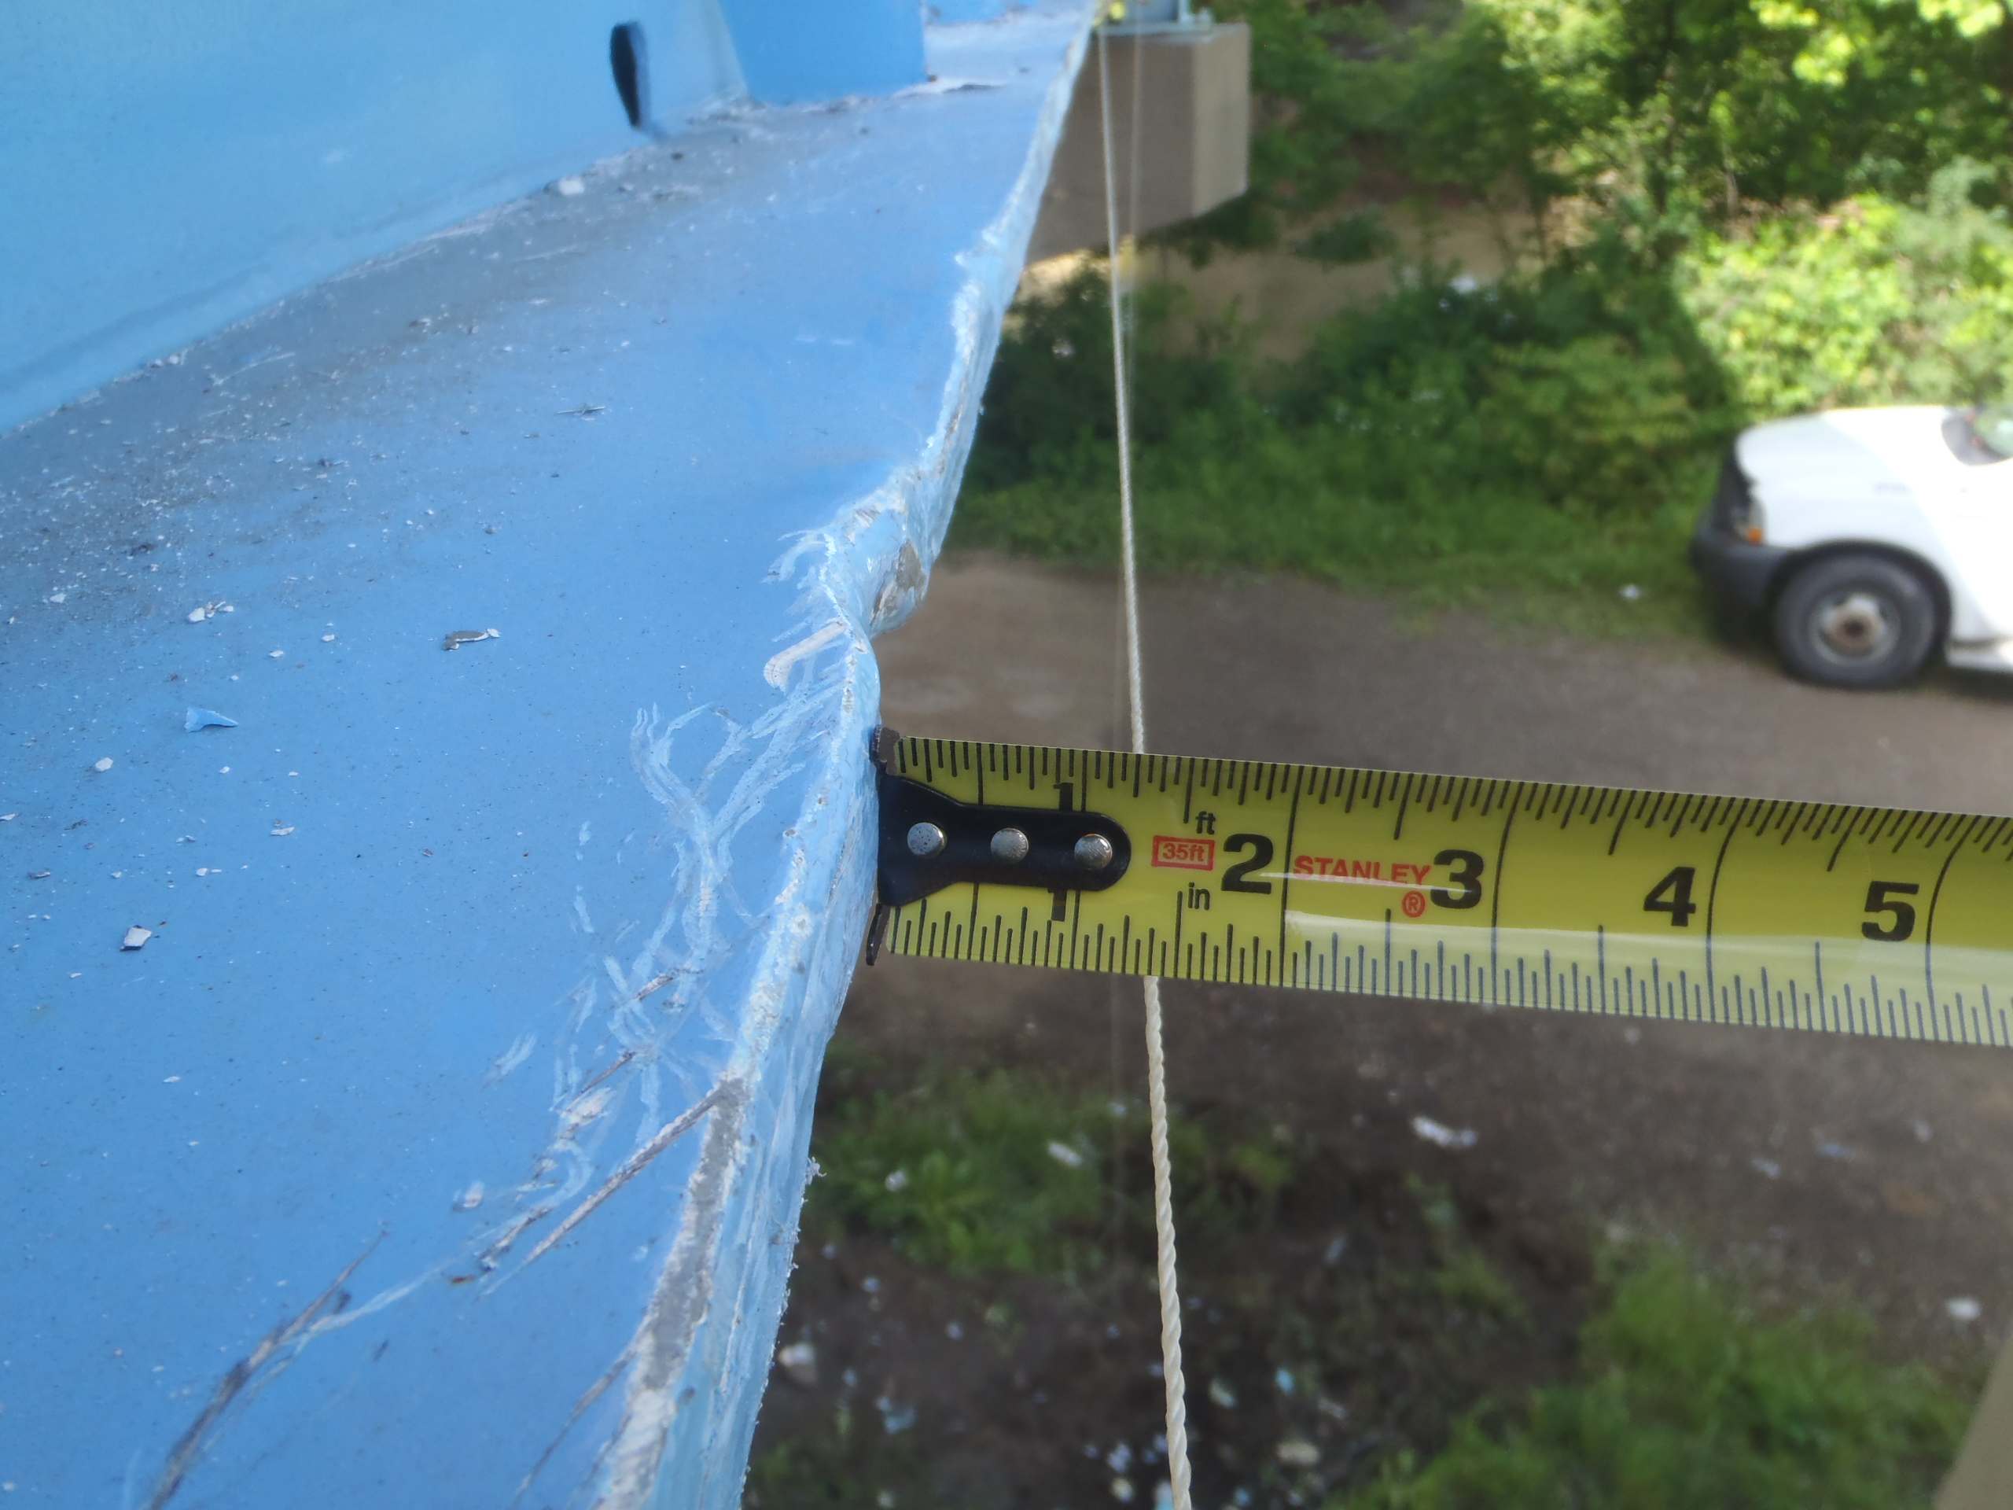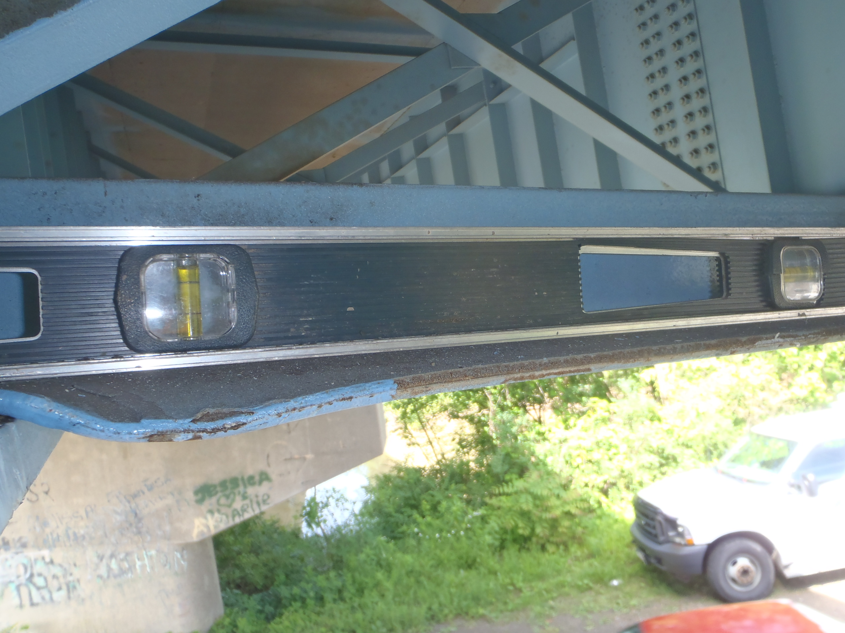
Span 3 Beam 1 Crossframe # 5

