D-5 BRIDGE WORK ORDER

TO: DOUG GEORGE DATE: 12/15/10

FROM: Curtis Zigan, D-5 Bridge Engineer By: Jeff Watson

BRIDGE NUMBER: GUE – 70 - 0943 L SFN:3001237

DESCRIPTION OF NEEDED WORK

Please weld broken cross frame in bay 1 @ beam 2 @ the forward abutment.

THANKS

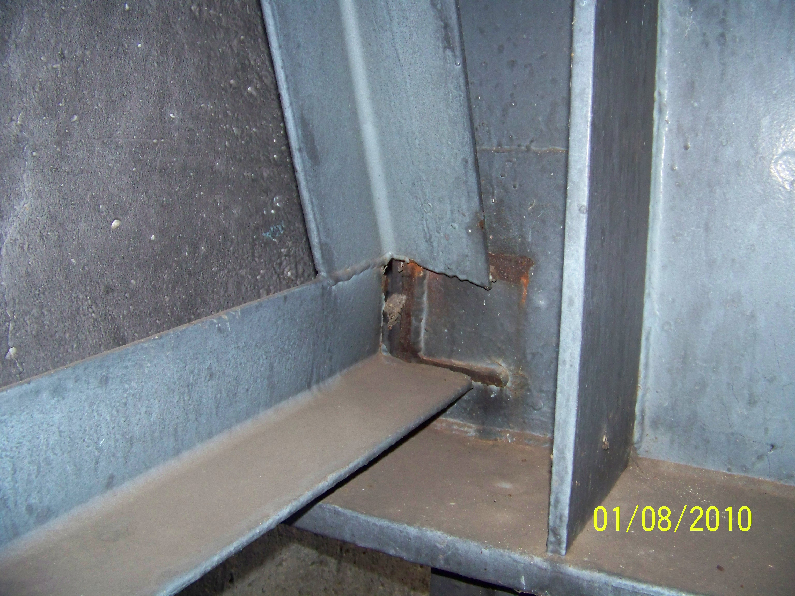

Please sign, date and return this form after the repairs are completed.
COUNTY or DEPARTMENT MANAGER__________________________________
DATE COMPLETED___________________________

C: bridge file
/tmp/in/input.doc

