BRIDGE MOUNTED OVERHEAD SIGN INSPECTION

BRIDGE NUMBER: GUE-70-0994R

SFN: 3001385

FEATUR INTERSECTED: EB I-70 over NB I-77

LOCATION OF THE SIGN ON BRIDGE: One sign on the right bridge rail over NB I-77.

TYPE OF SIGN (cantilever, box truss, skewed, flat, other): Flat.

CONDITION OF ANCHOR BOLTS/NUTS: Minor rust.

CONDITION OF CONCRETE: The deck edge has some leaching cracks.

CONDITION OF SIGN SUPPORTS: Good

CONDITION OF SIGN ATTACHMENTS: 2 of the clips are missing.

CONDITION OF SIGN LIGHTING: none

COMMENTS:
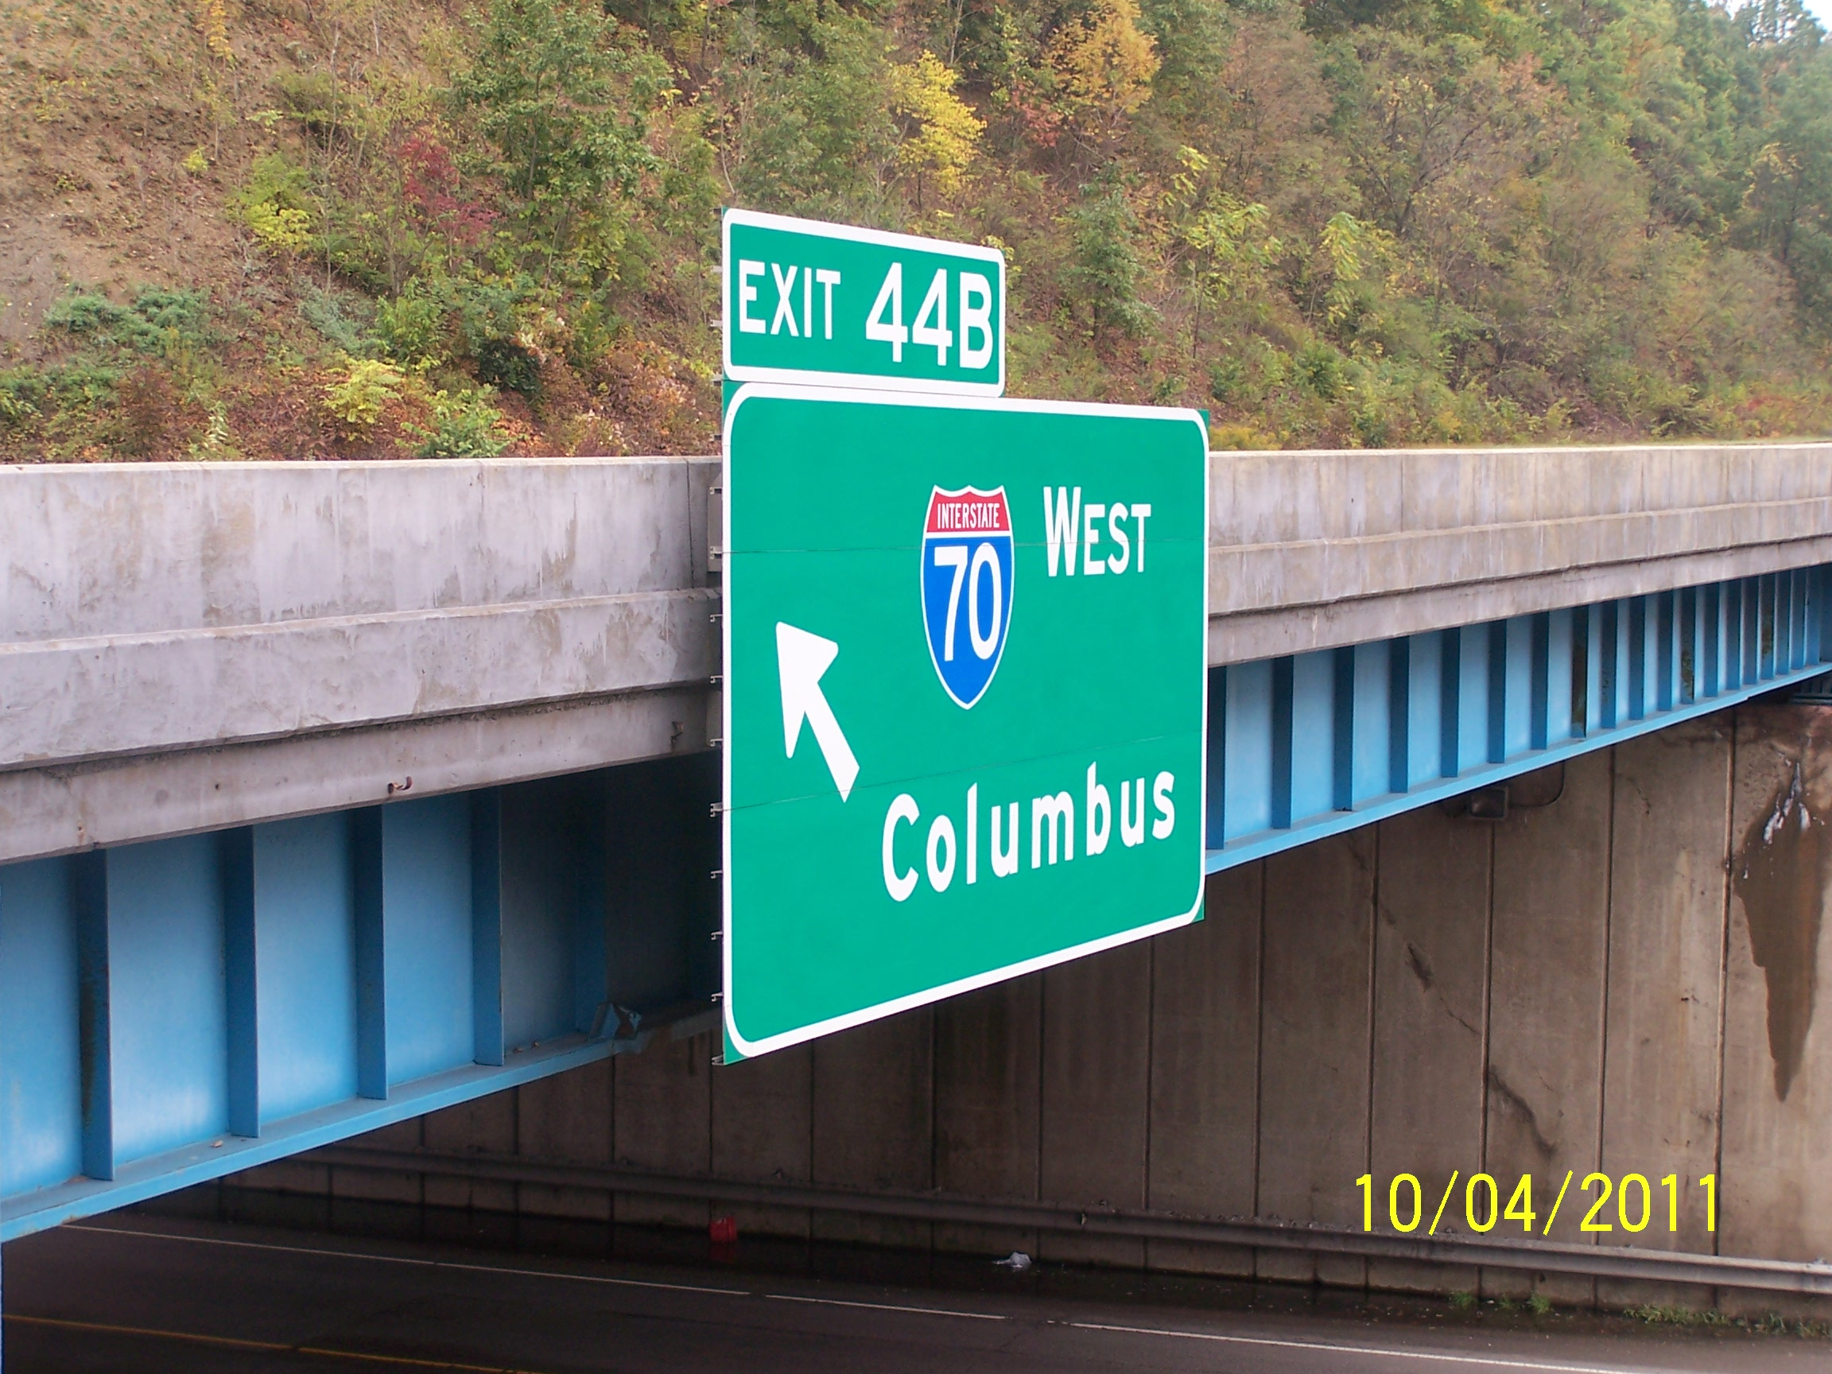
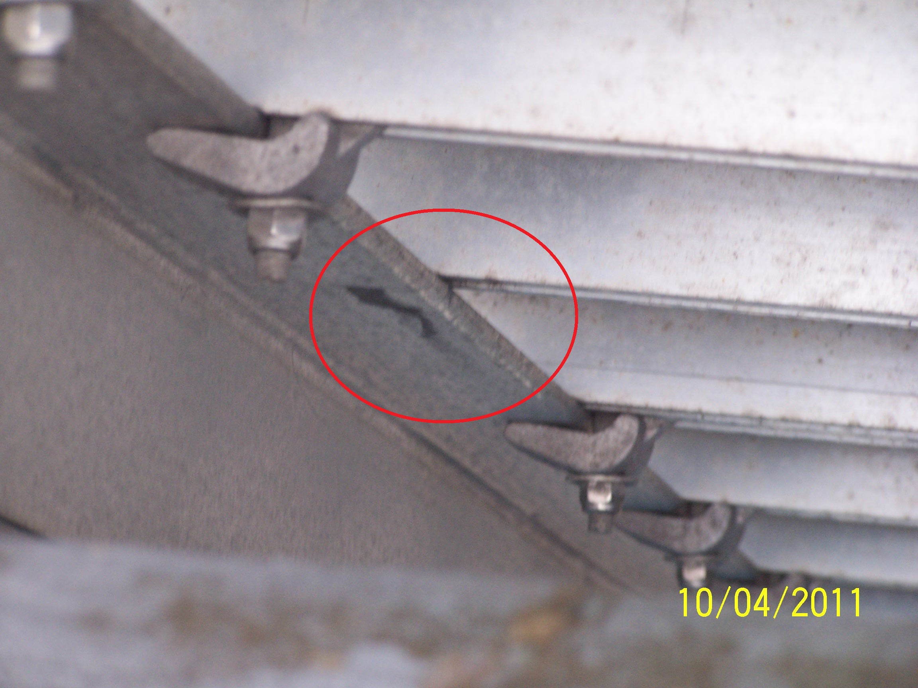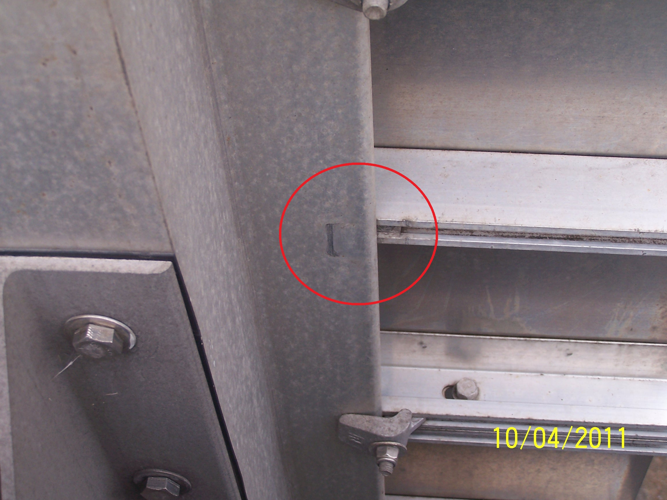

INSPECTED BY: Albert Abel
DATE: 11-20-2012

