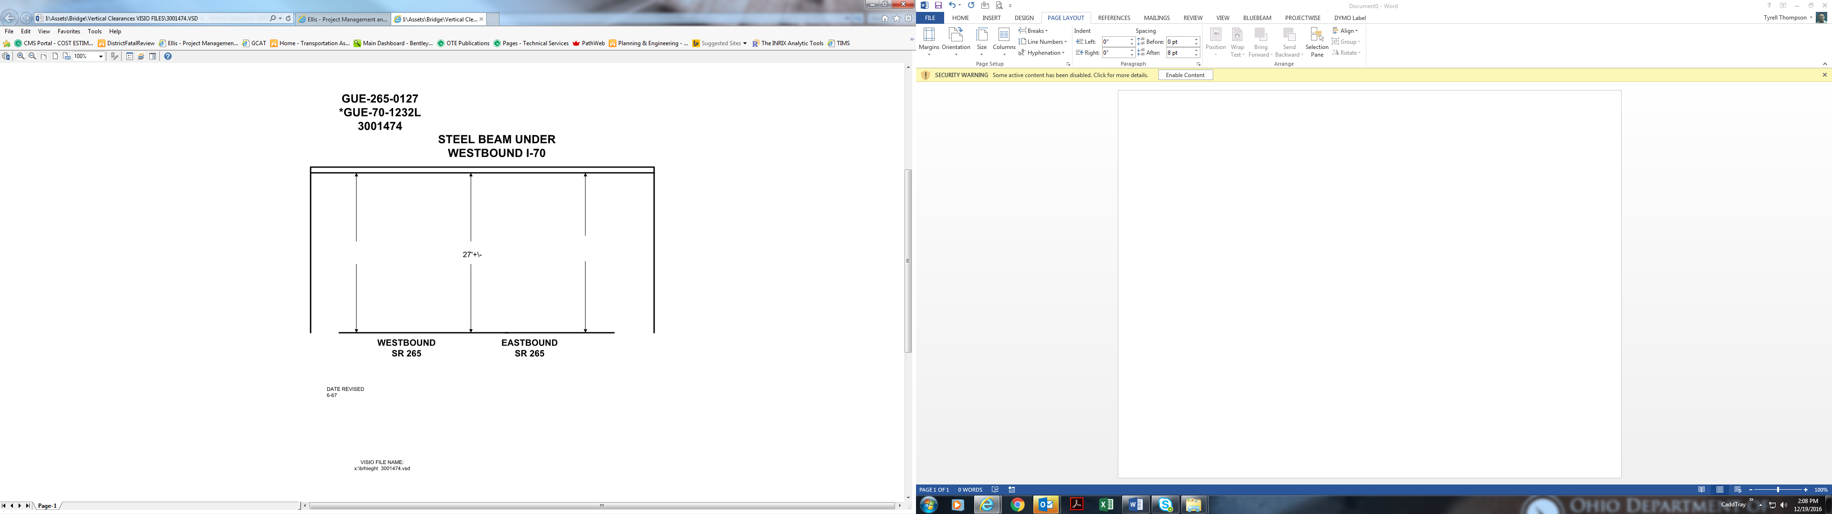

Date Revised: 6-67

27’ +/-