D-5 BRIDGE WORK ORDER

TO: Tom Bradford Date: 10-21-09

FROM: CURTIS ZIGAN, D-5 BRIDGE ENGINEER BY: Albert Abel

BRIDGE NUMBER: GUE-70-1334 SFN: 3001628

DESCRIPTION OF NEEDED WORK

Remove spalling deck concrete over eastbound 70.

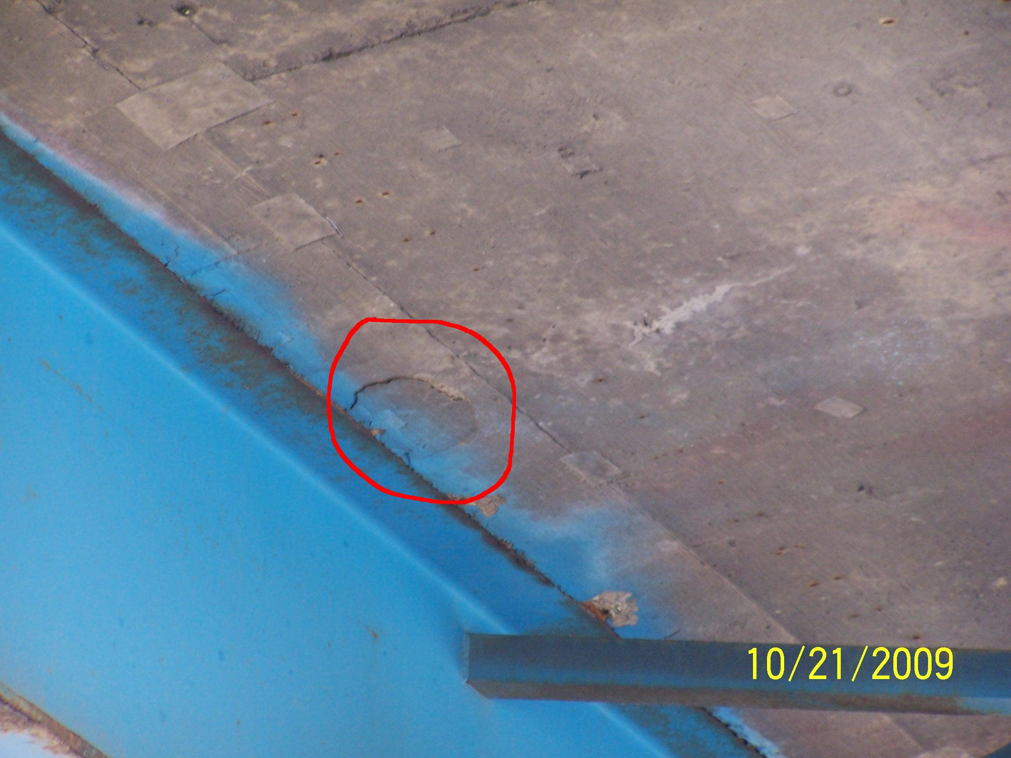

PLEASE SIGN, DATE AND RETURN THIS FORM WHEN THE WORK HAS BEEN COMPLETED.

COUNTY or DEPARTMENT MANAGER DATE COMPLETED

CC: bridge file
/tmp/in/input.doc

