TO: Bridge File DATE: 9-28-2012

By: Albert Abel, BSII

BRIDGE NUMBER: GUE-70-1656L SFN: 3001687

On September 26, 2012 the Bridge Engineer, Curtis Zigan was notified by the Guernsey County Manager, Mark Adkinson that bridge GUE-70-1656L had been hit by an unknown over-height load sometime in the recent past. I inspected the bridge for damage on September 28, 2012. Beam 1 of span 2 of the structure appeared to have been struck by a modular home or building leaving pieces of wood and aluminum flashing laying on the bottom beam flange. No structure damage was found only minor paint scrapes on the beam at the point of impact. No repairs will be required due to the strike

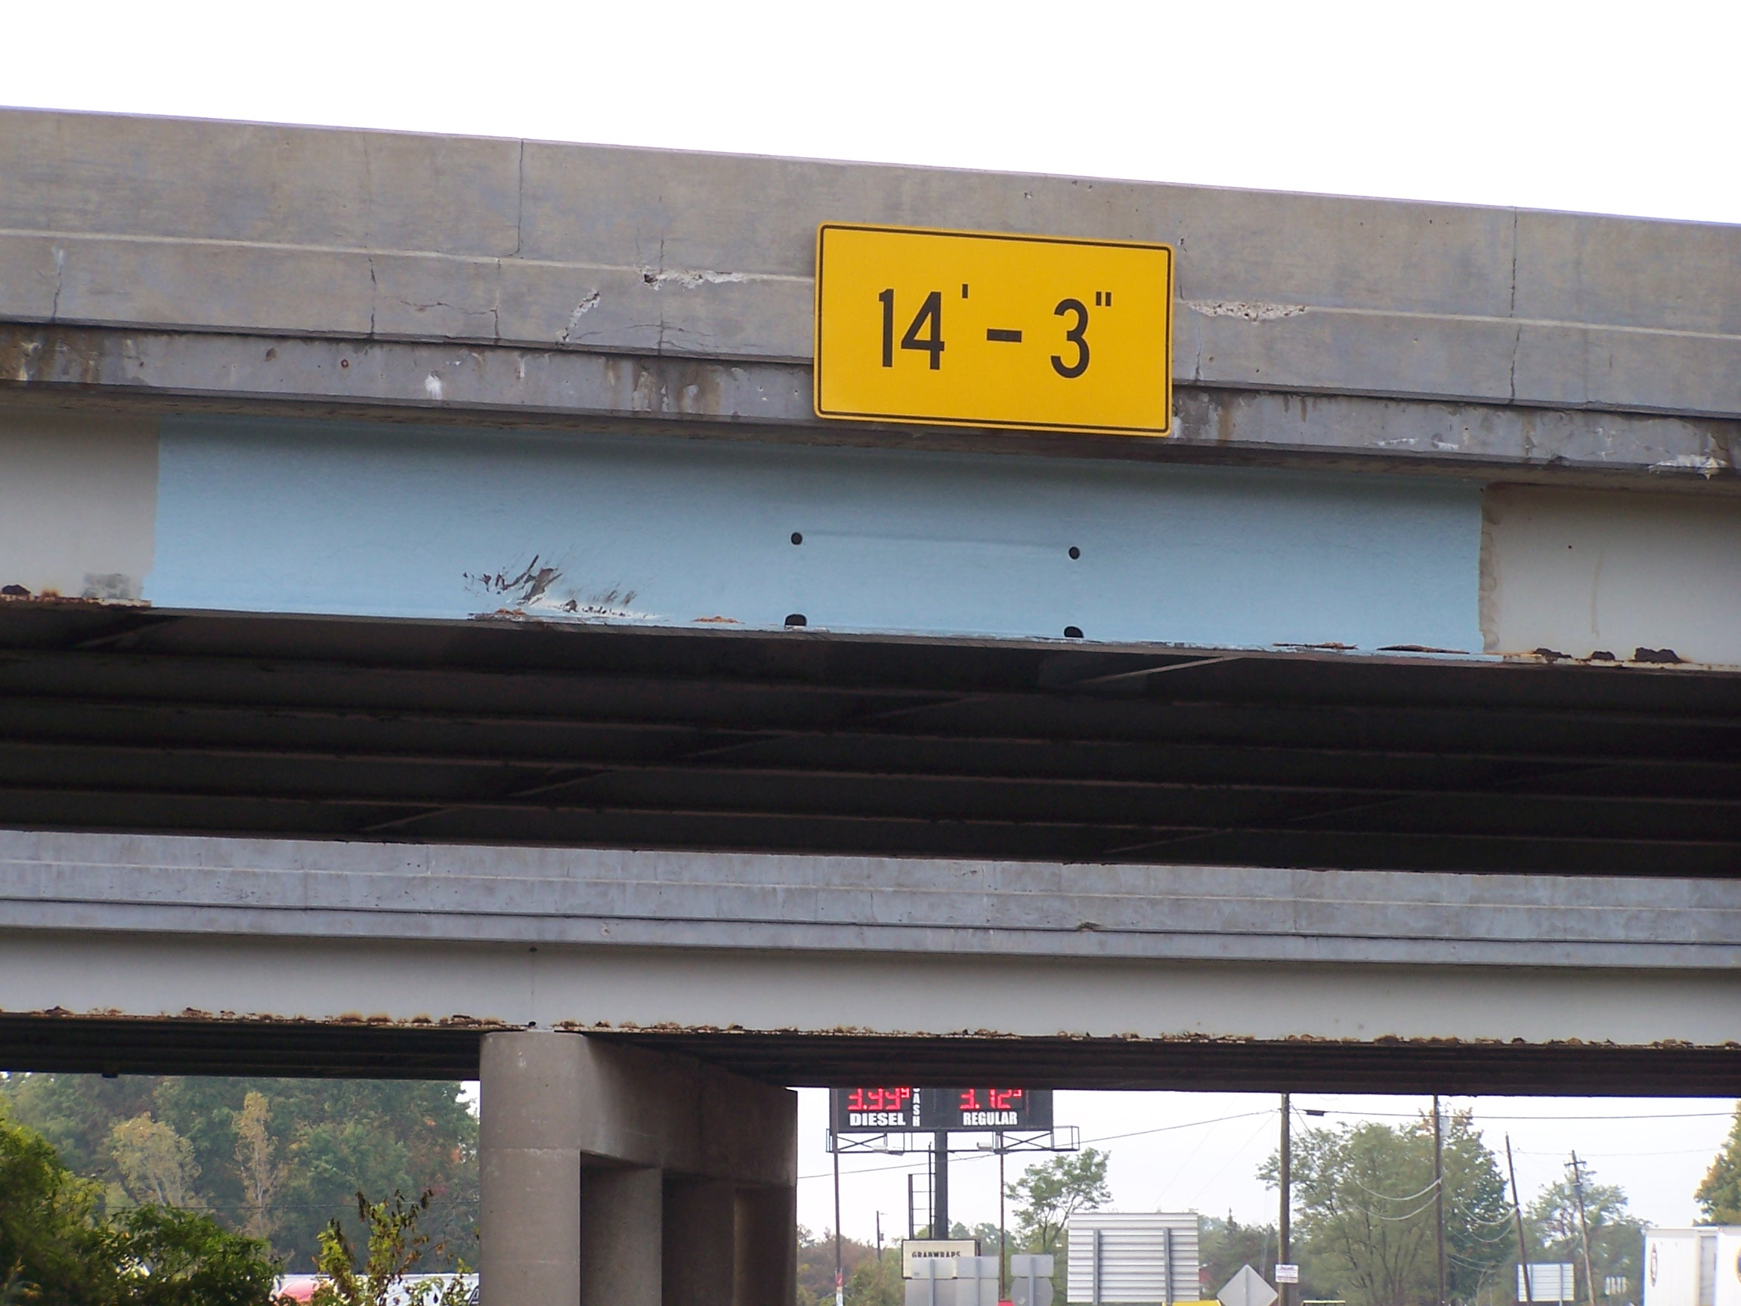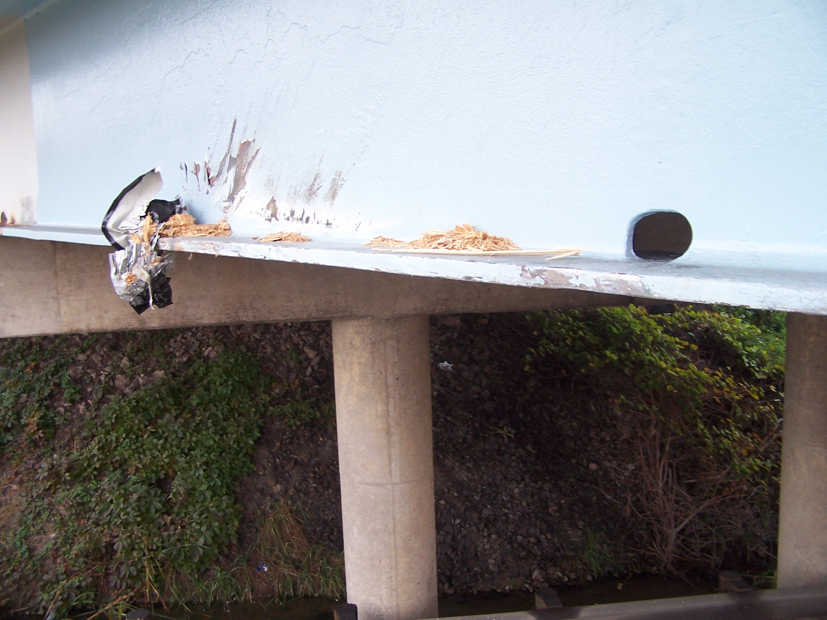

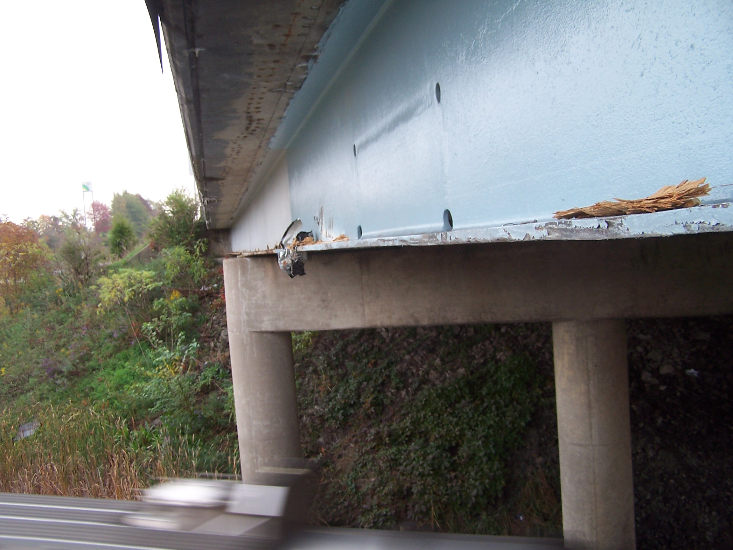

C: bridge file

/tmp/in/input.doc

