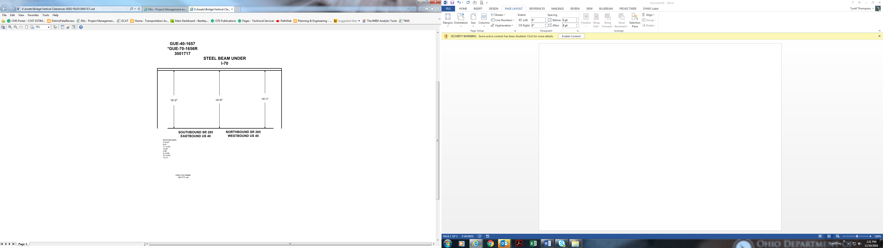

Date Revised: 4-16-87

6-91

11-12-92

12-95

4-98

6-13-99

10-14-09

1-5-11

15’-0” 14’-9” 15’-1”