Technical Bulletin

Issued: 12/21/2010

Topic: Viewing Orthophotos (Georectified Images) in Microstation V8i (SELECT Series2)

All provided orthophotos are georectified images. This means that along with each .tif there is an associated header file (.tfw) known as a Sister File or World File which contains the geospatial location of the image. The Raster Manager function is used in Microstation V8i to view orthophotos and mosaics. (Raster Manager can be found under ***File>Raster Manager***.)

**Set-up**

Before attaching images some Raster Manager Preferences must be set. (This is found under ***Workspace>Preferences>Raster Manager***.) In particular, the items boxed out in red need to be set as shown here:

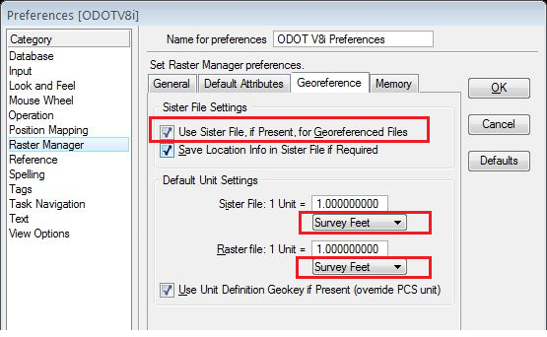

Note: If you are viewing images in the design file that we have provided you, all the settings should already be set appropriately. If you are using your own design file select ***File>Save Settings*** and you should not have to do this step again.

**Attaching Images**

You are now ready to attach your images. If the Raster Manager dialogue is not open yet, open it now. Select ***File>Attach*** and select your images. The .tfw files need to reside in the same folder as the .tif images, however, the .tfw files will not be visible in this dialogue. Because you have selected to use sister files (as seen above), Microstation will automatically attach the appropriate .tfw to the .tif images. Ensure that *‘Place Interactively’* is *NOT* checked – this function defeats the purpose of the georeferenced image. Also, because of the large file sizes it is recommended that you have *Raster Preview UNCHECKED*, as this can greatly decrease your download time for large images.

**Detaching Raster Files**

You can detach one or more raster references. Select the required files in the Raster Manager dialogue list box, or use the Raster Selection tool. Then select ***File>Detach*** or ***Detach All***.