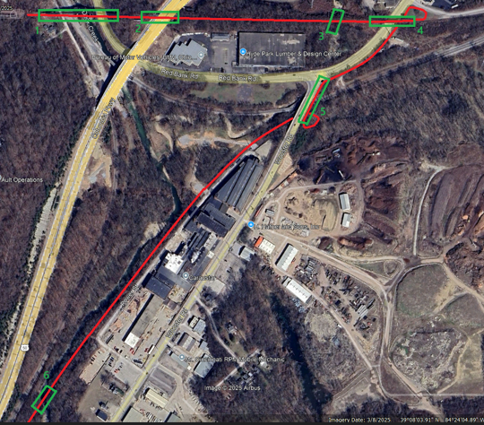
Wasson Armleder Shared Use Path- General Structures Scope (PID 113603)

The work proposed is based upon field inspections from an ODOT District 8 Bridge inspector and the logical work necessary to restore the bridges to a reasonable structural condition and longevity. The proposed work does not include any analysis or assumptions on the capacity of the existing bridge to carry the proposed dead loads and live loads. A field evaluation of the existing structures including identification of exact defect locations will need to be conducted by the Engineer of Record. Photos and inspector notes can be found on District 8’s I drive at the following location: \\D08fs100\project\Structures\ham\US50\Wasson Armleder Shared Use Path

Bridge #1 over Duck Creek, two railroads, and Red Bank Rd.
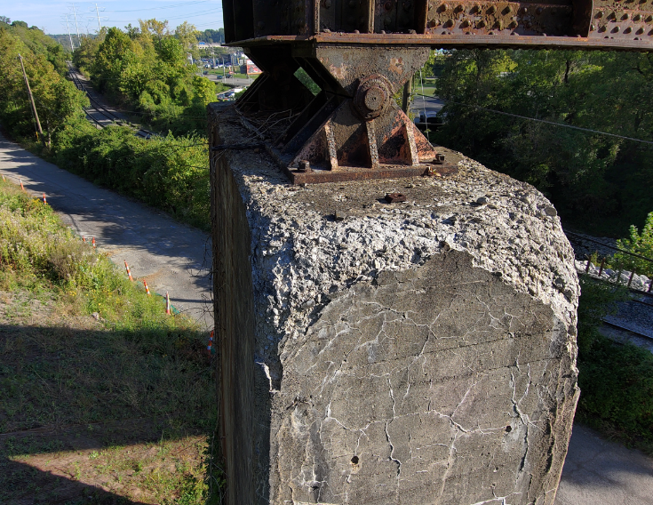
Recommended work:
- Remove all vegetation and vines within 20 feet of the structure.
- Paint superstructure steel and substructure steel with OZEU. Steel shall be painted with the railroad ties removed to allow painting of top flanges and lateral bracing.
- Point and tuck deteriorated stone on the west abutment.
- Replace concrete backwall on East abutment.
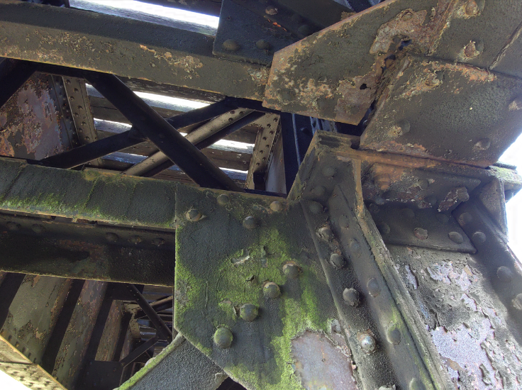
- Patch deteriorated portions of east abutment with 519 patching.
- Remove/replace all wooden railroad ties with new deck configuration.
- Patch pier 1 with 519 patching. Remove and reconstruct the deteriorated portions of the south pier face full thickness. Provide FRP exterior reinforcement with a development length of at 3 feet past the existing bearing
- Remove cantilever platforms as it is unlikely these will meet current codes to support live loads.
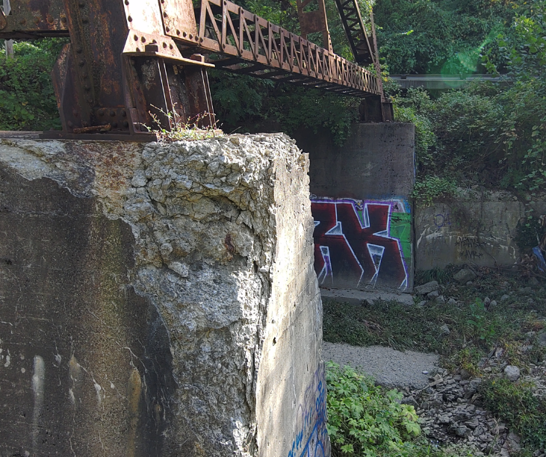
- Replace the deteriorated lower lateral gusset plate directly over the northwest leg of the 4 column steel pier.
- Remove and reconstruct the deteriorated concrete immediately below the southeast leg of the 4 leg steel pier. A temporary support will be needed. Provide FRP exterior reinforcement with a development length of at 3 feet past the existing bearing. Patch other deteriorated areas with 519 patching.
- Place Rock Channel Protection around foundations. A hydraulic study and/or stream channel cross sections with material removed may be needed to compensate for add RCP.
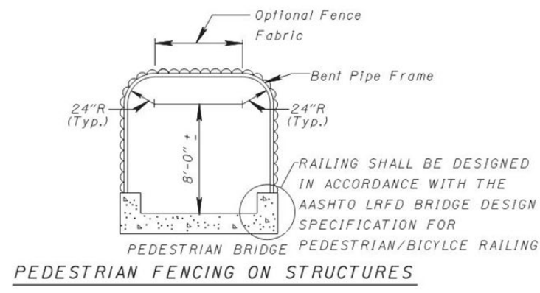
- Retrofit structure to accommodate new shared use path. Include Vandal Protection Fencing per Figure 309-28a.
- Ensure new dead loads and live loads do not exceed Cooper E-80 loading.
- Seal all FRP retrofits, patches, and existing concrete and with Epoxy urethane sealer. Color shall be gray. Include removal of existing paint (graffiti).

Bridge #2 over US 50
Recommended work:
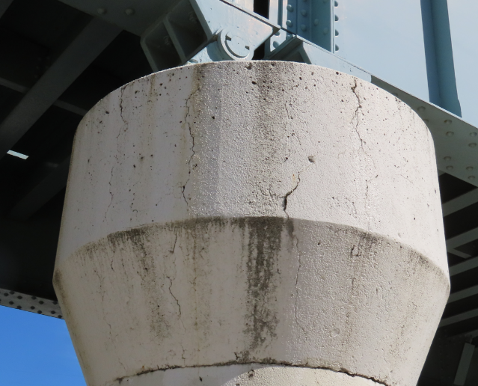
- Wrap Pier cap ends with FRP to provide confinement and protect existing vertical cracks from the elements. Seal with an epoxy urethane sealer, federal color 17778.
- Remove vegetation, wooden railroad ties, etc before construction of walkway.
- Retrofit structure to accommodate new shared use path. Include Vandal Protection Fencing per Figure 309-28a or 12’ tall fence as measured from the SUP surface.

Bridge #3 over a tributary of Duck Creek
Recommended work:
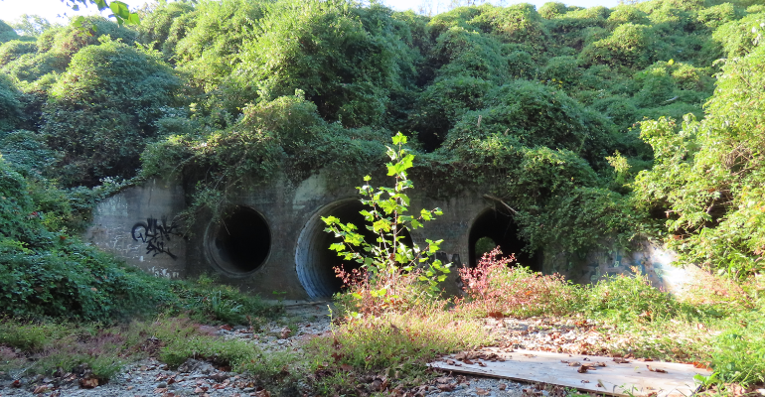
Remove vegetation from hillside. Inspect slopes for signs of erosion / slides.
- Repair deteriorated joints of precast concrete pipe with patching using trowelable mortar per SS 843.
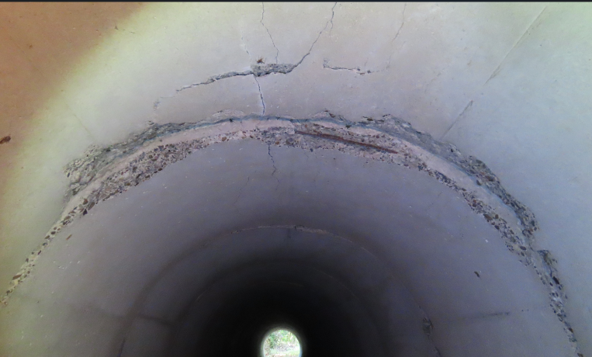
- Repair two “spot locations” exhibiting possible structural cracking with a close fit liner such as EIPI or a UV cured CIPP.

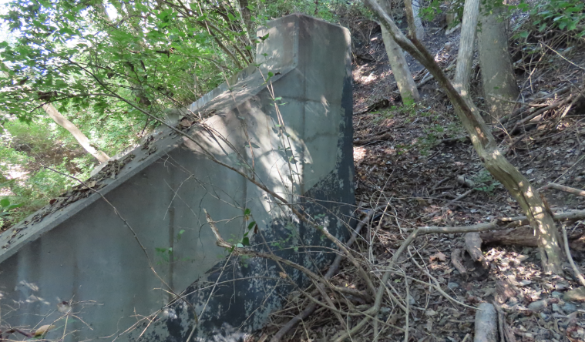
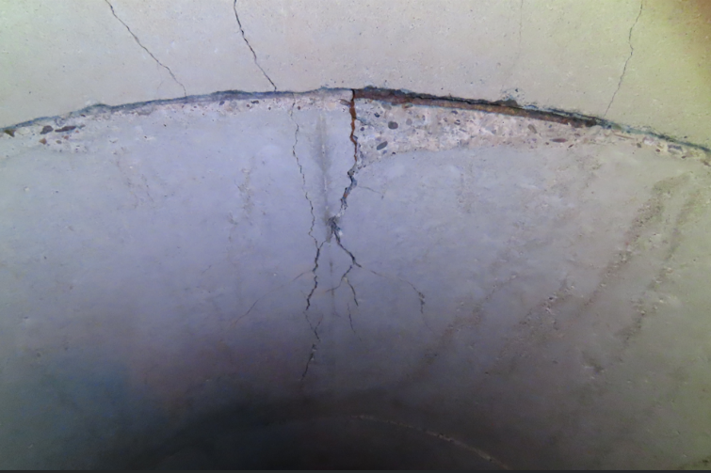

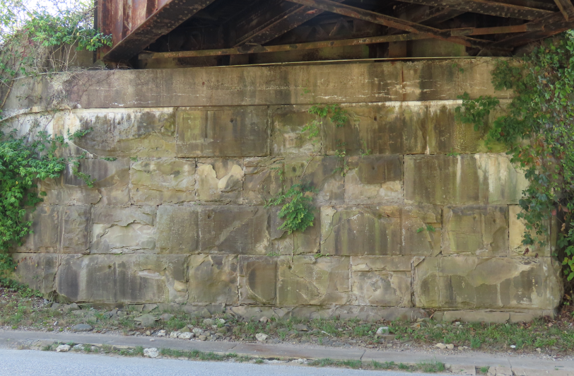
Bridge #4 Bridge over Wooster Pike
Recommended work:

- Point tuck stone abutments.
- Replace damaged lower lateral bracing.
- Remove/replace all wooden railroad ties with new deck configuration.
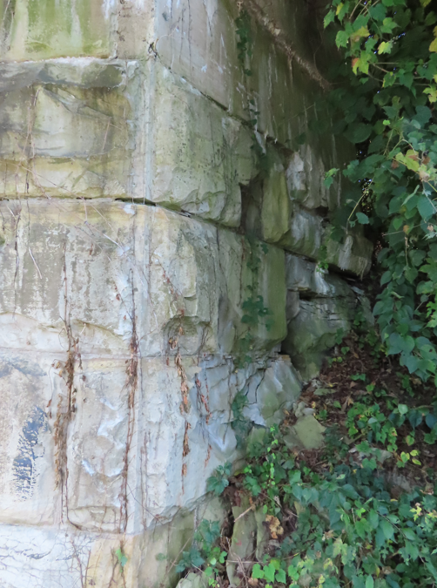
- Paint superstructure steel with OZEU. Steel shall be painted with the railroad ties removed to allow painting of top flanges and lateral bracing.
- Measure vertical clearance. Post VC if less than 14.5 feet.
- Retrofit structure to accommodate new shared use path. Include Vandal Protection Fencing per Figure 309-28a or 12’ tall fence as measured from the SUP surface.

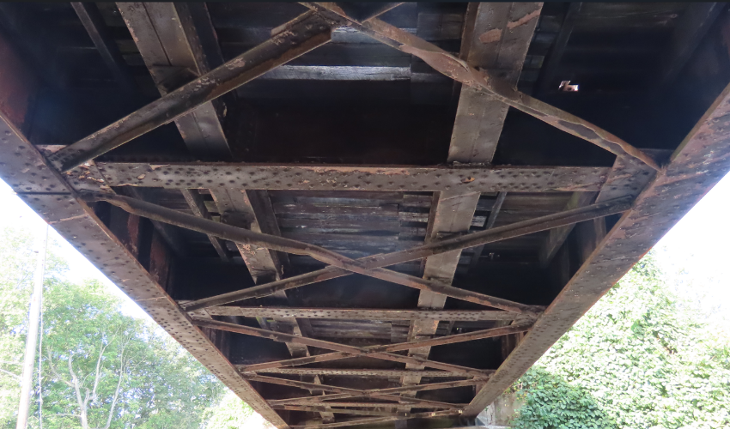

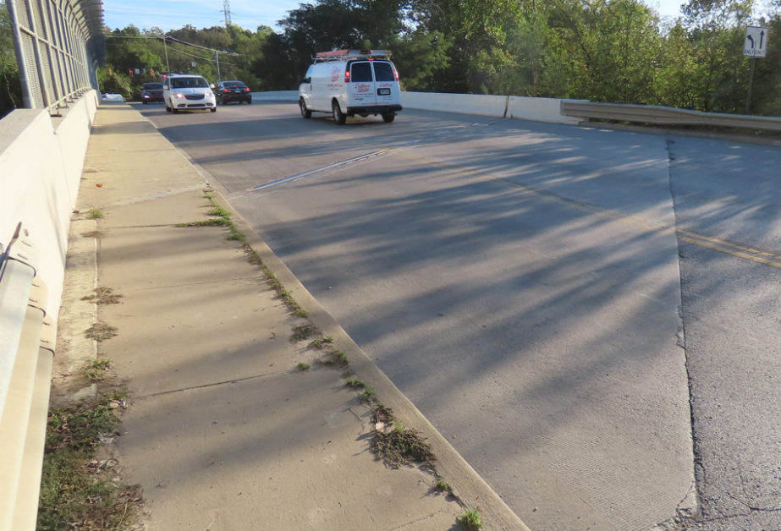
Bridge #5: Wooster Rd over Railroad
No need for structural repairs were found.
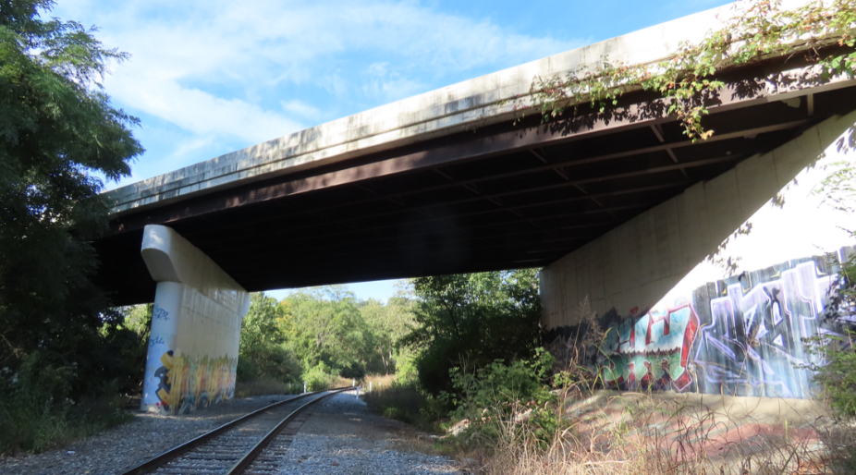
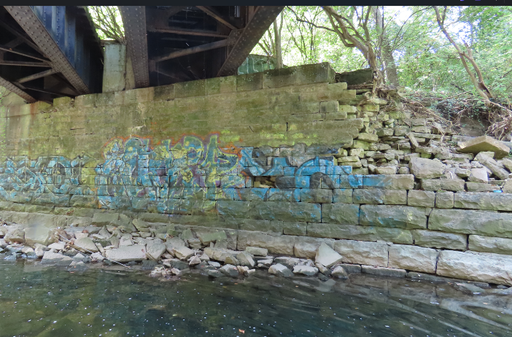
Bridge #6: Abandoned Railroad over Duck Creek
Preface: Determine the cost of the recommended rehabilitation work compared to the cost of complete replacement or realignment alternatives.
- Replace deteriorated lower lateral gusset plates.
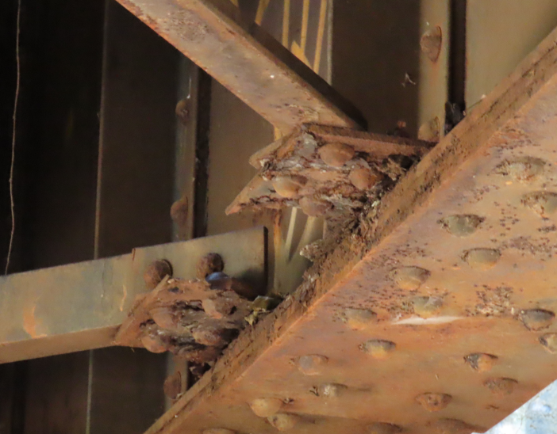
- Evaluate deterioration of bottom flange connection angles to determine if sufficient capacity remains. Consider repair or replacement alternatives for this deterioration. Temporary support may be required.
- Paint superstructure steel with OZEU. Steel shall be painted with the railroad ties removed to allow painting of top flanges and lateral bracing.
- Point and tuck deteriorated stone on abutments and piers.
- Replace the abutment bearings.
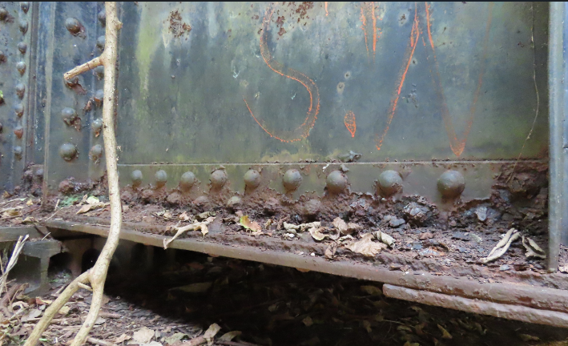
- Place Rock Channel Protection in scour holes around pier and at the west abutment. Cross sections and/or a hydraulic study may be required to compensate for the added RCP.
- Reconstruct or replace the Northwest stone wingwall. Provide sufficient stream armoring. Note that the scour is likely due to the alignment of the upstream channel that is directed at this location.
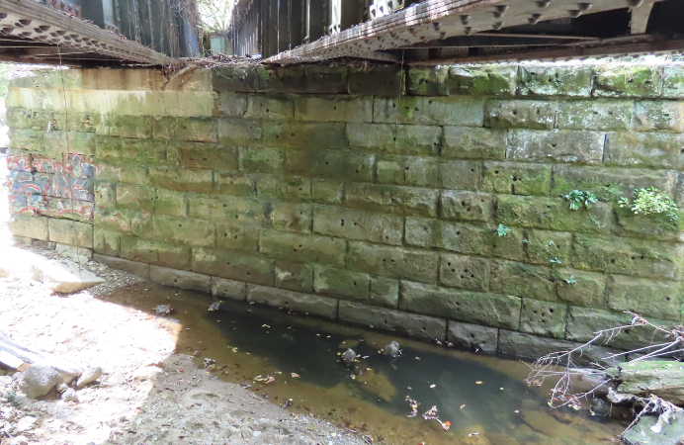
- Patch with 519 patching or replace deteriorated portions of concrete abutments, pier caps, wingwalls and backw alls.
- Retrofit structure to accommodate new shared use path.

Other Items
Retaining near Bridge #6
Tuckpoint stone retaining wall near the southwest corner of Bridge #6 (downstream). 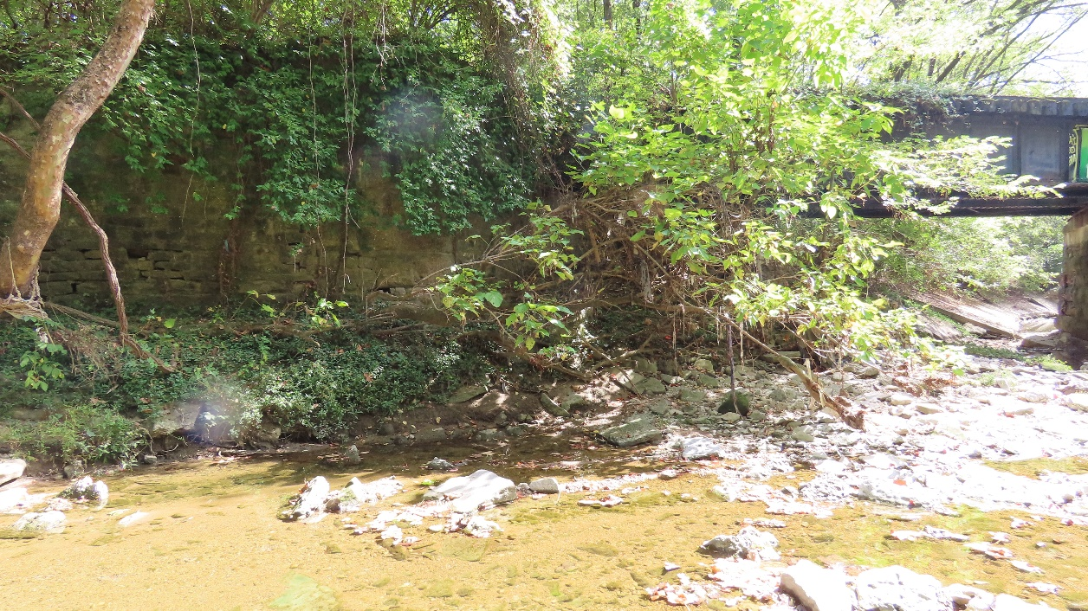

Remnants of a stone wall upstream of bridge 6 may need rehabilitated or replaced depending upon available R/W. Toe should be protected with RCP as well.
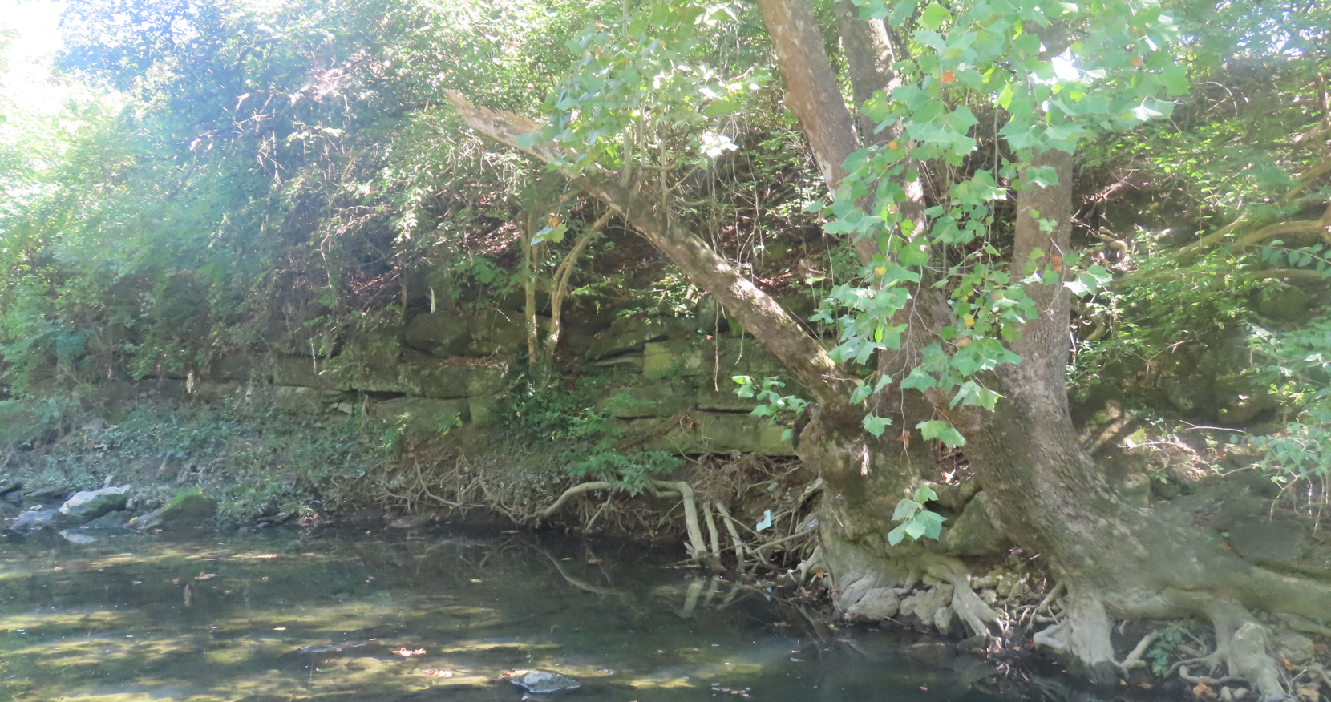

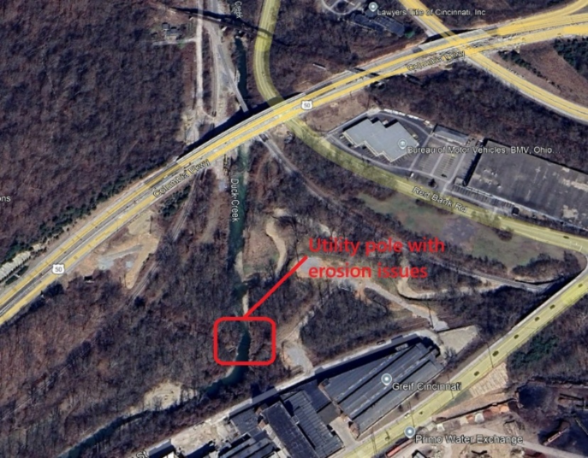
Utility pole with erosion issues

