March 02, 2026

Scott Knebel, P.E.
Crawford, Murphy, & Tilly, Inc.
8101 North High Street, Suite 150
Columbus, OH 43235

Re: HAM US 42 10.07 Reading Rd, PID# 123369, Stage 2 Review Comments

Mr. Knebel,

ODOT District 8 has reviewed the Stage 2 submission for the above referenced project. All comments have been provided electronically in PDF format with the word “REVIEWED” added to the file name. The disposition of comments has been completed in PDF format using either Blue Beam or Adobe. Instructions below on how to respond and add your comments to the PDF have been followed per the instructions provided below.

Responding to Comments in Blue Beam
The comment summary table in Blue Beam will be used to respond to comments.
- If a comment has been complied with, toggle the checkmark box for that comment.
- If the comment requires a response or further explanation, write your comments in the disposition column for that comment. Your name or initials should be added after your comment to track who typed the response. Do not toggle the checkmark box for comments with dispositions.

Responding to Comments in Adobe
The comments feature in Adobe will be used to respond to comments.
- If a comment has been complied with, toggle the checkmark box for that comment.
- If the comment requires a response or further explanation, add your written response to the comment you are responding to. This can be done by double clicking in the box with the given comment then typing enter twice to add space, then write your response. The text color for your response should be changed to red. Your name or initials should be added after your comment to track who typed the response. Do not toggle the checkmark box for comments with dispositions.

The Stage 2 submission is approved by District 8, provided our comments are appropriately addressed prior to submission of Stage 3 Plans. Per L&D, Vol. 3, Section 1406.4.3, please provide a formal written disposition to all of the Stage 2 comments with the submission of the Stage 3 plans. If you have any questions or comments please contact me by phone at 513-933-6583 or by email at Katherine.DeStefano@dot.ohio.gov.
Sincerely,
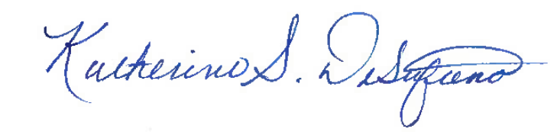
Katherine DeStefano, P.E.
Senior Transportation Engineer/Project Manager

Interim consultant Feedback

PID Number: 123369
Project Name:
Consultant: Crawford, Murphy, & Tilly, Inc.

Consultant Project Manager: Scott Knebel, P.E.
ODOT Project Manager (completing form): Katherine DeStefano
Review Submission: Stage 2

CONSULTANT EVALUATION
On a scale of 1 to 10 (low to high), ODOT is providing the following interim evaluation feedback. If you have any concerns with the feedback please contact the ODOT Project Manager.
Rating |  | Rate  1 to 10
1 | Project Management | 9
2 | Adherence to Project Schedule | 9
3 | Adherence to Project Budget (Design, R/W, and Construction) | 9
4 | Quality of Work Product (Reports, Plans, etc.) | 9
5 | Responsiveness | 9
6 | Quality of Technical Performance | 9

Comments:
A rating of 7 and above indicates that District expectations have been met.

