Location & Rankings

The intersection addressed in this study is WAR US 22 19.24 (Clarksville Rd). The intersection is within Washington Township just north of the Village of Clarksville and west of the City of Wilmington.

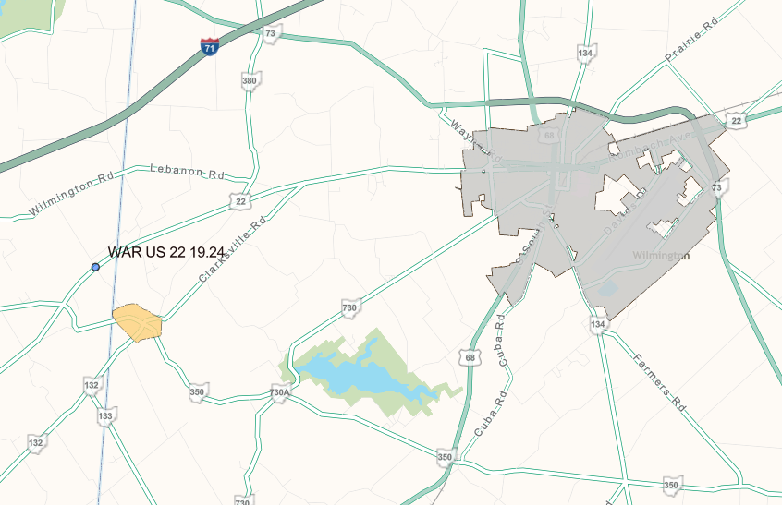
Figure 1: Intersection Location Map

The intersection is ranked on the 2024 Highway Safety Improvement Program (HSIP) priority ranking list as rural intersection #105. The intersection is not listed on the current SIP Map. The subject intersection has not appeared on any Safety Analyst study lists in the past 5 years (2017-2018 SA lists, 2020-2021 SA lists, and FY25 HSIP list). The TOAST score for WAR US 22 12.82-19.77 is 90.80%. There are no congestion issues on US 22 in this area.

The purpose of this study is to analyze the crash trends at this location and recommend countermeasures to mitigate any safety or congestion issues.

Potential Stakeholders

The major stakeholder for the study location is the Ohio Department of Transportation (ODOT). ODOT is responsible for all maintenance on US 22. Warren County Engineer’s Office (WCEO) is a minor stakeholder for this study location because Clarksville Rd is a county route. ODOT will coordinate with WCEO should funding be awarded for a project. A public involvement meeting will be included as part of the project development process.

ODOT will take the lead on applying for safety funding and managing any future projects.

Physical Conditions

At the studied intersection, US 22 has 1 travel lane in each direction with no turn lanes. The functional classification for US 22 is a rural major collector. The speed limit on US 22 is 55 MPH. There are no speed zones within the study limits. A traffic count was collected on US 22 approximately 0.5 miles southwest of Clarksville Rd in 2022 showing an AADT of 2,156.

Clarksville Rd has 1 travel lane in each direction with no turn lanes. Clarksville Rd is classified as a rural local roadway. The speed limit is 55 MPH. There are no speed zones within the study limits. StreetLight Data was used to estimate a turning movement count at the US 22/Clarksville Rd intersection. This data shows the volumes of traffic on US 22 and Clarksville Rd are very similar (2,000 – 3,000 vehicles per day).

The intersection of US 22 and Clarksville Rd is stop controlled on Clarksville Rd with free flow traffic on US 22. There are no turn lanes for any approach at this intersection, no intersection lighting, and no pedestrian facilities. There are dual stop ahead warning signs and dual stop signs with cross traffic does not stop plaques for both approaches on Clarksville Rd. There are dual intersection ahead warning signs with street name plaques for both approaches on US 22.

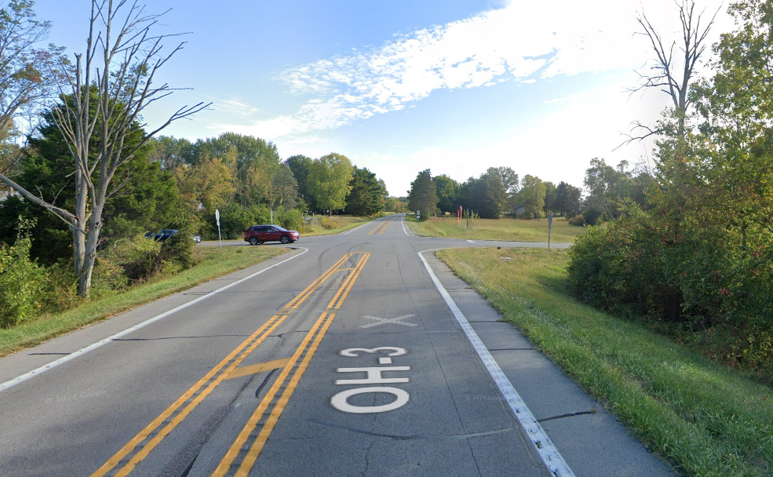
Figure 2: Google Street View Looking Northeast on US 22

The travelled lanes on US 22 are approximately 12’ wide with 4’ wide paved shoulders. The travelled lanes on Clarksville Rd are approximately 10-11’ wide with 0’ wide paved shoulders. All measurements were made using Google Maps.

There are 2 culverts near the US 22/Clarksville Rd intersection: CFN 1839769 (48” concrete) and CFN 1855157 (30” concrete). Both culverts would be impacted by a future transportation project (realignment, roundabout, etc.).

The studied intersection is surrounded by farm fields and residential homes. There are no driveways off US 22 within 500’ of the intersection. Clarksville Rd is used as a main connection from US 22 to IR 71. Clarksville Rd dead ends to the north at Wilmington Rd. The IR 71/Wilmington Rd interchange is 3.5 miles to the west of Clarksville Rd.
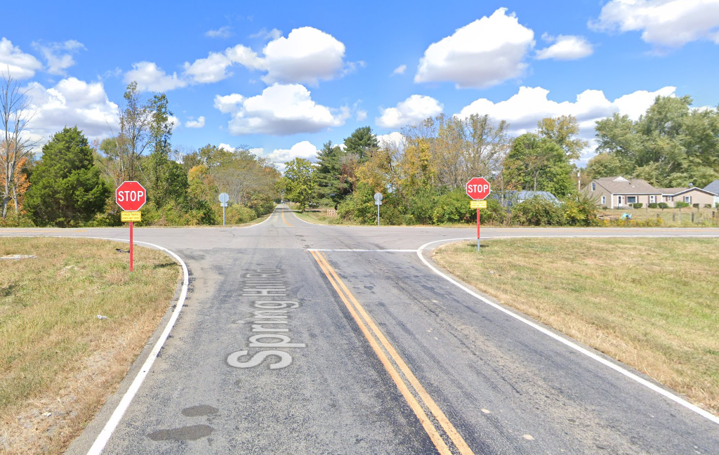
Figure 3: Google Street View Looking Northwest on Clarksville Rd

Background Information

Multiple work orders have been completed within the past 5 years. In 2021, ODOT installed oversized stop signs on Clarksville Rd. In 2023, ODOT added additional cross traffic does not stop plaques (some stop signs did not have one). In the fall of 2023, ODOT implemented new pavement markings on US 22 in an attempt to lower speeds and reduce the number of crashes. The new pavement markings can be seen in Figure 2. The lane widths were narrowed on the approach to the intersection and rumble stripes were added to the center and edge lines. An FHWA study (Two Low-Cost Safety Concepts for Two-Way Stop-Controlled, Rural Intersections on High-Speed Two-Lane, Two-Way Roadways - FHWA-HRT-08-063) from 2008 showed this countermeasure could lower speeds by 3-4 mph. Unfortunately, before/after speed data did not show a noticeable difference in speeds along US 22 near the intersection. Additionally, the number of angle crashes at the intersection have increased in the past 3 years with the most angle crashes in 2024.

ODOT receives public inquiries at the US 22/Clarksville Rd intersection on a routine basis. The typical request is for flashing LED border stop signs, for flashing beacons on warning signs, or for a traffic signal. Crash data is updated regularly when the public inquiries are received.

The rural intersection at US 22/Clarksville Rd has not appeared on any Safety Analyst study lists in the past 5 years (2017-2018 SA lists, 2020-2021 SA lists, and FY25 HSIP list).

The most recent paving project was PID 83823. This project installed a fine polymer asphalt concrete overlay on US 22 in 2013. A crack sealing project (PID 96537) was also completed in 2019. The current work plan, through FY2031, has 1 proposed project in the study area. PID 116337 (FY2028) will resurface US 22 with an asphalt concrete overlay with repairs. Construction on this project is scheduled to begin in the summer of 2028. This resurfacing project will need to be coordinated with the proposed construction of any safety project.

Primary Crash Pattern

From 2022-2024, there were 22 total crashes at the US 22/Clarksville Rd intersection. There were 7 crashes in 2022, 6 crashes in 2023, and 9 crashes in 2024. There were 0 fatal crashes, 2 serious injury crashes, 13 minor injury crashes, 4 possible injury crashes, and 3 property damage only crashes. The fatal and injury crash rate was 86.4%. All 22 crashes at the intersection were angle crashes. Crashes occurred most often in dry (86%) and daylight (77%) conditions.

The primary crash pattern is angle crashes at the intersection of US 22/Clarksville Rd. There were 22 total angle crashes from 2022-2024. There were 15 angle crashes involving westbound vehicles on US 22. The most common angle crash was between westbound and northbound traffic with 10 occurrences. See the crash diagram for additional information.

Failure to yield was the most common reason for an angle crash to occur. Only 3 of the 22 angle crashes were caused by running a stop sign. The angle crashes occurred most often from 2-7 PM during the peak PM commuting hours.

Historically, there have been 2-3 angle crashes at the US 22/Clarksville Rd intersection each year from 2015-2020. However, the past 4 years have seen a significant increase in the number of angle crashes. There have been at least 5 angle crashes each year from 2021-2024, with a peak of 9 angle crashes in 2024. A long-term solution is needed to eliminate the potential for high severity angle crashes.

Table 1: Angle Crashes by Year at the US 22/Clarksville Rd Intersection
2015 | 2016 | 2017 | 2018 | 2019 | 2020 | 2021 | 2022 | 2023 | 2024
4 | 3 | 1 | 3 | 2 | 3 | 5 | 7 | 6 | 9

Primary Crash Countermeasure

The proper signs and pavement markings are already in place at the US 22/Clarksville Rd intersection. Low cost countermeasures (oversized stop signs, cross traffic does not stop plaques, and pavement markings) have been implemented at this intersection in the past 5 years. A long-term solution is needed to eliminate the potential for high severity crashes. The injury rate at this intersection is over 86% based on the last 3 years of full data.

ODOT District 8 received safety funds in early 2025 to install LED border flashing intersection ahead warning signs on US 22 in both directions approaching the US 22/Clarksville Rd intersection. A total of 4 signs will be installed (2 signs in each direction). These signs will be installed in the Summer/Fall of 2025.

StreetLight Data was used to create an estimated AADT and turning movement count at the intersection. This data was used to complete a signal warrant analysis utilizing ODOT’s Traffic Signal Warrant Spreadsheet. Based on this analysis, a traffic signal is not warranted at the US 22/Clarksville Rd intersection. ODOT District 8 will not pursue a new traffic signal at this location because a traffic signal is not warranted and a new traffic signal is predicted to increase the number of overall crashes.

All-way stop control is not being considered at this intersection. The 85th percentile speeds on US 22 are near 60 mph and the nearest stopped conditions on US 22 are over 8 miles away in either direction (Nelson Ave to the north and SR 123 to the south).

Based on the historical crash data and past countermeasures, the recommended countermeasure at this time is to construct a single lane modern roundabout at US 22/Clarksville Rd. If funding is awarded to this project, a new traffic count will need to be collected. Then, proper traffic analysis would be completed to confirm a traffic signal is unwarranted and a single lane modern roundabout would operate sufficiently in the design year.

Safety analysis was completed for the proposed single lane modern roundabout. The ECAT shows a proposed reduction of 1.3 crashes per year and a net present value of safety benefits of $961,175.25 with the construction of a roundabout. The proposed roundabout has a benefit/cost ratio of 0.35.

Relevance to the Ohio Strategic Highway Safety Plan (SHSP) Strategic Highway Safety Plan (SHSP)

These recommended countermeasures help the state meet the performance measurement goals stated in the Ohio Strategic Highway Safety Plan. The countermeasures recommended are aiding in reducing fatalities, serious injuries, and all crashes on public roads in Ohio. The major emphasis area addressed in this study is intersections.

Ohio’s top strategies for addressing intersections include using new technology and implementing proven, low-cost systemic safety improvements. Low-cost improvements have already been tried at this location without success. Therefore, the recommended countermeasure is a single lane modern roundabout. The roundabout is the best long-term improvement for safety. The roundabout is the only alternative that can eliminate the potential for high severity crashes.

