PROJECT OVERVIEW
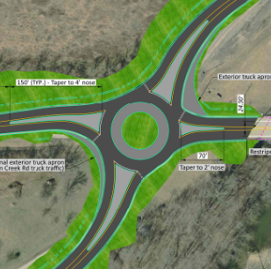
ODOT D8 has worked with the Office of Roadway Engineering to layout a single lane roundabout at the intersection of US-22 and SR-380/Creek Rd in Clinton County. The intersection is heavily skewed and has a bridge constraint to the east of the intersection.

PROJECT NEED
The purpose of the project is to improve safety at the intersection. The intersection is ranked #123 on the 2025 HSIP rural intersection list. Crash data from 2022-2024 at the intersection shows a total of 20 crashes with an average of 6.67 crashes per year and a 60% injury rate. There were 15 angle crashes, of which 1 was a serious injury, 7 minor injuries, 1 injury possible and 6 PDO. There were also 2 rear end crashes (1 minor injury, 1 PDO), 1 PDO sideswipe passing crash, 1 minor injury fixed object crash and 1 minor injury head on crash. The majority of angle crashes involved SB SR-380 vehicles pulling out in front of NB/EB US-22 vehicles (7 crashes with 4 injuries). There were also 5 angle crashes involving NB Creek Rd vehicles pulling out in front of SB/WB US-22 vehicles, with 2 resulting in injury.

EXISTING CONDITIONS
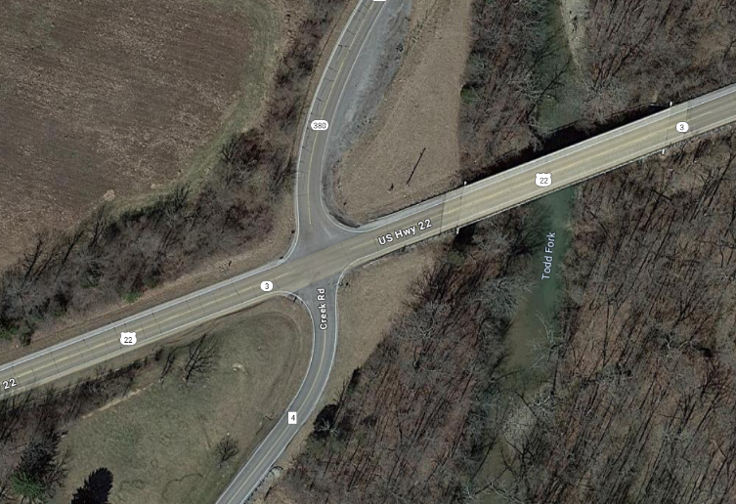
US-22 is a single lane in both directions with no turn lanes. SR-380 is a stop condition on the north side of the intersection with no turn lanes. Creek Rd is a stop condition on the south side of the intersection with no turn lanes. Both US-22 and SR-380 are classified as “Major Collector” in ODOT’s Functional Classification System. Creek Rd is classified as a local road. The speed limit on all legs of the intersection is 55mph. US-22 west of the intersection has an AADT of 2925 and east of the intersection is 5030. SR-380 has an AADT of 2392 and Creek Rd is 749. The TOAST score on US-22 is 0.878. The TOAST score on SR-380 is 0.733.
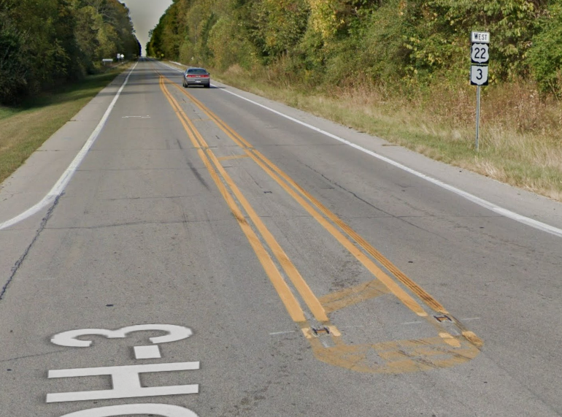
In 2023, ODOT D8 implemented an innovative striping condition at the intersection that has been studied by FHWA whereas the through lanes on the major route at a TWSC are narrowed by widening out the centerline with striping and rumble strips. This effectively slows down vehicles on the free flow movement allowing the side street drivers better ability to judge gaps and oncoming travel speeds. Studies showed a speed reduction of about 3-4mph. After studies for our location did not show a decrease in travel speeds or a reduction in crashes.

ECAT
Based on the existing conditions and AADT of this intersection, the ECAT existing conditions report has a predicted average crash frequency of 4.0 crashes per year and an expected average crash frequency of 4.7 crashes per year. This means there is a 0.7 crashes per year potential for safety improvement. The proposed conditions of a roundabout results in a predicted average crash frequency of 1.2 crashes per year, a reduction of 2.8 crashes per year over the predicted. This has a net present value of safety benefits of $3,186,789, resulting in a benefit cost ratio of 0.92.

This project scores 74/100 on the HSIP scoring tool, receiving the greatest amount of points for ratio of observed fata and serious injuries to observed total crashes, relative severity index and equivalent property damage only index.

ESTIMATE
ORE developed a preliminary design and cost estimate for this work. D8 inflated it more and increased the contingency to account for some design changes we would like to see once a consultant is selected. The construction cost estimate for this project is $2,750,000. This project can be constructed in FY29. D8 is also requesting $400,000 for PE in FY26, $125,000 for DD in FY28, and $200,000 for right of way in FY28. The District would request this project to be designed and constructed with the WAR-22 roundabout project on the January 2026 programmatic.

ATTACHMENTS
- HSIP Scoring Tool
- DSRT Sign Off
- Crash Analysis
- Crash Diagram
- Preliminary Design/Geometric Layout
- Estimate
- ECAT Files
- Misc Files

