DISTRICT ENGINEER’S FORMAL REPORT
Accident Date: September 22nd, 2025

Damage to Bridge No. HAM-275-2338L (SFN 3112063) caused by a vehicular impact



Prepared By:
District 8 Bridge Department
Kristen Stacklin, E.I., - Transportation Engineer 2

On Site Inspectors:
Dwayne Bishop - Bridge Specialist 2 (inspected on 9/22/2025)

Reviewed by: Brandon Collett, PE, District Bridge Engineer
Exhibit “A”:

- Bridge Number(s): HAM-275-2338L
- Structure File Number(s): 3112063
- Date, time of accident: September 22nd, 2025 at 6:33 AM.
- Location of Accident: State Route 32 over West Main Street
- Persons and vehicles involved: See Ohio Traffic Crash Report 202501238.
- Statements of those involved: See Ohio Traffic Crash Report 202501238.
- Statements of witnesses: See Ohio Traffic Crash Report Traffic Crash Report 202501238.

Exhibit “B”, Ohio Traffic Crash Report (202501238):

The crash report is attached to this document.

Exhibit “C”, Conditions Prior to the Accident:

- Condition of structure HAM-275-2338L prior to accident:

This bridge carries IR-275 over SR-4 in Springdale. The superstructure is comprised of a composite reinforced concrete deck and parapets on a 3-span rolled W36x232 and W36x170 beam superstructure with a total length of 196.34’. The bridge was constructed in 1960 and underwent a minor rehabilitation in 1977 and 1991 and a major rehabilitation in 2006.

The previous inspection report (See Inspection Report) completed on February 25, 2025 rated all 2352 linear feet of steel open girder/beams in Condition State 1 (no damage) out of 4, 4 being worst. The steel protective coating rated all 21390 square feet to be in Condition State 1.

Below are photos of this area that was impacted from the 2/25/2025 inspection before the collision.
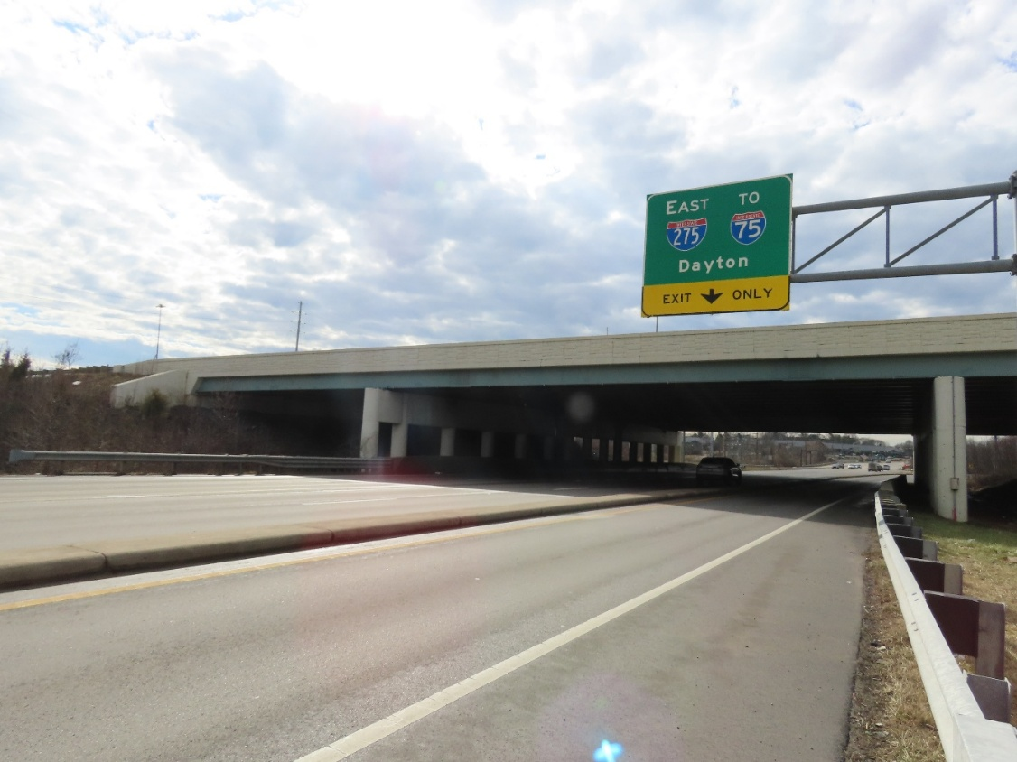
Beam 1 on 2/25/2025 prior to impact.
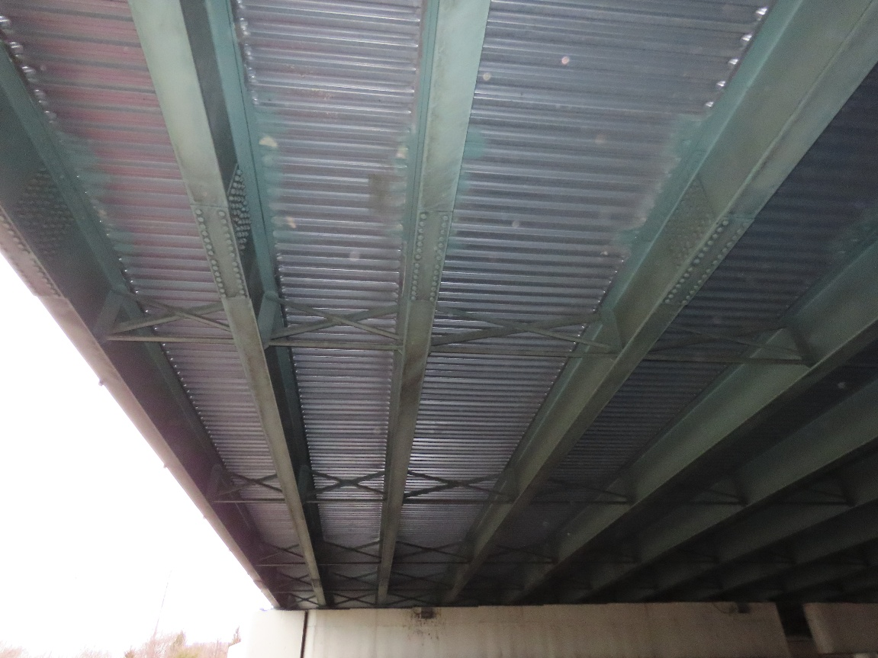
Beam 1, 2, 3, and 4 on 2/25/2025 prior to impact.

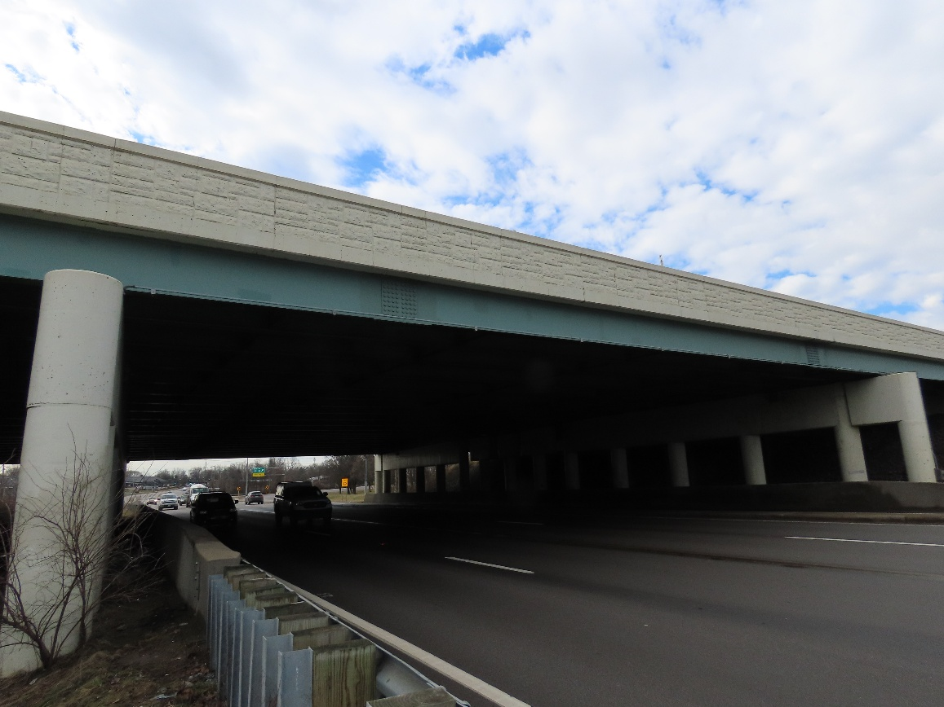
Beam 1 on 2/25/2025 prior to impact.
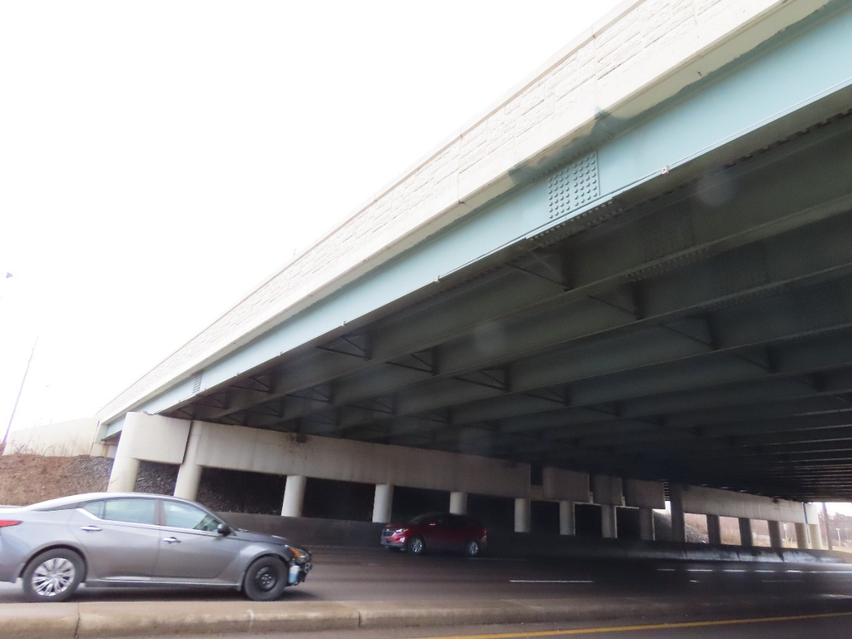
Beams 1 through 4 and bay 1 cross frame on 2/25/2025 prior to impact.

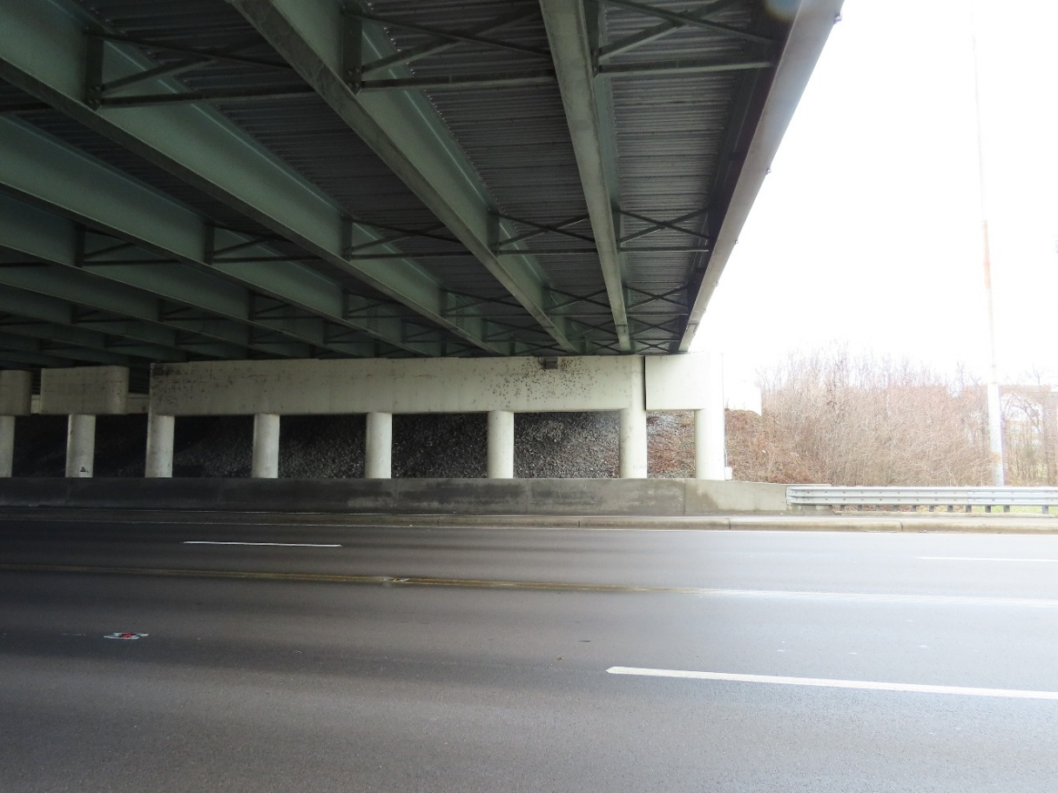Beams 1 through 5 on 2/25/2025 prior to impact.

Exhibit “D”, Conditions After the Accident:

- Condition of structure after the accident:

The north fascia beam (beam 1) has gouges to the bottom flange and to the utility conduit due to the impact. The paint has been damaged and some of it missing around the impact to beam 1. Beam 1 was displaced horizontally and vertically due to the impact.
Bottom flange horizontal displacement: 1”*
Bottom flange vertical displacement: 0.25” downward movement
Length of horizontal damage: 11.67’*

* A proper “sting line” for comparison damage comparison measurements could not established due to the deflection occurring over traffic lanes that were open to traffic and due to utility attachment conflicts. Survey will be needed to determine actual measurements.

The vertical clearance was taken at beam 1 and is 16’2” of vertical clearance. The vertical clearance in the bridge’s inventory is 15.33’ in the northbound direction and 15.5’ in the southbound direction, therefore the vertical clearance of the bridge was not affected by the damage.

A cross-frame between beams 1 and 2 is bent from the impact. A cross-frame member between beams 4 and 5 is also bent from the impact. Beams 4 has scrapes to the bottom flange as well as significant displacement of the bottom flange. The beams were inspected close-up via bucket truck. The flange of beam 4 on the north side of the bridge was displaced upwards on the north side, downwards on the south side, and horizontally towards the south.
Bottom flange vertical displacement: 5” of upward movement and 3.25” downward movement
Bottom flange horizontal displacement: 4”
Length of impact damage: 7’

Beam 5 has gouges and paint scrapes on the web and near the top flange. There is also a deflection in the top flange of beam 5.

- Pertinent photos of the damage are provided at the end of this document.

Exhibit “E”, Cause of Accident:

- Cause of accident: See Ohio Traffic Crash Report 202501238.

Exhibit “F”, Repair Procedures and Costs:

- Repair procedure:

The damage to the steel beams include areas around the splice plate. Due to this, heat straightening alone is not a possible repair option. The bottom portions of the beam will have to be cut out and replaced to the midpoint of the splice. The gouges can be repaired by grinding and repainting. The two damaged cross frames, one between beams 1 and 2 and the other between beams 4 and 5, will need to be replaced. The work will be done with PID 124859 as an ODOT Let project that will sell in 2026. Plans will be prepared by ODOT’s design department to detail the repairs.

- Scope of Repairs to be made:

- Cut the flange and a portion of the web from beam 4 from the start of the impact area to the midpoint of the splice and replace with a new flange and web. Replace all bottom flange splice bolts and possibly web splice bolts for the partial replacement of the beam. Replace the cross frame between beam 1 and 2 and at minimum the lateral bracing member of the cross frame between beams 4 and 5. Grind the impacted and gouged steel. Repaint affected beams and repair areas using a three coat OZEU system that matches the existing paint. Temporary supports for the beam will be needed.

- Estimated Cost to Repair:
Each collision repair is a unique and the predicted cost of repair can vary significantly based upon many factors including contractor availability, urgency of repair, and material supply/costs. The initial estimate for the contract work is estimated to be $500,000. ODOT costs for crash response, inspection, engineering, plans preparation, sale/advertising, and construction administration are estimated to be around $50,000.

Exhibit “E”, Pertinent Photos After the Accident:
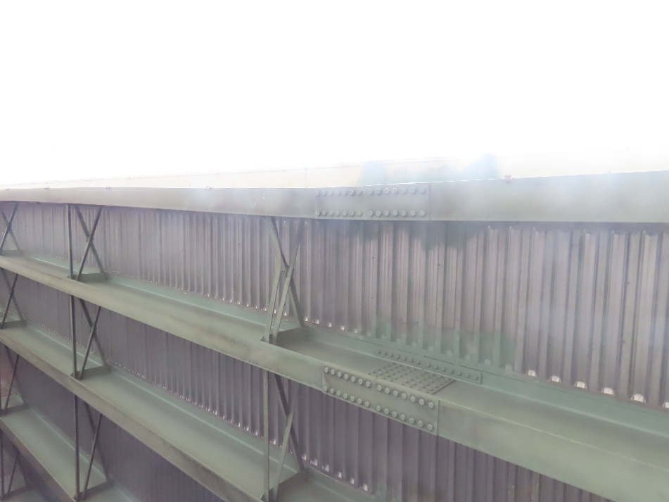

Beam 1 and cross frame after impact
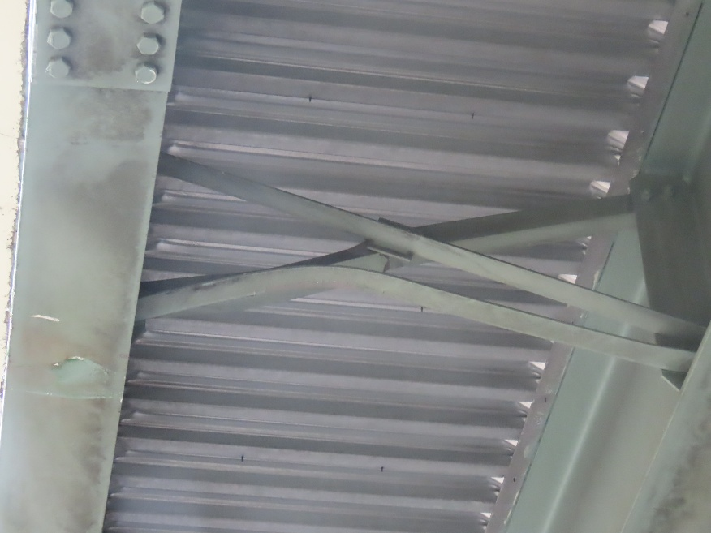

Cross frame between beams 1 and 2 after impact.
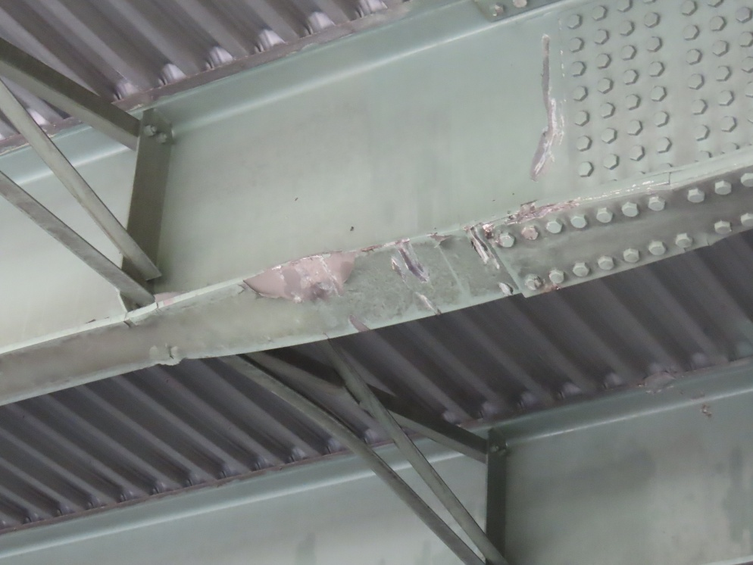

Gouges in flange and web and deflection of flange of beam 4 and deflection of bracing member between beams 4 and 5 after impact

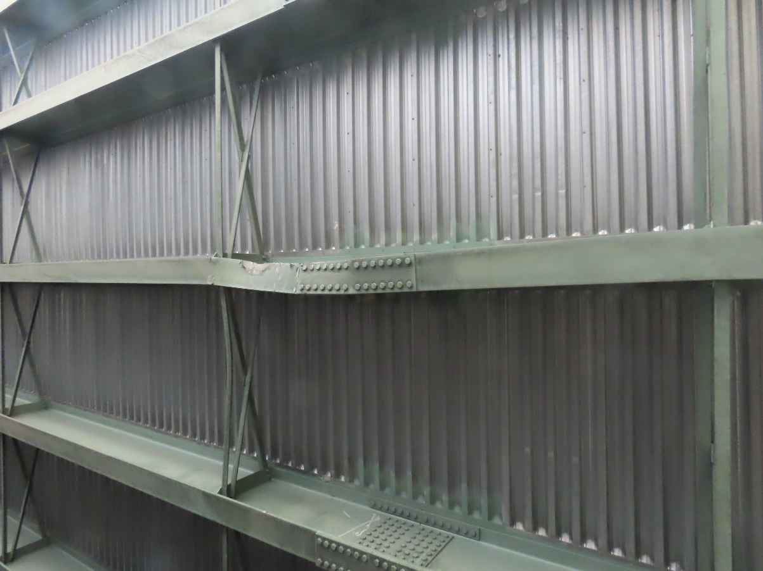

Deflection and gouges to beam 4 and deflection of bracing member between beams 4 and 5 after impact
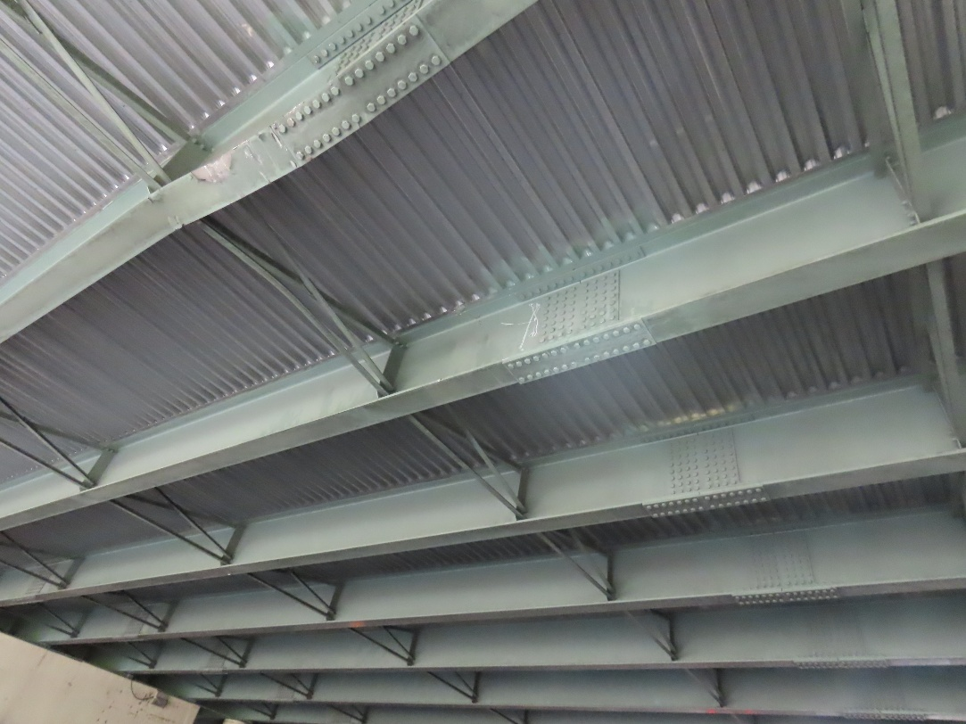

Damage to beam 4 and gouges in beam 5 after impact

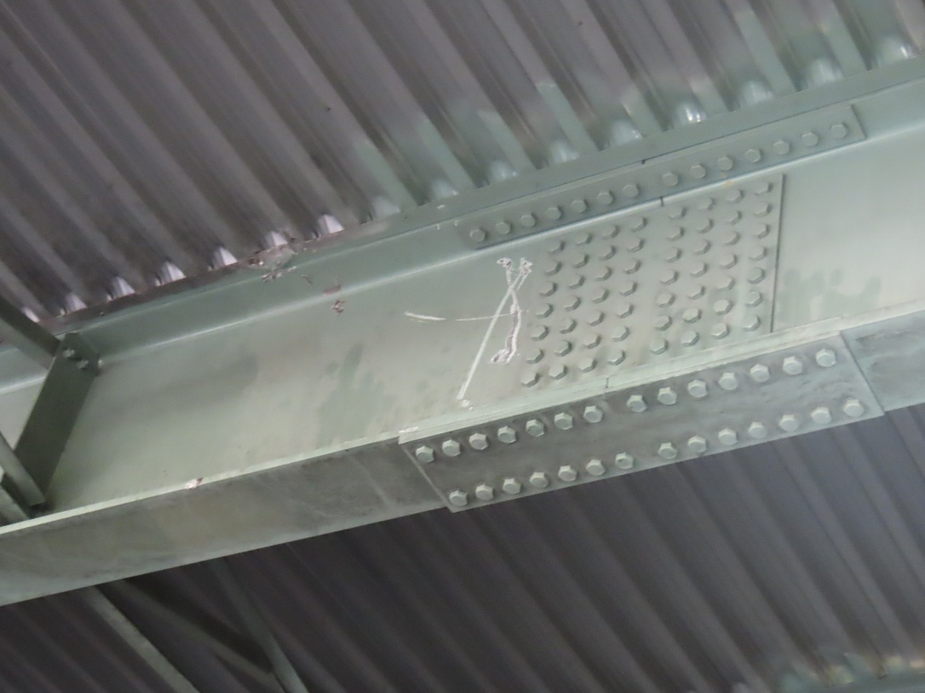

Damage to beam 4 and gouges in beam 5 after impact

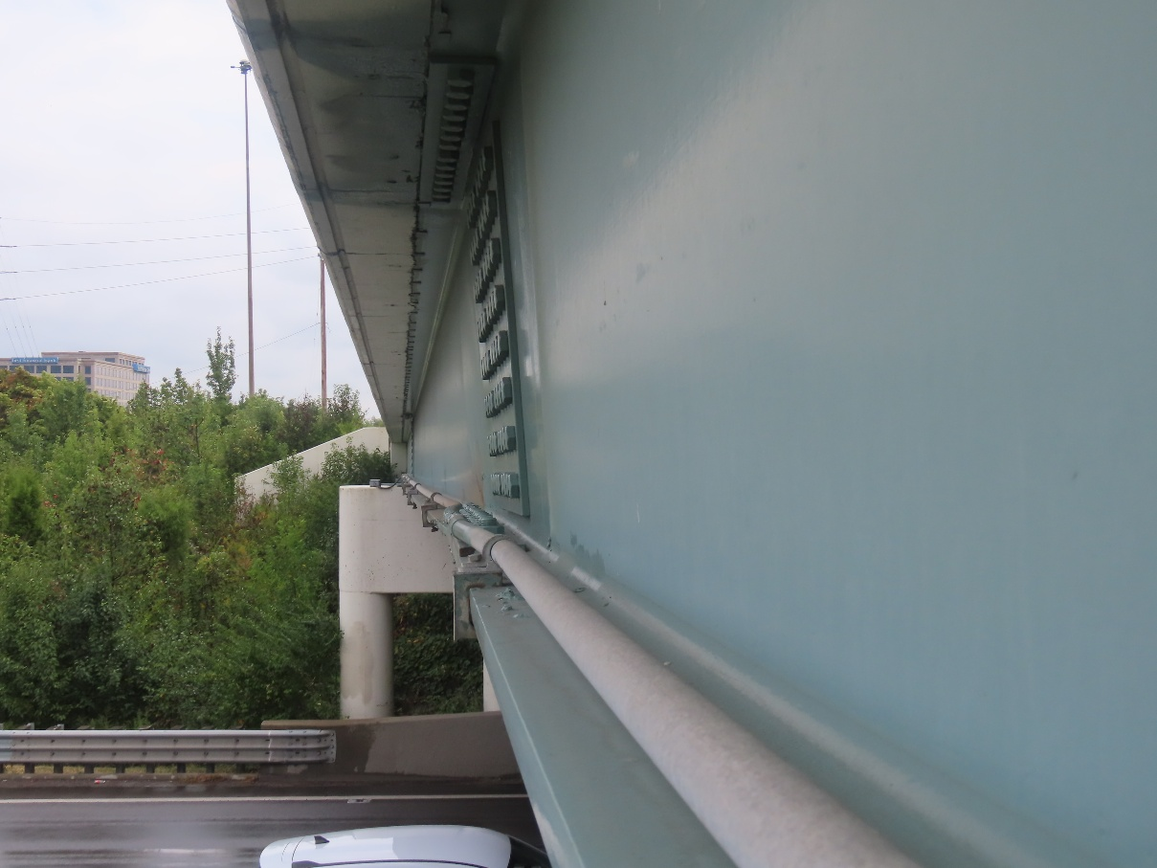
Deflection of Beam 1 after impact
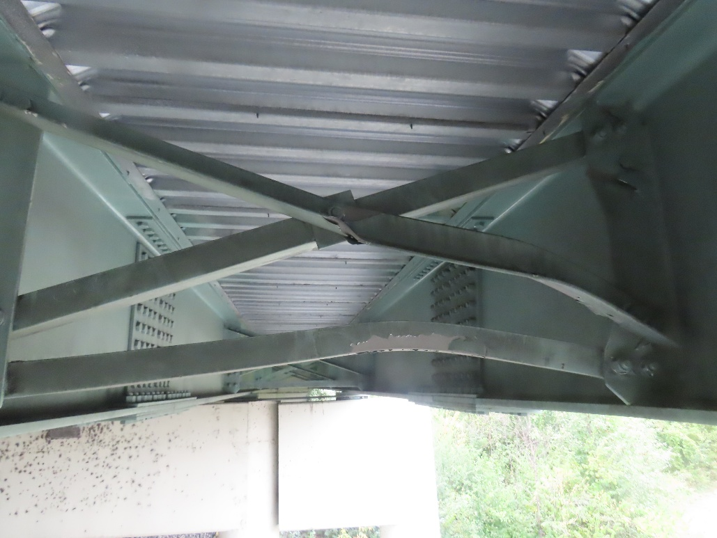
Damage to cross frame between beam 1 and 2 looking west after impact
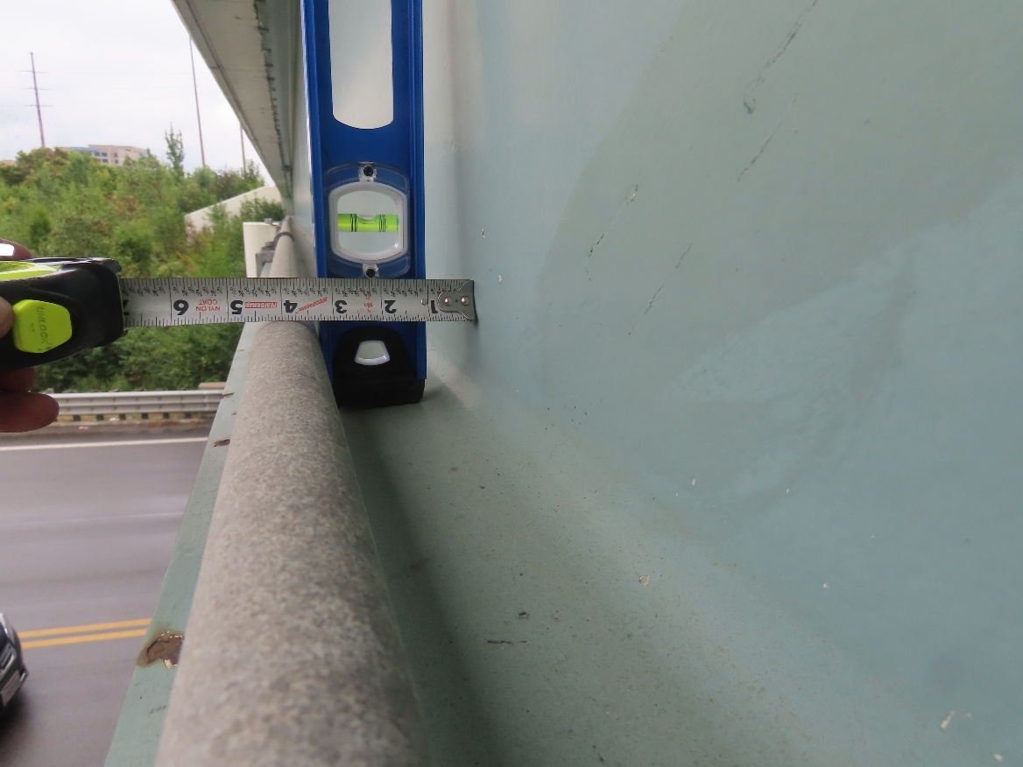
Beam 1 displacement looking east after impact

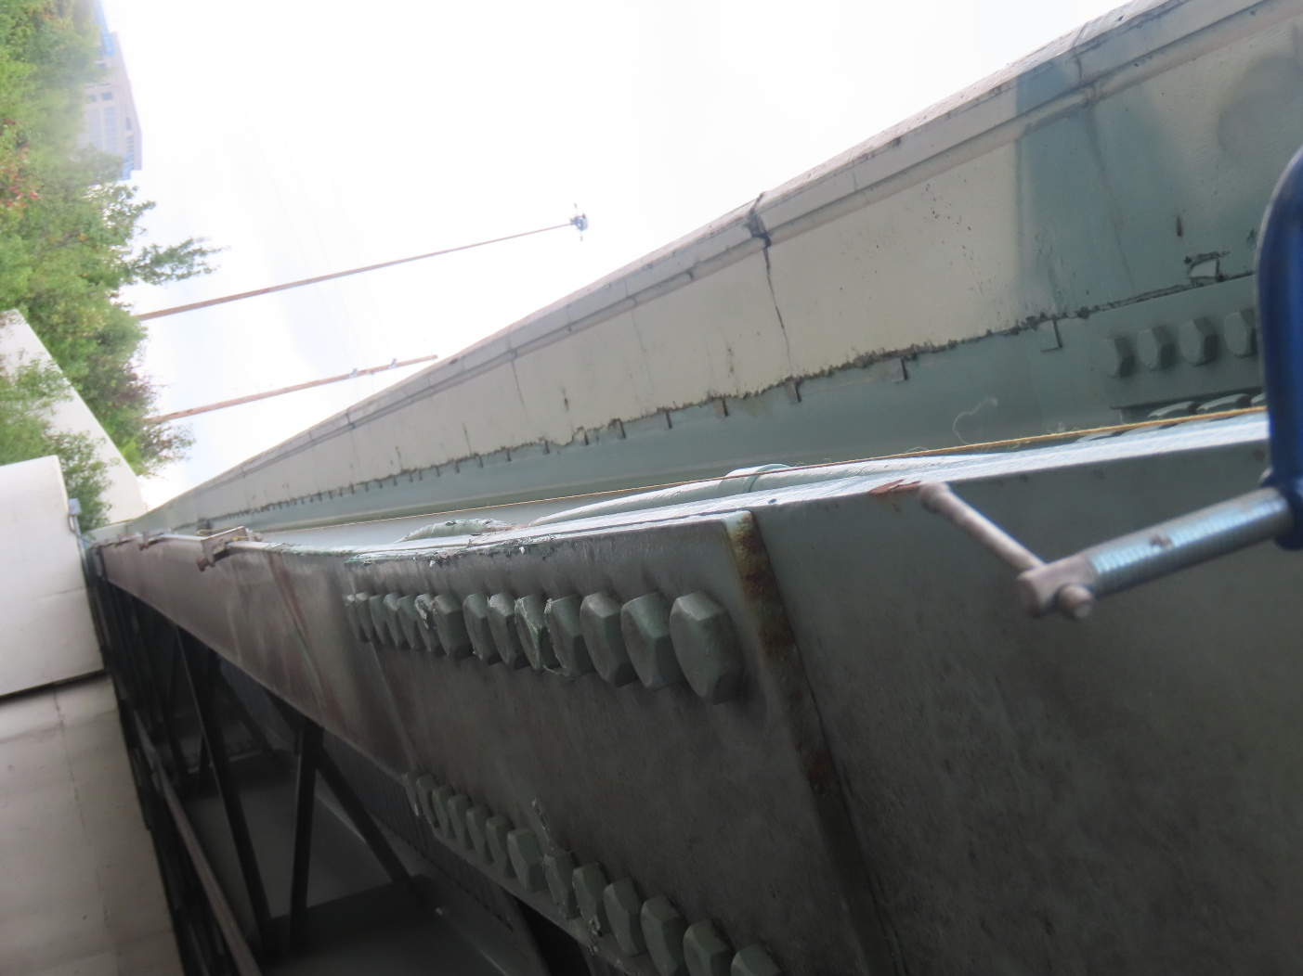

Beam 1 horizontal displacement looking east after impact

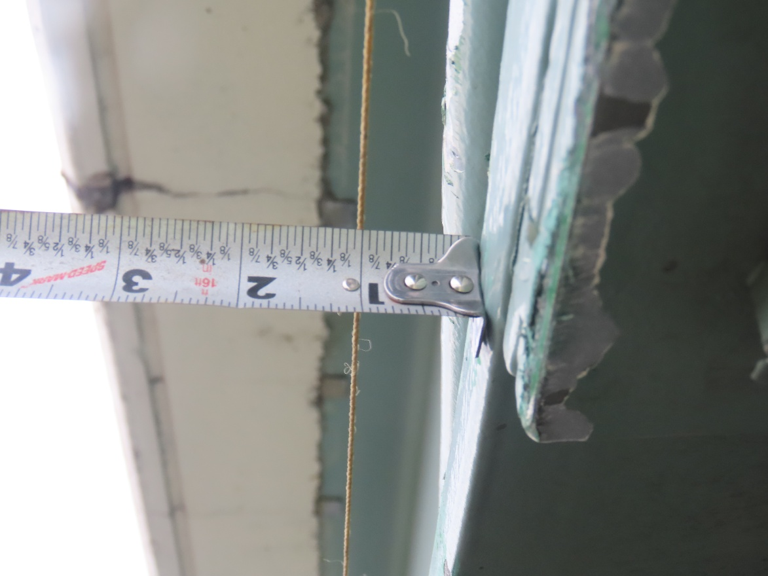
Beam 1 horizontal displacement looking east after impact
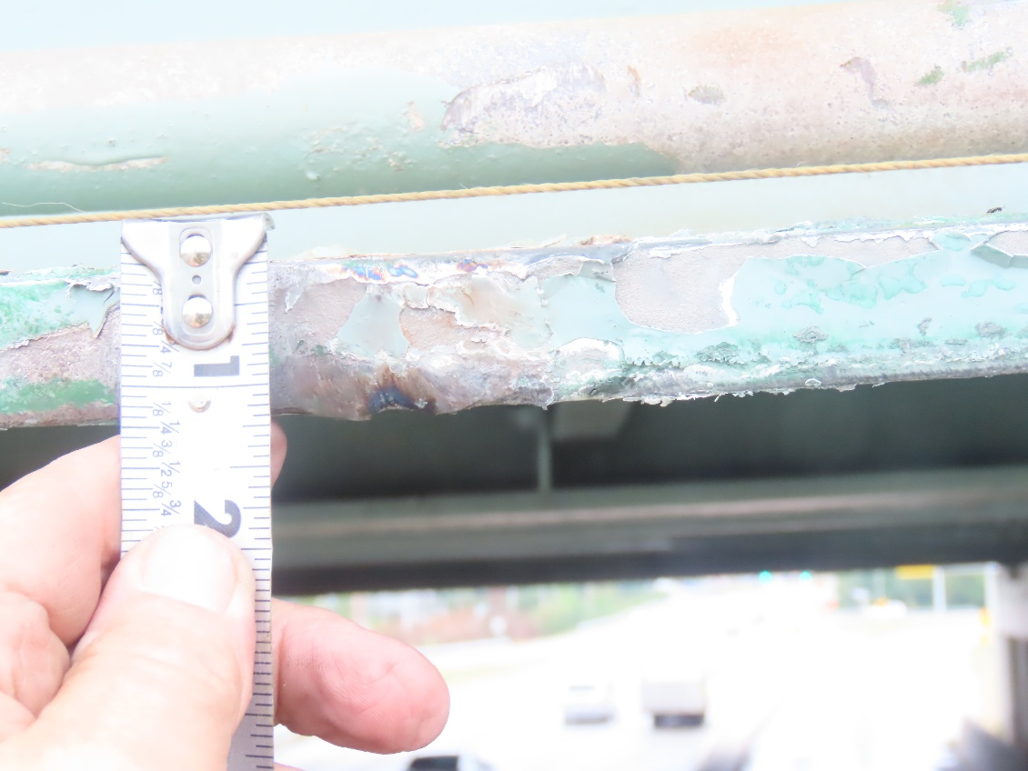

Gouges and vertical displacement of bottom flange of beam 1 after impact

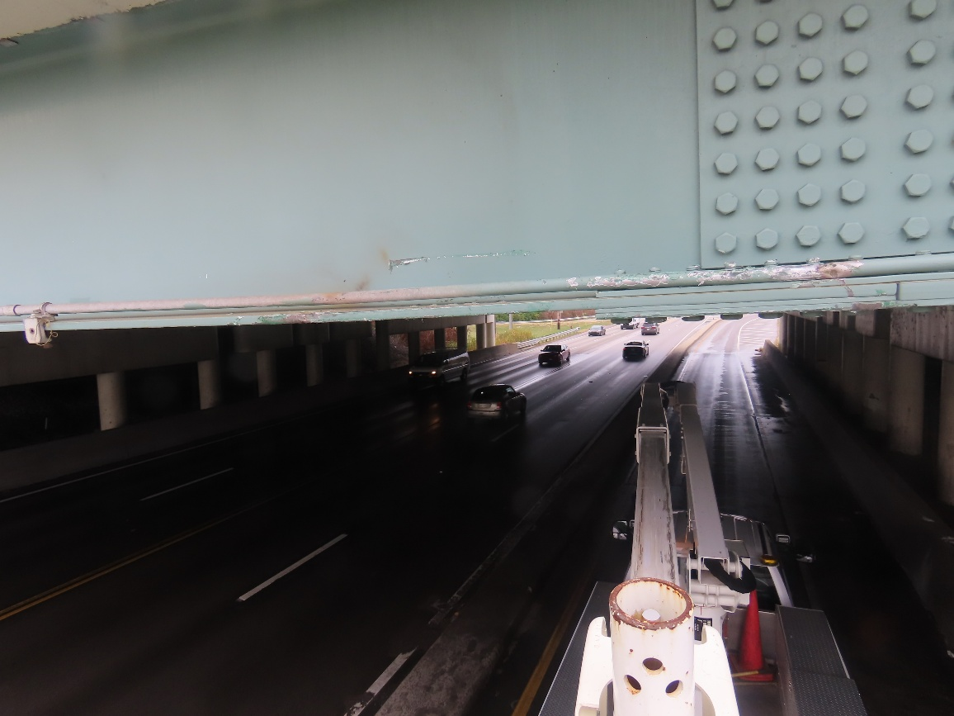
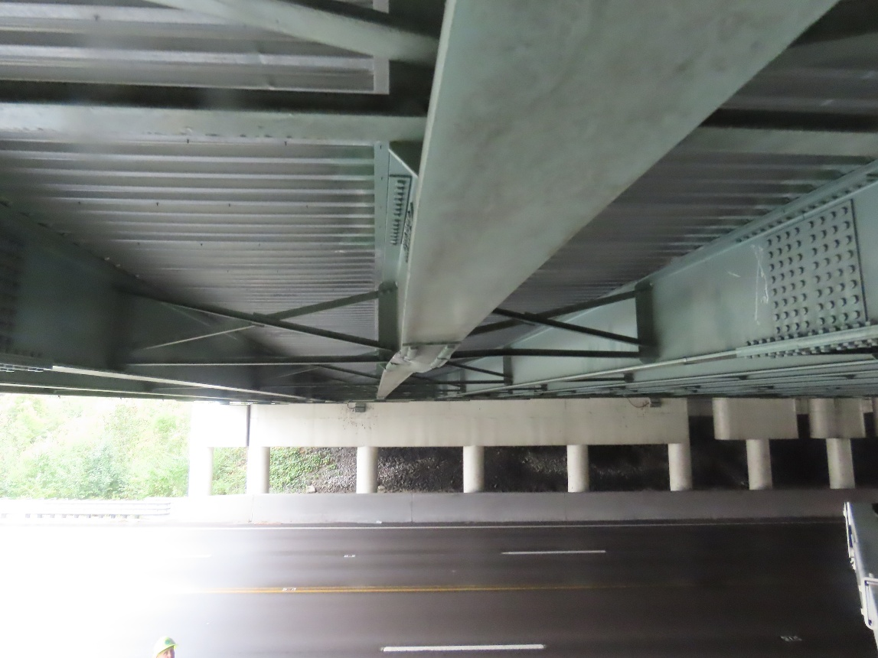
Scrapes and gouges to beam 1 and utility conduit carried on bridge after impact

Deflection of the bottom flange of beam 4 after impact
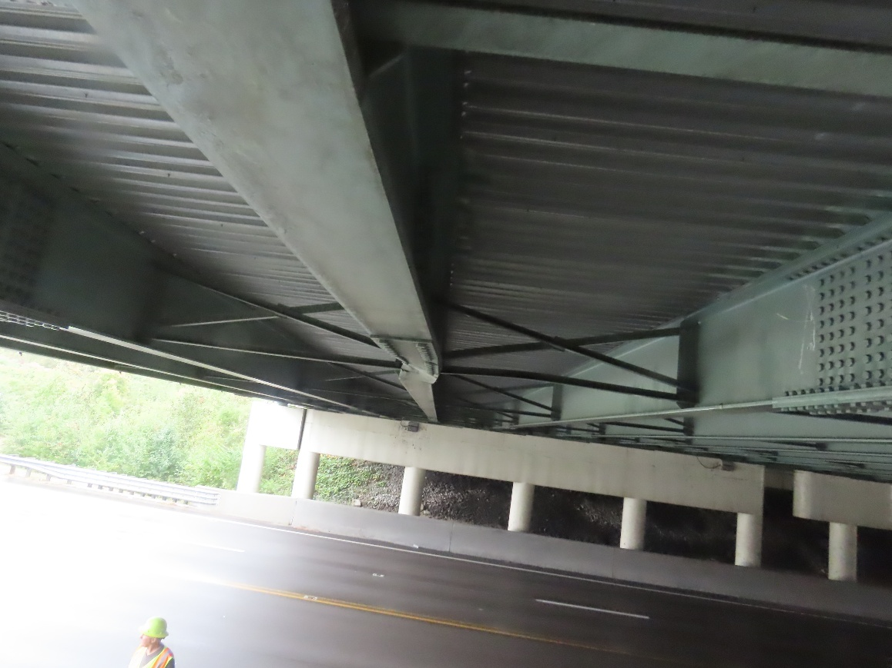
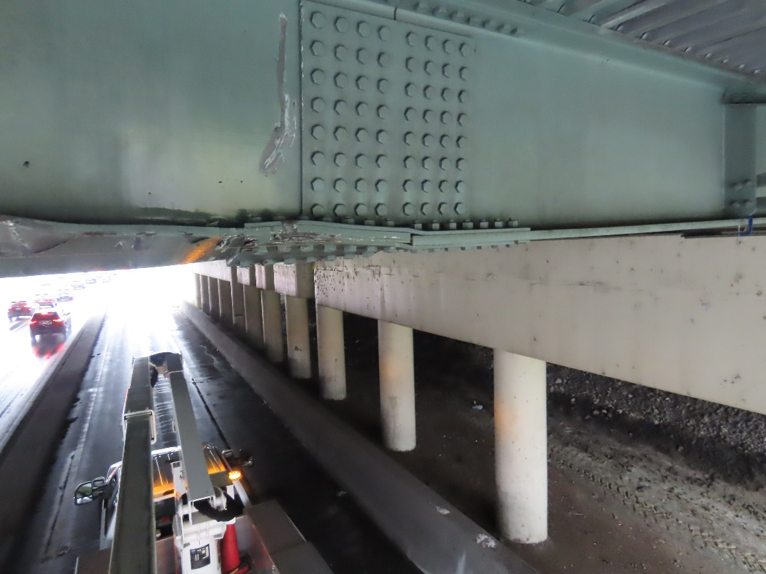
Deflection of the bottom flange of beam 4 after impact

Gouges to beam 4 and deflection of the bottom flange of beam 4 after impact

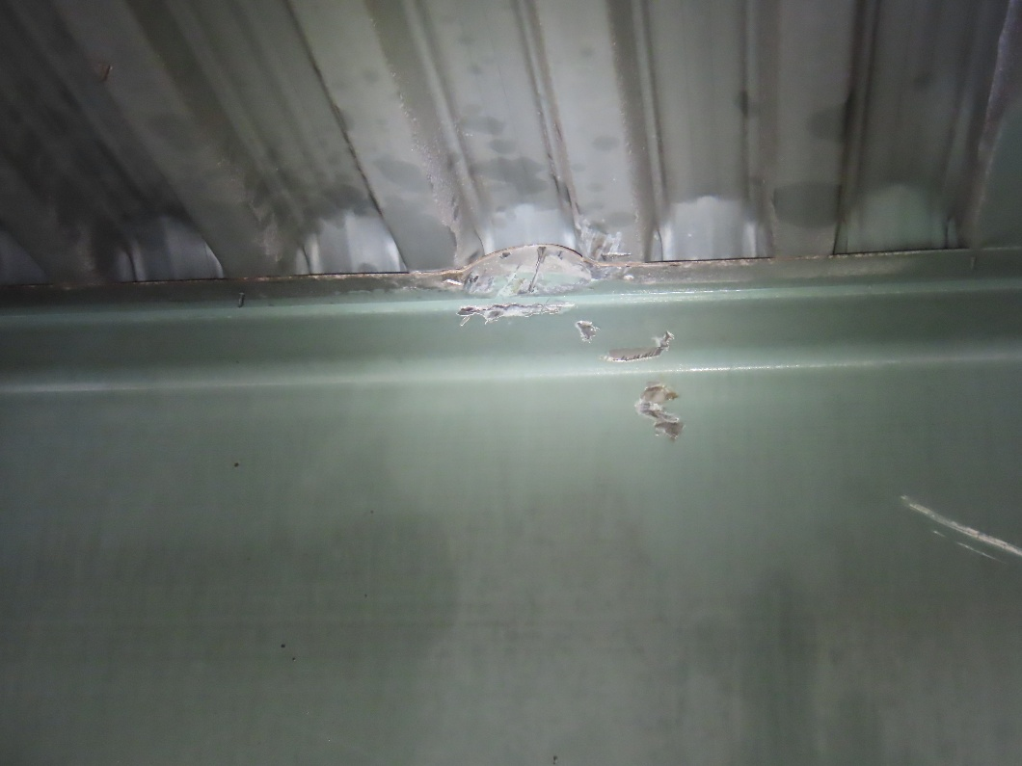

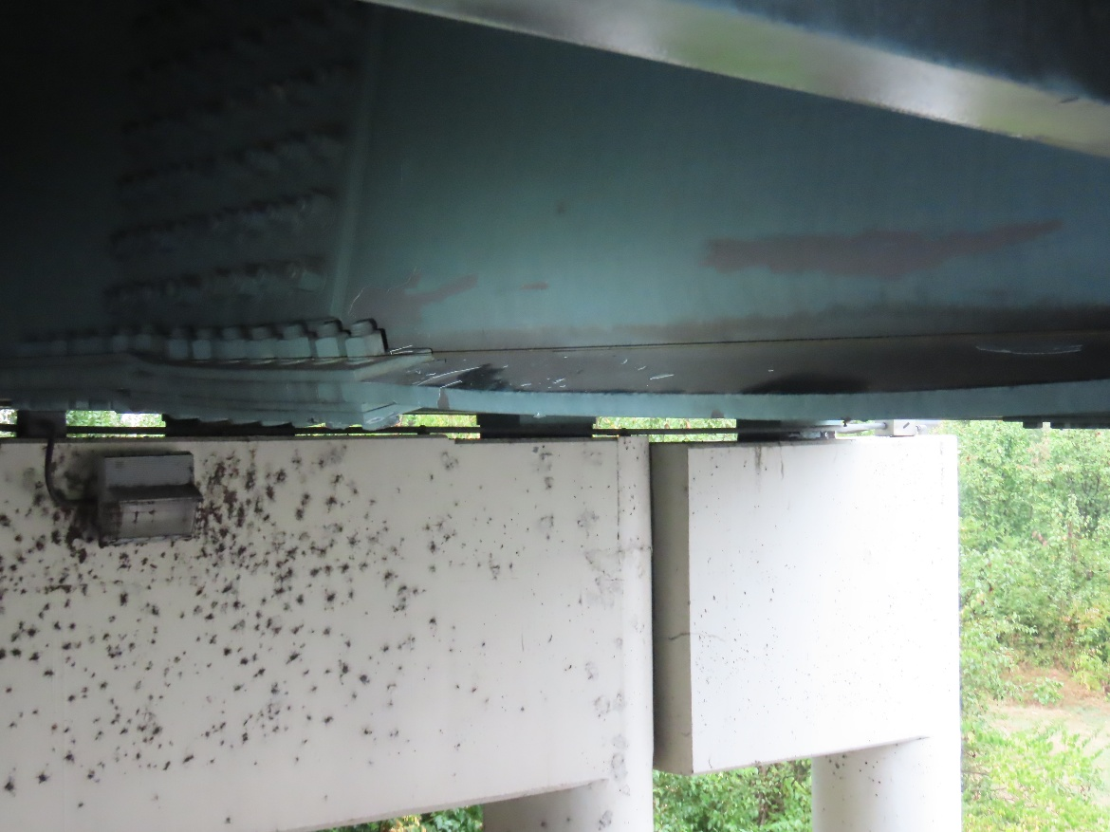
Gouges and deflection to top flange of beam 5 after impact

Deflection of bottom flange of beam 4 looking North after impact
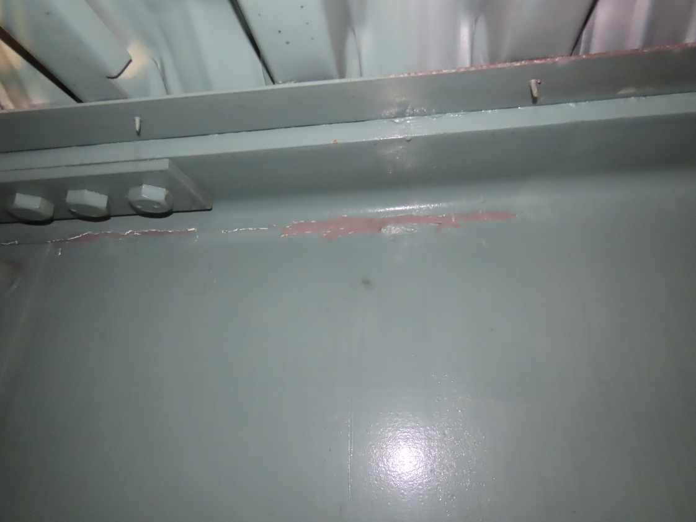
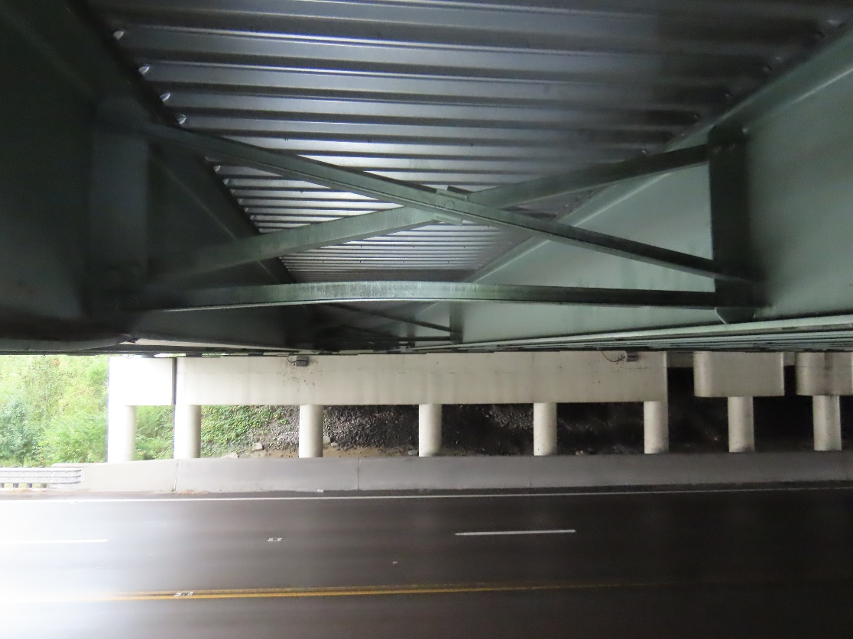
Deflection of cross frame member between beams 4 and 5 after impact

Paint missing from south side of beam 4 after impact
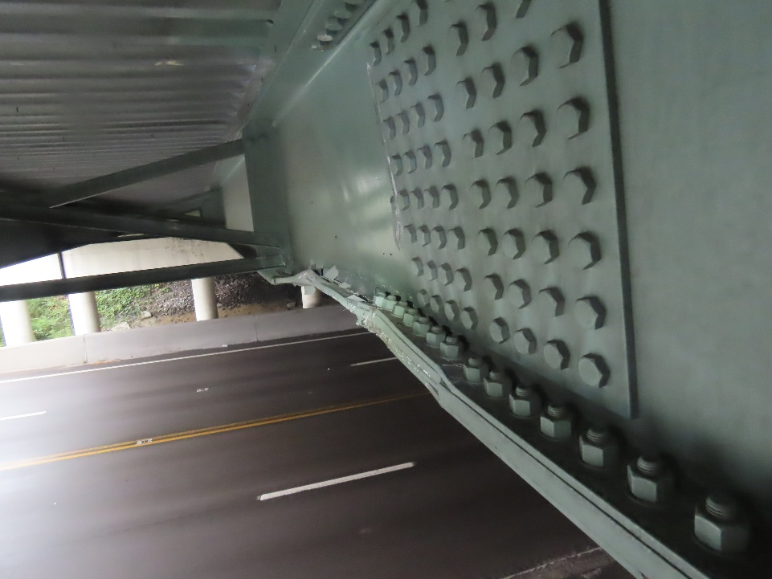

Deflection of bottom flange of beam 4 looking east
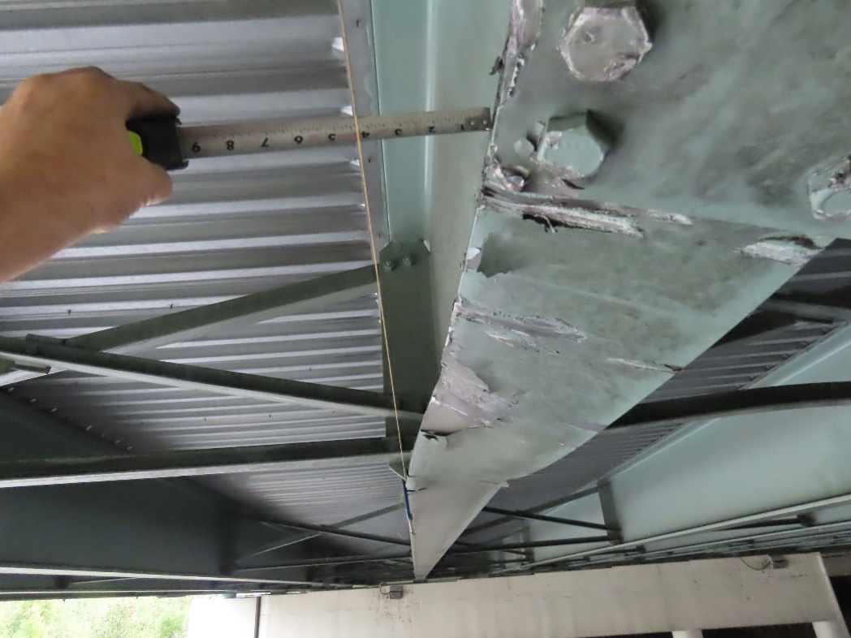

Horizontal deflection of beam 4 looking east after impact
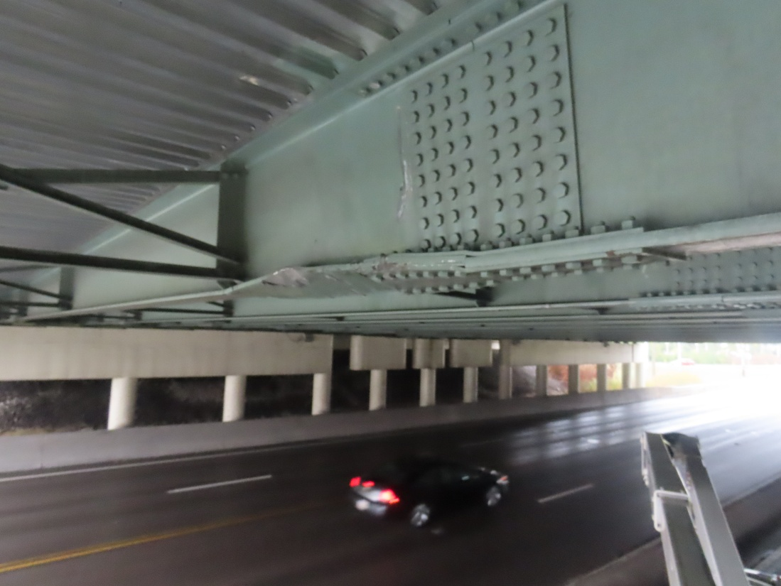
Deflection of the bottom flange of beam 4 after impact
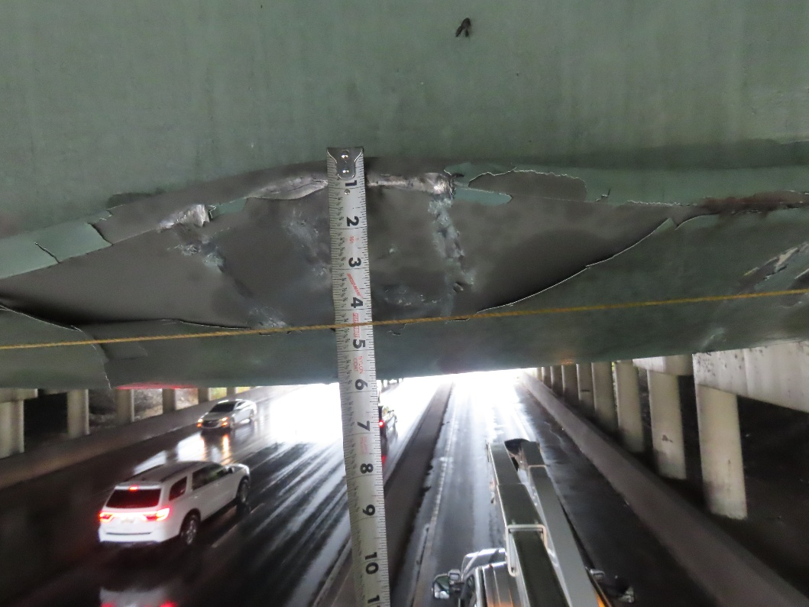

Vertical displacement of the bottom flange of beam 4 after impact

