SCOPE NARRATIVE
Project HAM IR 275 23.38L
PID 124859

General Information
This Narratives Document contains specific scope information not included in the SAFE system on various relevant topics.

Structures and Project Scope

Rehabilitate the HAM-275-2338L bridge (SFN 3112063) that carries WB I-275 over SR 4 due to damage from an overheight collision as follows:
- Temporarily relocate utility on Beam 1. Work with ODOT ITS Department in Central Office for options.
- Heat Straighten Beam 1. The width of the impact appears to have occurred over several lanes. A LiDAR scan of the bridge has been requested from the ODOT D8 surveying department to help determine limits. Grind smooth impact location per CRSH Plan Insert Sheet, detail FC2-2.
- Replace cross frame in Bay 1-2, first cross frame east of the first splice including the stiffener on Beam 1.
- Replace the lower half of Beam 4 from the first cross from east of the splice west to the middle of the first splice per CRSH Plan Insert Sheet detail WC1-2 and WC1-3 except on the splice end. At the splice end, the web and bottom plates will need to be removed. Replace the bottom flange splice plates. Shop drill the west side of the place, but require the east side to be filed drilled. The web plates appear to be in sufficient condition to re-use. Provide additional blank (undrilled) web and bottom flange splice plates in case of fit-up issues. The east end of the welded field splice in the bolted splice area shall be drilled in the field to allow sufficient length for a run-off tab. (ask OSE for detail). Replace all bolts in the web splice and flange splice.
- Replace the cross frames on either side of beam 4 to the east of the splice. Replace the stiffeners attached to beam 4 on both sides.
- Heat Straighten Beam 4 (portions not replaced). The width of the impact appears to have occurred over several lanes. A LiDAR scan of the bridge has been requested from the ODOT D8 surveying department to help determine limits.
- Grind the web scrapes on beam 5.
- Paint: Paint the damaged areas with a 3 coat OZEU paint system. Use a lump sum pay item as exact limits won’t be know when considering contractor damage. Color to match existing.
See framing plan with damage locations in I:\Structures\ham\ir275\2338l\Bridge Hit 9-22-2025

Maintenance of Traffic

Maintain traffic as follows:
Extents of heat straightening repair and partial beam replacement not yet determined. Need 3D scan to determine limits.

MOT Not yet reviewed by Work Zone Traffic Engineer (Scott Kraus).

Design Designations

 | HAM-275-2338 | HAM-4-9.9
Functional Classification
Design Functional Classification
Opening Year ADT (2026)
Design Year ADT (2038)
Design Hourly Volume
Direction Distribution
Trucks (24 Hour B&C)
Posted Speed (mph)
Design Speed (mph) | 55 | 55 | 60

General Information

- Existing Plans:
 | Arch No | Name | Year | PID | Description
1 | 08c1495 | HAM-50B-20.37 | 1958 | n/a | Original Construction
2 | 08c2357 | HAM-275-21.52 | 2006 | n/a | Major rehabilitation and widening

Photos are available at: I:\Structures\ham\ir275\2338l\Bridge Hit 9-22-2025

Project Map

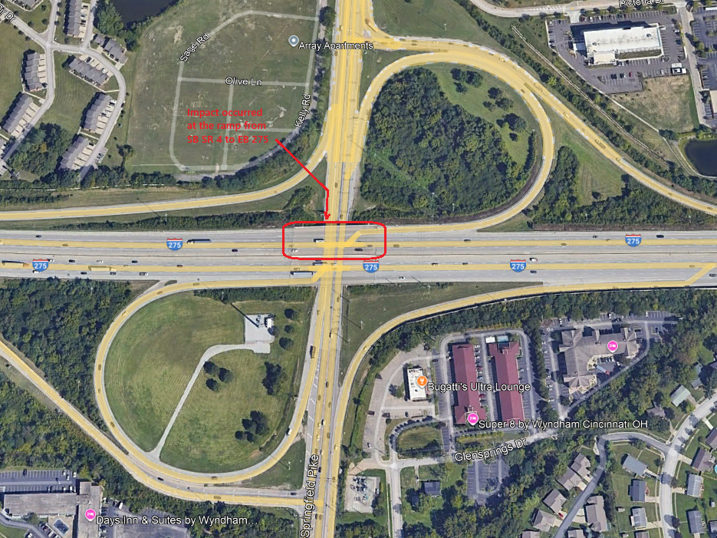

Project Schedule
Note: This the schedule in Ellis at the time of scoping (9/26/25). Refer to Ellis for the official scheudle.

