SCOPE NARRATIVE
Project HAM IR 275 23.38L
PID 124859

General Information
This Narratives Document contains specific scope information not included in the SAFE system on various relevant topics.

Structures and Project Scope

Rehabilitate the HAM-275-2338L bridge (SFN 3112063) that carries WB I-275 over SR 4 due to damage from an overheight collision as follows:
- There is a lighting conduit attached Beam 1 that is for underdeck lighting. Relocate this utility to Beam 2 prior to the repair work.
- Heat Straighten Beam 1. Grind smooth impact location per CRSH Plan Insert Sheet, detail FC2-2. The width of the impact will require closure of the SB Entrance Ramp to EB IR 275 and the SB SR 4 right thru lane.
- Replace cross frame angles and bolts in Bay 1-2, first cross frame east of the first splice including the stiffener on Beam 1.
- Repair Beam 4 as follows: Temporarily support Beam 4 on either side of the repair area capable of carrying the dead load of the beam. A load equivalent to half of the dead load shall be jacked into the beam at the support locations and maintained during repairs. Heat Straighten Beam 4. Remove and replace the bottom flange splice plates and bolts. Provide new bottom flange splice plates. Holes shall be field drilled to match existing on both sides of the splice and beam. Provide new bolts for the flange and web. Web splice plate/bolts are not required to be replaced unless determined to be necessary for heat straightening. Replace the lower cross frame angle east of the splice between B4 and B5. Grind smooth impact location per CRSH Plan Insert Sheet, detail FC2-2. The width of the impact will require closure of the SB Entrance Ramp to EB IR 275. The temporary support will need to be protected from traffic.
- Grind the web scrapes on beam 5.
- Paint: Paint the damaged areas with a 3 coat OZEU paint system. Use a lump sum pay item as exact limits won’t be known when considering contractor repair/damage. Color to match existing.
See framing plan with damage locations in I:\Structures\ham\ir275\2338l\Bridge Hit 9-22-2025

Maintenance of Traffic

Maintain traffic as follows:
WEEKEND CLOSURE:
One weekend closure of the following routes will be allowed as follows for heat straightening and splice repair work:
- Close SB SR 4 to eastbound I-275. Detour traffic to WB I-275 to Winton Rd to EB I-275.
- Close SB SR 4 right through lane for eat straightening work.
- To take live load off of Beam 1 and Beam 4 during heat straightening, close the NB SR 4 to WB I-275. Detour to EB I-275 to SR 747 to WB I-275. Barrell off the WB 275 shoulder across the bridge to ensure vehicles do not pull over in this area.
These traffic modifications shall begin on a Friday beginning at ____ PM and shall be removed by the following Monday Morning at ____AM.
WEEKNIGHT CLOSURES:
Closures for painting and/or cross frame work are allowed between the hours of ____AM to ___PM as follows:

MOT Not yet reviewed by Work Zone Traffic Engineer (Scott Kraus).

General Information

- Existing Plans:
 | Arch No | Name | Year | PID | Description
1 | 08c1495 | HAM-50B-20.37 | 1958 | n/a | Original Construction
2 | 08c2357 | HAM-275-21.52 | 2006 | n/a | Major rehabilitation and widening

Photos are available at: I:\Structures\ham\ir275\2338l\Bridge Hit 9-22-2025

Project Map

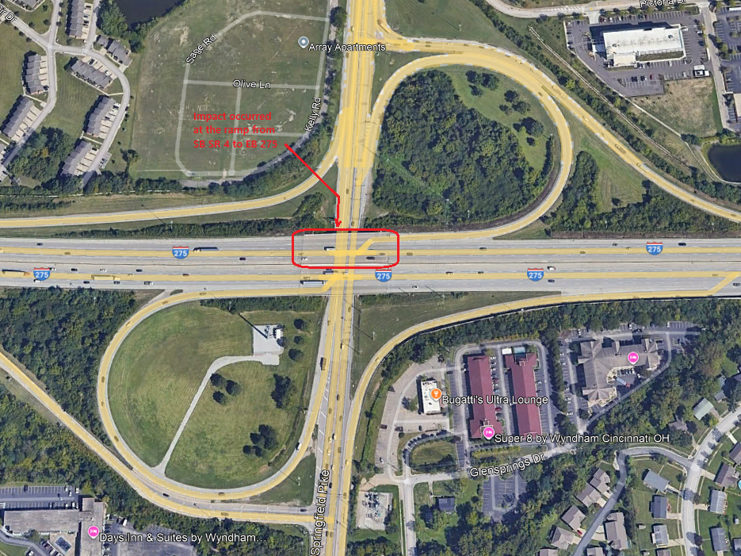

Project Schedule
Note: This the schedule in Ellis at the time of scoping (11/07/25). Refer to Ellis for the official scheudle.

