BRIDGE SCOPE NARRATIVE
HAM US 50 29.39 Ramp
PID: 120924

General Information
This Narratives Document contains specific scope information not included in the SAFE system on various relevant topics. This will be a 2 part scope.

Project Scope

Repair the slope along Ramp L that carries a ramp from Red Bank Rd to Eastbound US 50. Prepare a feasibility study that will determine the following:

- Geotechnical study. Study shall include __ borings. Provide location of proposed borings to District Geotechnical Engineer prior to field drilling.
- Hydraulic Study of the stream to determine the channel size with the proposed wall/slope treatments. This stream is located in a Zone AE Flood area so it must be designed to produce a “no rise” condition.
- Wall details including type, length, location and height. The designer should consider the following wall types:
A.
B.
4. Slope treatments on either side of the stream including length, slope, location, height, and type. Include cross sections at 25’ intervals showing existing and proposed wall/slopes.
5. Show construction limits in plan view including existing features, ordinary high water mark, existing R/W and existing easements.
6. Culvert at Ramp L STA 4+00: Reconstruct as needed. Show location of new headwall/outlet in plan view.
7. Culvert at Ramp L STA 5+46.21: Slip line broken back culvert with UV cured pipe. Remove deteriorated end section or extend pipe as necessary. Show location of pipe, extents to be treated, and outlet headwall/end treatment.

ODOT will determine if R/W is necessary at the conclusion of the Feasibility Study.

Maintenance of Traffic- Construction Access

MOT and Construction access will be determined by ODOT at the conclusion of the Feasibility Study.
Scott Kraus to provide comments.
Utilities

Utility Coordination:
Consultant to try to avoid utility conflicts throughout design while holding to the scope of work. If utility conflicts cannot be avoided, they should be minimized. Consultant to provide a copy of the OUPS ticket information to ODOT PM (if applicable). Up to date utility contacts shall be used at each plan submission. Utility contact information can be requested by consultant from ODOT PM. If Ohio 811 (OUPS) are more than two (2) years old, a design non-marking ticket shall be requested to obtain most up to date Utility Members List. The ticket does not need to be submitted to obtain the Utility Members List.

Consultant to provide a utility set of plans with the utility lines shown in color using the most recent version of ODOTcadd_UTPen.tbl at each plan submission. This file is found in the standard ODOTcadd executable file that can be downloaded from the CADD services webpage. Additionally, Consultant to prepare a summary of potential utility conflicts at each plan submission. Summary to be provided to Utility Companies at each plan submission. Summary to include, but not limited to station and offset of conflict, type of conflict (direct, decreased cover, proximity, etc.), utility owner (if known) and utility type. Consultant to use District 8's 'standardized' letter for sending submissions and plans to Utility Companies for review and comment. Consultant to provide the ODOT PM a copy of all Utility Correspondence. Consultant to compile Utility Company responses and forward to the ODOT PM. Final compilation of utility correspondence is due 35 days after plan submission to utilities.

A “no response” from a utility on a plan submission review cannot be considered as “no comment”, “no conflicts” and/or “a confirmation of the consultant’s findings” from the utility. A written response (email is sufficient) must be received from the utility verifying that they have no comments, no conflicts and/or they agree with the conflicts identified by the consultant.

Consultant to review the Utility Company responses and evaluate. The evaluation of the responses shall include validating that a conflict does exist or that a utility may remain in place. If a conflict does exist, consultant should provide an evaluation of the feasibility of potential resolutions. A disposition of utility status (i.e. utility to stay in place, utility facility relocation plan in writing or plan format) is required at the Stage 3 submission. This disposition shall be included to the utilities with the Stage 3 plan submission. This disposition shall be formulated based on utility responses from previous plan submissions.

A draft utility note shall be submitted after evaluation of the Stage 3 utility coordination in word format. The note should include discussion about the existing utilities for each utility, if they are staying in place and in service or if they are being relocated. If a utility is relocating, information about the location of their relocation should be included. Additionally, the relocation time frames should be included in the utility note as discussed with the utility companies. Example utility notes can be provided by the District utility coordinator upon request.

Design Designations

OPENING YEAR AADT (2029)
DESIGN YEAR ADT (2041)
DESIGN HOURLY VOLUME (2041)
DIRECTIONAL DISTRIBUTION
TRUCKS (24 Hour B&C)
Td
FUNCTIONAL CLASS
NHS

General Information

- Existing Plans:
 | Arch No | Name | Year | PID | Description
1 | 08c1397 | HAM-50-(29.83-30.33) | 1958 | n/a | Original Construction
2 |  | HAM US 50 29.00 | 2024 | 110570 | Nearby Rehabilitation and resurfacing
3 |  | HAM Inverts FY2025 | 2025 | 110633 | Invert Paving of large upstream culvert
4
5
6
7

Photos from the PIP are available at:
I:\Structures\ham\US50\2955\Erosion Upstream
Location Map

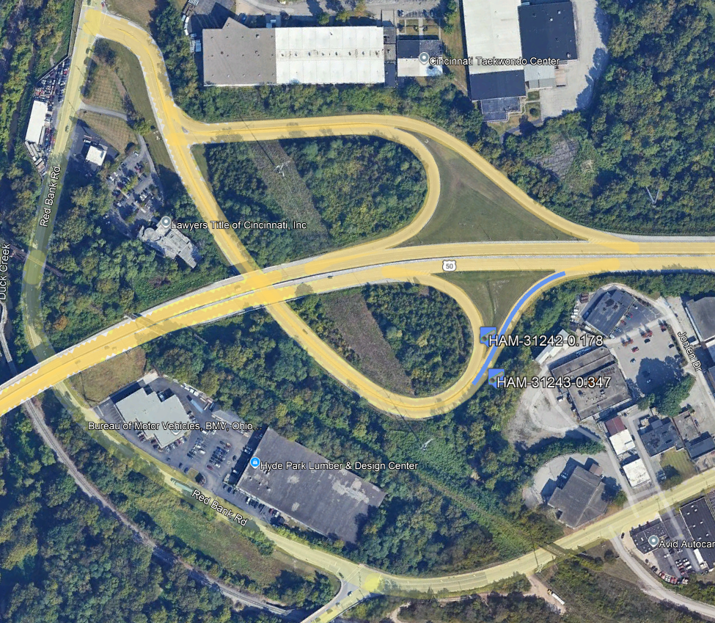

Schedule

The tentative Milestones shown below are for information purposes only and are as of 9/17/25. The official schedule is maintained in Ellis.

